DATA: 24 / 11 / 2016
ALUNO(A):
3º Bimestre
TURMA: 3º ALIM_MAT
PROFESSORA: CRISTIANE DE BRITO CRUZ PROVA TIPO 4

Nota
Valor 100

AVALIAÇÃO BIMESTRAL .
INSTRUÇÕES:
- Leia as instruções com atenção.
- Entregue junto com a prova: seu cartão de vistos e seu trabalho (não será dado outro prazo para entrega).
- Escreva seu nome completo com letra legível. Seus dados de identificação são importantes;
- Não esqueça de preencher o gabarito, caso não preencha perderá a pontuação das mesmas;
- Somente será permitido o uso de caneta esferográfica azul ou preta;
- Utilize o verso da prova para rascunho das questões subjetivas;
- É terminantemente proibido o uso de celulares, tablets, notebooks, caderno ou qualquer meio de consulta;
- Em havendo sinal de cola a avaliação será atribuída nota 0,0 para os alunos envolvidos;
- Não se preocupe em não entender todas as palavras do texto. Passe a “vista” rapidamente umas 3 vezes e vá para as perguntas.
- Cuidado ao conferir as palavras para não rasurar o gabarito nem as questões subjetivas, não será dada a você uma nova prova para passar a limpo;
- Escreva mais 10 tipos de filmes e programas de TV com a tradução (diferentes dos da prova) ou faça 10 exemplos de frases comparando que não se encontram aqui na prova para obter 15 pontos extras. Obs: não avise a quem está plicando nem pergunte nada. Faça no verso da prova onde está escrito RASCUNHO indicando aqui que fez. ( ) Eu fiz a pontuação extra.

FOLHA DE RESPOSTAS
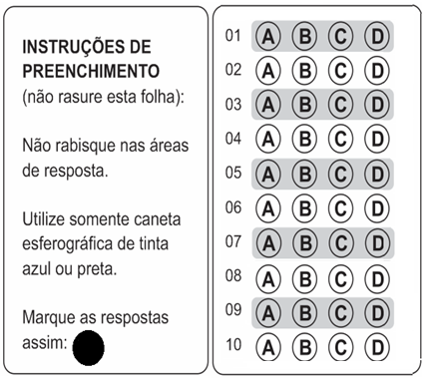

Henry’s Crime
Henry, a tollbooth worker, is unknowingly roped into a bank robbery by acquaintances, and when the police show up, Henry is the only one who gets caught. During a four-year jail stint, he befriends Max, a wise, older gentleman, who leads Henry to consider his purpose in life. Upon his release, Henry returns to the bank he didn't rob, and realizes he went to jail for a crime he didn't commit. So, he might as well go ahead and commit the crime.
Genres : Comedy, Thriller and Crime/Gangster
Running Time : 1 hr. 48 min.
Release Date : April 8th, 2011
Starring : Keanu Reeves, Vera Farmiga, James Caan, Danny Hoch, Fisher Stevens
Directed by : Malcolm Venville
Produced by : Scott Fischer, Sacha Gervasi, Stephen Hays (II)
VOCABULARY: tollbooth=cabine de pedágio; unknowingly=intensionalmente; acquaintances=conhecidos; stint=restrição; befriend=tornar-se amigo.

Soul Surfer
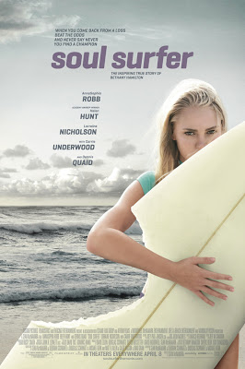
Bethany was born to surf. A natural talent who took to the waves at a young age, she was leading an idyllic, sun-drenched, surfer girl's life on the Kauai Coast, competing in national competitions with her best friend Alana, when everything changed in a heartbeat. On Halloween morning, Bethany was on a typical ocean outing when a 14-foot tiger shark came out of nowhere and seemed to shatter all her dreams. In the moving aftermath of this headline-making story, Bethany fights to recover and grapples with the future. Strengthened by the love of her parents, Tom and Cheri, she refuses to give in or give up, and begins a bold return to the water. Still, the questions keep hammering her: Why did this happen? Why did she have to lose everything? Will she ever feel the joy and power of riding the waves again? And if she can't be a surfer, then who is she? The devastating 2004 tsunami in the Pacific Ocean unexpectedly gives Bethany a new perspective. Traveling to Phuket, Thailand with her youth-group leader Sara Hill, she witnesses life beyond her own shoreline and discovers her greater purpose--she can make a difference in the lives of others. Filled with a new sense of hope and direction, she returns home with a renewed resolve to conquer her own limitations and set an encouraging example for people facing adversity. At the National Championships, Bethany bravely faces off with her fiercest rival, Malia Birch, and takes her astonishing one-armed surfing technique to the limit. But as the horn blows, and the suspenseful competition kicks off, Bethany is no longer thinking about the challenges of her body. Now, her surfing, her biggest dreams and her life have become about pushing her own physical limits to touch the souls of others.
VOCABULARY: idyllic= idílico(rural,bucólico) ; sun-drenched= cheio de sol ; heartbeat= batimento (cardícado), num piscar de olhos ; outing= excusão, saída ; came out of nowhere=apareceu do nada; shatter= estilhaçar; aftermath= consequência, resultado; grapples= combater, pelejar; strengthened=fortalecida; bold=bravo/corajoso; hammering=atormentando; witnesses=testemunha; conquer= conquistar,dominar ; fierce= feroz, ameaçador; astonishing= surpreendente, assombroso ; horn= buzina, trombeta, sinal sonoro.
Genres : Drama, Kids/Family, Adaptation, Biopic and Sports
Release Date : April 8th, 2011
Starring : AnnaSophia Robb, Dennis Quaid, Helen Hunt, Kevin Sorbo, Lorraine Nicholson
Directed by : Sean McNamara
Produced by : David Zelon, David Tice, Ricardo S. Galindez

QUESTIONS

- Sobre o filme “Henry’s Crime” é ERRADO dizer que:
- É um documentário.
- É sobre um roubo de banco.
- É sobre a prisão de Henry e seu aprendizado.
- É do gênero gangster.

- O filme “Henry’s Crime”:
- Conta a história de um rapaz que foi preso injustamente.
- Conta a história de uma amizade que surge na prisão.
- Conta a saga de um jovem que foi preso injustamente e acaba cometendo o crime após sair da prisão.
- Todas as respostas acima estão corretas.

- No filme do primeiro texto:
- Henry é o gangster.
- Henry é um viciado em drogas.
- Henry é o único a ir pra cadeia.
- Henry mente para a polícia.

- Observe a frase abaixo:
Henry befriends Max, a wise, older gentleman, who leads Henry to consider his purpose in life.

Sobre este trecho podemos afirmar que:
- Henry is older than Max.
- Max is as young as Henry.
- Max is wiser than Henry.
- Henry is not so young as Max.

- Marque a frase que possui uma comparação entre Hanry e Max, onde um equivale (é igual) ao outro pela característica dada:
- Henry is more intelligent than Max.
- Henry is the most aggressive in the movie.
- Max is the wisest inmate in prision.
- Henry is as guilty as Max.
Obs: guity = culpado(a); inmate=presidiário

- O filme “Soul Surfer” e errado dizer que:
- É uma história baseada em fatos reais.
- Fala da vida de uma menina que era surfista, sofreu um acidente, mas superou.
- Fala de alguém que passou os limites do corpo e deu exemplo para muitos.
- É um filme de aventura.

- No filme “Soul Surfer”:
- Bethany é uma surfista campeã.
- Bethany sofre um acidente com um tubarão.
- Bethany supera os limites de sua deficiência e dá exemplo aos jovens.
- Todas as respostas acima estão corretas.

- Observe o trecho abaixo:
Bethany was leading an idyllic, sun-drenched, surfer girl's life on the Kauai Coast, competing in national competitions with her best friend Alana, when everything changed in a heartbeat.

- Alana is not the most important friend for Bethany.
- Alana is the most important friend for Berthany.
- Alana is the least important friend for Bethany.
- Alana is as important as the other Bethany’s friends.

- Observe a frase abaixo:
The devastating 2004 tsunami in the Pacific Ocean unexpectedly gives Bethany a new perspective.

Caso este tsunami tenha sido o MAIS DEVASTADOR de todos os tempos do Oceano Pacífico, então a frase correta estaria na alternativa:
- That tsunami in the Pacific Ocean was the best devastating of all the times.
- That tsunami in the Pacific Ocean was the least devastating of all the times.
- That tsunami in the Pacific Ocean was the most devastating of all the times.
- That tsunami in the Pacific Ocean was the worst devastating of all the times.

- Observe o trecho abaixo:
Bethany bravely faces off with her fiercest rival, Malia Birch, and takes her astonishing one-armed surfing technique to the limit.

Podemos dizer que, Malia Birch:
- É tão boa quanto Bethany.
- É melhor do que Bethany.
- Não é tão boa quanto Bethany.
- É menos talentosa que Bethany.

- Compare os personagens abaixo utilizando-se dos símbolos dados:
Adjetivos que podem ser utilizados:
HANDSOME/BEAUTIFUL, GREAT, POWERFUL, INTELLIGENT, STRONG, MODERN, OLD, YOUNG, CRUEL, RUTHLESS, AMERICAN, INTENSE, SHY, HOT, NEW, COMPETENT, GENEROUS, FAMOUS, GOOD, BAD, TALL, etc.
Captain America = Iron man ________________________________________________________
Captain America = Iron man ________________________________________________________
Captain America +/- Iron man ________________________________________________________
Captain America +/- Iron man ________________________________________________________
Captain America > Iron man ________________________________________________________
Iron man > Captain America ________________________________________________________
Captain America > … ________________________________________________________
Iron man > … ________________________________________________________
Captain America < … ________________________________________________________
Iron man < … ________________________________________________________
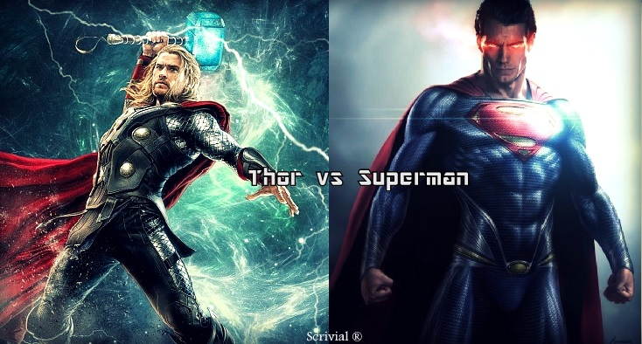
Thor = Superman ________________________________________________________
Thor = Superman ________________________________________________________
Thor +/- Superman ________________________________________________________
Superman +/- Thor ________________________________________________________
Superman > Thor ________________________________________________________
Thor > Superman ________________________________________________________
Superman > … ________________________________________________________
Thor > … ________________________________________________________
Superman < … ________________________________________________________
Thor < … ________________________________________________________

- Use o Comparativo de Superioridade.
- New York is (_____________________________) Lisbon. (big)
- Rolls Royce is (_____________________________) a Volkswagen. (expensive)
- English is (_____________________________) German. (easy)
- Peter is (_____________________________) John. (handsome)
- Coffee is (_____________________________) tea in Portugal. (popular)
- A motorbike is (_____________________________) a bike. (fast)
- Cities are (_____________________________) towns. (noisy)
- These Jeans are (_____________________________) the other ones. (good)
- A rainy day is (_____________________________) a windy day. (bad)
- Roses are (_____________________________) daisies. (bautiful)

- Use o Comparativo de Igualdade:
- The blue car is (_____________________________) the red car. (fast)
- Peter is (_____________________________) Fred. (not/tall)
- The violin is (_____________________________) the cello. (not/low)
- This copy is (_____________________________) the other one. (bad)
- Oliver is (_____________________________) Peter. (optimistic)
- Today it's (_____________________________) yesterday. (not/windy)
- The tomato soup was (_____________________________) the mushroom soup. (delicious)
- Grapefruit juice is (_____________________________) lemonade. (not/sweet)
- Nick is (_____________________________) Kevin. (brave)
- Silver is (_____________________________) good. (not/heavy)

- Preencha a tabela com o que falta
ADJETIVE | COMPARATIVO |  |  | SUPERLATIVO
 | IGUALDADE | SUPERIORIDADE | INFERIORIDADE | SUPERIORIDADE | INFERIORIDADE
CRAZY | as crazy as | crazier than | less crazy than | the craziest | the least crazy
INTERESTING | (-) not so interesting as
PEACEFUL
FULL | (-)
FRESH | (-)
HOPEFUL
ANGRY
NORTHERN | (-)
COMMON | (-)
HUNGRY
IMPORTANT

- Relacione a tabela com tipos de filmes e programas de Tv e sua definição:

- ROMCOM
- THRILLER
- SITCOM
- CARTOON
- WESTERN
- BIOPIC
- SCI-FI
- COOKERY
- MAKE OVER
- TALK SHOW
( ) Traditional romance blended with elements of comedy. Nearly always resolves with a happy ending.
( ) A film about the western United States in the 1800s, usually with cowboys.
( ) Stories whose central struggle pits an innocent hero against a lethal enemy who is out to kill him or her.
( ) A programme hosted by famous chefs, who teach people how to cook.
( ) A show that helps people change their image or lifestyle.
( ) A programme that features animated characters.
( ) Programmes hosted by a TV personality, (or host) featuring guests who talk about their lives.
( ) An amusing TV series about fictional characters. Also known as a situation comedy.
( ) A film based on the events of someone’s life
( ) Stories whose central struggle is generated from the technology and tools of a scientifically imaginable world.

RASCUNHO
_______________________________________________________________________________________
_______________________________________________________________________________________
_______________________________________________________________________________________
_______________________________________________________________________________________
_______________________________________________________________________________________
_______________________________________________________________________________________
_______________________________________________________________________________________
_______________________________________________________________________________________
_______________________________________________________________________________________
_______________________________________________________________________________________
_______________________________________________________________________________________
_______________________________________________________________________________________
_______________________________________________________________________________________
_______________________________________________________________________________________
_______________________________________________________________________________________
_______________________________________________________________________________________
_______________________________________________________________________________________
_______________________________________________________________________________________
_______________________________________________________________________________________
_______________________________________________________________________________________
_______________________________________________________________________________________
_______________________________________________________________________________________
_______________________________________________________________________________________
_______________________________________________________________________________________
_______________________________________________________________________________________
_______________________________________________________________________________________
_______________________________________________________________________________________
_______________________________________________________________________________________
_______________________________________________________________________________________
_______________________________________________________________________________________
_______________________________________________________________________________________
_______________________________________________________________________________________
_______________________________________________________________________________________
_______________________________________________________________________________________
_______________________________________________________________________________________
_______________________________________________________________________________________
_______________________________________________________________________________________
_______________________________________________________________________________________
_______________________________________________________________________________________
_______________________________________________________________________________________
_______________________________________________________________________________________
_______________________________________________________________________________________
_______________________________________________________________________________________

