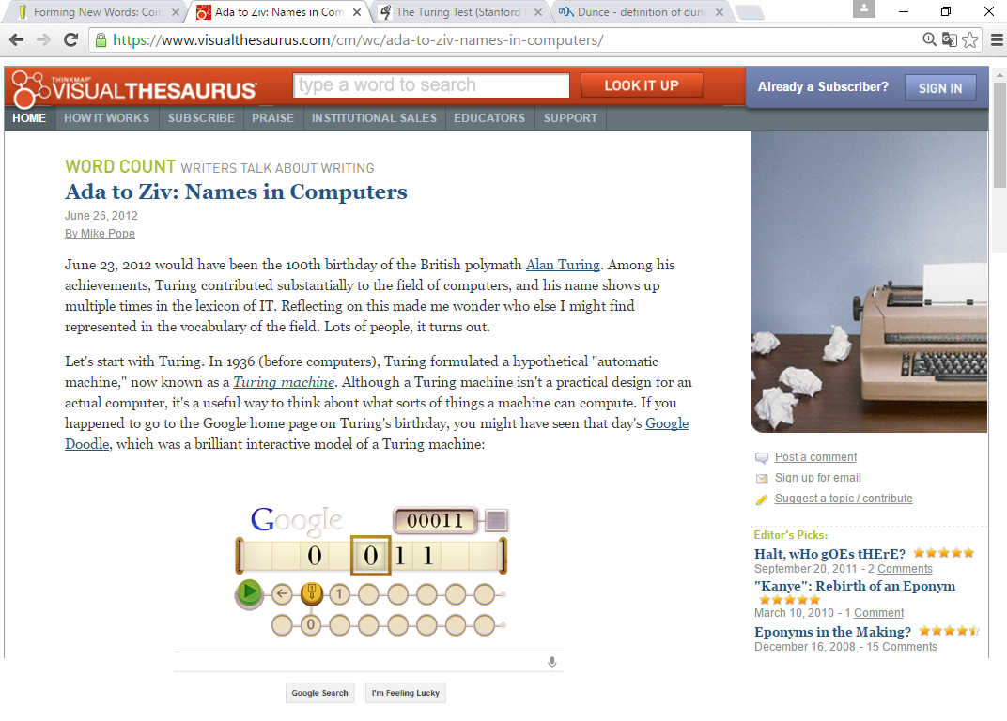

(Someone has also built a Turing machine out of LEGO.)
Along these lines, a computer or computer language is said to be Turing complete if it can theoretically compute any algorithm. These days, not only is your desktop computer Turing complete, but so is your phone. Turing also left us the Turing test, which tries to distinguish humans from computers, as I mentioned in the article about CAPTCHAs.
Many computer languages are named for people. The language Ada honors Ada Lovelace, a 19th-century mathematician (and the daughter of Lord Byron) who worked with Charles Babbage on an early mechanical computer. The computer scientist Niklaus Wirth created two languages named for people: Pascal for Blaise Pascal, and Euler for the mathematician Leonhard Euler. The language Haskell is named for the American mathematician Haskell Curry, Erlang is named for the Danish mathematician Agner Krarup Erlang, and Gödel is named for the logician Kurt Gödel. There's even a language named for the artist M. C. Escher. (If you're familiar with Escher's work, you might be able to imagine why it would inspire computer scientists.) In a less formal process, the name of the operating system Linux arose as a combination of the originator's first name (Linus Torvald) and Unix, which was the name of the system he was copying.
The computer industry is rich in "laws" and principles, some of which you might know, that are named after people. In 1965, Intel's Gordon Moore observed that the capacity of computer chips seemed to double every year. Moore's Law, as it was eventually called, was prescient: although he only looked forward to 1970, his law has described computer chip technology for nearly 50 years, which enabled the kind of miniaturization that lets you carry a computer (i.e., a smartphone) in your pocket.Many people have probably heard, and possibly suffered, some variation of Brooks's Law ("Adding manpower to a late software project makes it later"), which comes from Fred Brooks's legendary 1975 book The Mythical Man-Month. Linus's Law, named in honor of Linus Torvald, says that "given enough eyeballs, all bugs are shallow," which is a kind of programmer version of the proverb "many hands make work light." An important design principle in software is Postel's Prescription, named for Jon Postel, which states that designs should be "conservative in what they send, liberal in what they accept," a maxim that sounds nearly Biblical in its wisdom. This principle has been critical for the development of the Internet; it's what makes it practical for us to request a web page that might live on an entirely different computer halfway around the world.
Certain programming techniques have their words as well. George Boole was an English logician who invented Boolean algebra. The logic in digital computers ultimately just consists of head-spinningly complex chains of Boolean tests (on/off, true/false) and of Boolean operators (AND, OR, and NOT). A more obscure programming technique is currying, which I mention only because it's a second thing in computers, in addition to the programming language, that's named for Haskell Curry. There are names pretty well hidden in the LZ compression algorithm, named for Abraham Lemper and Jacob Ziv, which you and I take advantage of every time we use .GIF or .PNG files.
(…) Most of these name-related terms aren't used much in everyday English, of course, although several (Turing test, Moore's Law, Linux) appear often in general-interest articles or books about computers. But it's pleasing that the everyday life of programmers does remember people who have contributed so much to our understanding of the field.
https://www.visualthesaurus.com/cm/wc/ada-to-ziv-names-in-computers/
- A frase abaixo diz que:
Many computer languages are named for people. The language Ada honors Ada Lovelace, a 19th-century mathematician (and the daughter of Lord Byron) who worked with Charles Babbage on an early mechanical computer.
- A Sra Ada Loverlace foi a inventora do computador mecânico.
- A Sra Ada Loverlace era esposa de Lord Byron.
- A Sra Ada Loverlace inventou a linguagem Ada.
- A Sra Ada Loverlace estudava matemática com seu tio.

- A frase abaixo diz que:
The computer scientist Niklaus Wirth created two languages named for people: Pascal for Blaise Pascal, and Euler for the mathematician Leonhard Euler. The language Haskell is named for the American mathematician Haskell Curry, Erlang is named for the Danish mathematician Agner Krarup Erlang, and Gödel is named for the logician Kurt Gödel.
- Pascal e Euler criaram as linguagens de computador usadas até hoje.
- Niklaus Wirth era amigo de Blaise Pascal.
- Haskell Curry era americano e Agner Krarup Erlang era inglês.
- Gödel estudava lógica.

- O texto fala de palavras relacionadas a internet e computação que foram feitas através do processo que nomeamos:
- Coinage
- Backformation
- Eponym
- Conversion

- A palavra theoretically retirada do texto foi feita pelo processo de:
- Acronym
- Prefixation
- Compunding
- Sufixation

- A palavra mathematician retirada do texto foi feita pelo processo de:
- Acronym
- Prefixation
- Compunding
- Sufixation

- Se a partir da palavra miniaturization surgisse o verbo miniaturize teremos então um processo de formação de palavras chamado:
- Backformation
- Conversion
- Clipping
- Blending

- Observe o período abaixo e responda:
The computer industry is rich in "laws" and principles, some of which you might know, that are named after people. In 1965, Intel's Gordon Moore observed that the capacity of computer chips seemed to double every year. Moore's Law, as it was eventually called, was prescient: although he only looked forward to 1970, his Law has described computer chip technology for nearly 50 years, which enabled the kind of miniaturization that lets you carry a computer (i.e., a smartphone) in your pocket.

Escreva os referentes das palavras em destaque:
YOU (1ª LINHA) The reader (o leitor)
IT (2ª LINHA) Moore’s Law
HE e HIS (3ª LINHA) Moore
YOU e YOUR (4ª LINHA) The reader (o leitor)

- Observe o período abaixo:
An important design principle in software is Postel's Prescription, named for Jon Postel, which states that designs should be "conservative in what they send, liberal in what they accept," a maxim that sounds nearly Biblical in its wisdom. This principle has been critical for the development of the Internet; it's what makes it practical for us to request a web page that might live on an entirely different computer halfway around the world.

Escreva os referentes das palavras em destaque:
THEY (2ª LINHA) designs
ITS (2ª LINHA) maxim
THIS (2ª LINHA) principle
IT’S (3ª LINHA) principle
US (3ª LINHA) The readers (os leitores), Os usuários de computador

- Observe o trecho abaixo:
Certain programming techniques have their words as well. George Boole was an English logician who invented Boolean algebra. The logic in digital computers ultimately just consists of head-spinningly complex chains of Boolean tests (on/off, true/false) and of Boolean operators (AND, OR, and NOT).

De que fala este trecho?
Certas técnicas de programação têm suas palavras também. George Boole foi um lógico inglês que inventou a álgebra Boolean. A lógica nos computadores digitais basicamente consiste em um complexo sistema de correntes de cabeças girantes de testes Boolean (ligado/desligado, verdadeiro/falso) e dos operadores Boolean (E, OU, e NÃO).

- O trecho abaixo:
(…) Most of these name-related terms aren't used much in everyday English, of course, although several (Turing test, Moore's Law, Linux) appear often in general-interest articles or books about computers. But it's pleasing that the everyday life of programmers does remember people who have contributed so much to our understanding of the field.
- Fala da importância de se estudar computação nos dias atuais conhecendo estas nomenclaturas específicas.
- Fala que estes nomes que vieram de pessoas que são usados na informática são desnecessários hoje em dia.
- Comenta que no dia-dia estes nomes realmente são lembrados e contribuíram muito para o nosso entendimento na área.
- Diz que no dia-dia de pessoas comuns isso não é importante apesar desses personagens terem contribuído bastante no entendimento da área.
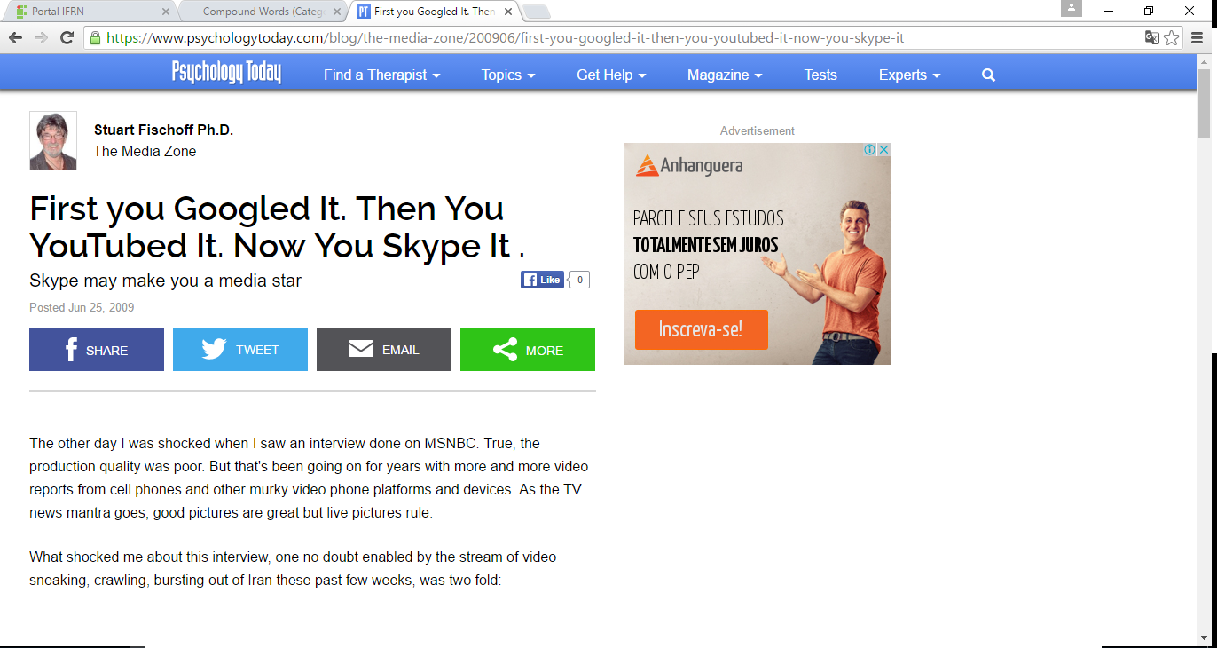

First, there was the setting of the interview. The woman interviewed was Iranian, an author and political commentator. I don't recall her name, but such women are in great demand nowadays, helping to "explain" Iran. She was not in Iran. She was talking from London. No big deal. Most Iranians criticizing the Iranian government on TV do it from a safe distance.
But here's the catch. The woman wasn't in a studio and she wasn't appearing via satellite uplink. She was Skyping the interview.
That's right! She was sitting in front of her monitor looking into her webcam, talking to the MSNBC desk jockey. She was giving her take on the uprising and where Iranian women fit in all this, especially in light of the on-camera murder of a 27 year old Iranian woman, Neda Agha Soltan, allegedly at the hands and rifles of paramilitaries working for the government.
(Neda has become both icon and symbol of the election protest and its violent suppression by the state. This cell phone video will now rival that of the brave young man who stood up to the tanks at Tiananmen Square in Beijing, in 1989. Symbols are valuable political and revolutionary tools and have incredible shelf life in a media conscious world.)
Second, it is the staggering implications of this Skype-conducted interview that commands immediate attention. Just the financial implications are stunning:
The additional operating cost to a news network to do a video interview via SKYPE is essentially zero. By comparison, and looking at the low end of the cost scale, the costs of doing a bare bones, traditional, remote, nonprime time 30-minute studio-based satellite interview starts at around $1,900 and goes up from there. If the interview requires location shooting with the attendant satellite uplink enabled trucks, personnel, etc., the dollar costs can rise into the multiple thousands.
Thousands vs. zero (or the cost of a webcam and mike). You can see where this is going, can't you? Pretty soon, everyone will be able to be interviewed by everyone else. The entire world becomes a green room and the population just waits for their own personal, "heeeere's Johnny" or Sally, Shoshona, Indira, or Qhang Chu before they slide into a desk chair, and smile as their home becomes their personal sound stage.
As viewers, we'll tolerate bad or no make-up, cheesy sets and lighting, fish-eye camera angles on faces and the halting quality of computer based telephony. Eventually it will get better, of course. Vanity demands it! Indeed, there are already video cameras which can electronically add suntans and, to an extent, erase blemishes, so we can all look telegenic, TV-presentable. HD will complicate matters but that obstacle will be crushed by need and creativity.
As I said, I was shocked by the interview; even stunned. But it didn't surprise me. Five years ago, when my wife and I were talking about moving away from L.A., I had one BIG reservation: How will I continue to do TV interviews if I leave this media capital of the world. For years, I would and could just roll out of bed and land at CNN, CBS or ABC or NBC, even PBS, do an interview, then roll back home again, all without raising a sweat.
Further, reporters had been to our house, many times, to do quick and dirty interviews. Same for reporters from Germany, England, Australia, Sweden, you name the country. To be a media psychologist in L.A., especially from the 70's through the 90's was to be at the center of the media universe.
And I adored that. I loved it. I can't help it. I can't be demure about it. Or modest. I did interviews. I did them often. I did them well. (…)
I liked the minor celebrity that it accorded me with my students, my colleagues, and the very occasional-man-on-the-street or the waiter-at-the-coffee-house-in-Silverlake. (…)
So the issue was this: If I leave L.A., my media interview career could be near-fatally damaged, the party over, the thrill gone. If I stay in L.A., that might happen anyway because in L.A. television, aging is a felony.
After leaving L.A. my wife, playing the prophet tried to reassure me that pretty soon being in L.A. wouldn't matter since people will be able to do TV interviews from their homes, probably via satellite uplinks.
I allowed myself to be reassured by her optimism but, deep, deep inside, I figured she was seeing rainbows where I saw bad moons rising.
(…) And then, along came Skype. My wife, it appears, was actually quite prescient. Therein lies the other shocking implication of the Skype interview on MSNBC: TV interviewing has been democratized.
With Skype and looser broadcast quality standards, I'm back in the interview game. Yes, probably a billion people are in the game as well. With Skype, now everyone effectively lives in L.A., even if their mailing address is in North Dakota, Trinidad or Kabul.
With Skype technology, the world of televised communications tilted just slightly on its axis.
So, Mr. DeMille, once again I'm, ready for my close-up...Are you?
Stuart Fischoff, Ph.D., was Senior Editor of the Journal of Media Psychology and Emeritus Professor of Media Psychology at Cal State, Los Angeles.
https://www.psychologytoday.com/blog/the-media-zone/200906/first-you-googled-it-then-you-youtubed-it-now-you-skype-it

- O texto fala sobre:
- A facilidade de hoje em dia das pessoas perderem tempo nas redes sociais.
- Da dificuldade das pessoas relacionar-se através da internet nos dias atuais.
- De como hoje em dia qualquer pessoa pode fazer uma entrevista ou reportagem através da internet e celulares.
- De como é difícil a educação dos filhos e o contato com a família após as redes sociais que tanto tomam o tempo de jovens e adultos.

- O autor do texto inicia:
- Dizendo que viu uma reportagem muito mal feita de uma mulher Iraniana.
- Criticando a forma como a entrevistadora iraniana estava vestida.
- Ironizando o uso extremo das redes sociais na mídia mundial.
- Satirizando o uso do Skype como plataforma para a imprensa.

- No trecho abaixo:
The additional operating cost to a news network to do a video interview via SKYPE is essentially zero. By comparison, and looking at the low end of the cost scale, the costs of doing a bare bones, traditional, remote, nonprime time 30-minute studio-based satellite interview starts at around $1,900 and goes up from there. If the interview requires location shooting with the attendant satellite uplink enabled trucks, personnel, etc., the dollar costs can rise into the multiple thousands.

O autor critica o uso da Skype por que:
- Custa muito pouco dinheiro para quem faz a entrevista.
- Tem curto zero e não tem o preparo adequado para que a entrevista fique de qualidade.
- Não é utilizada apenas por pessoas adultas e jornalistas graduados.
- Não paga impostos ao governo pelo uso da imagem das pessoas, o que é ilegal.

- No trecho abaixo:
Thousands vs. zero (or the cost of a webcam and mike). You can see where this is going, can't you? Pretty soon, everyone will be able to be interviewed by everyone else. The entire world becomes a green room and the population just waits for their own personal, "heeeere's Johnny" or Sally, Shoshona, Indira, or Qhang Chu before they slide into a desk chair, and smile as their home becomes their personal sound stage.

- You na primeira linha se refere ao leitor.
- Everyone se refere a população como um todo.
- They e their refere-se a population na linha 3.
- Todas as respostas acima estão corretas.

- Marque a letra cujas palavras são formadas apenas pelo processo de sufixação:
- Interviewed; commentator; Iranians; criticizing; conscious.
- Skyping; webcam; especially; paramilitaries; revolutionary.
- Comparison; traditional; L.A; reporters; occasional-man-on-the-street.
- waiter-at-the-coffee-house-in-Silverlake; television; televised; technology; slightly.

- O autor fala no trecho abaixo:
As viewers, we'll tolerate bad or no make-up, cheesy sets and lighting, fish-eye camera angles on faces and the halting quality of computer based telephony. Eventually it will get better, of course. Vanity demands it! Indeed, there are already video cameras which can electronically add suntans and, to an extent, erase blemishes, so we can all look telegenic, TV-presentable. HD will complicate matters but that obstacle will be crushed by need and creativity.
- Que estas entrevistas e reportagens através de pessoas comuns é ruim, pois não tem nenhuma técnica.
- Que as entrevistas nos celulares e câmeras portáteis tendem a melhorar por conta das tecnologias cada vez melhores dos equipamentos.
- Que nada supera a qualidade de um estúdio para fazer entrevistas e reportagens bem feitas e que a mídia jamais vai perder espaço.
- Que não importa o quanto possamos nos aborrecer ao sermos entrevistados por qualquer pessoa na rua elas vão continuar abordando a todos.

- Observe o trecho abaixo:
After leaving L.A. my wife, playing the prophet tried to reassure me that pretty soon being in L.A. wouldn't matter since people will be able to do TV interviews from their homes, probably via satellite uplinks.
I allowed myself to be reassured by her optimism but, deep, deep inside, I figured she was seeing rainbows where I saw bad moons rising.

Escolha a resposta que está INCORRETA:
- O referente dos pronomes I e ME é o autor do texto.
- O referente de THEIR é people.
- O referente de SHE e HER é a esposa do autor.
- No primeiro parágrafo THEIR não tem referente.

- No trecho:
But here's the catch. The woman wasn't in a studio and she wasn't appearing via satellite uplink. She was Skyping the interview.

- Temos uma palavra feita pelo processo de prefixation.
- Temos uma palavra feita pelo processo de borrowing.
- Temos uma palavra feita pelo processo de conversion.
- Temos uma palavra feita pelo processo de eponym.

- A palavra abaixo formada pelo processo de compounding está na letra:
- Government
- Skype-conducted
- Essentially
- Nonprime

- Relacione as colunas de acordo com cada processo de formação das palavras retiradas dos dois textos:

- Network ( h ) CLIPPING
- Traditional ( d ) ACRONYM
- Telegenic ( i ) EPONYM
- L.A ( j ) PREFIXATION
- Skype ( b ) SUFIXATION
- a billion ( a ) COMPOUNDING
- televise ( c ) BLENDING
- Techno ( e ) COINAGE
- Turing Machine ( f ) CONVERSION
- Disadvantage ( g ) BACKFORMATION

