
ALUNO(A):
TURMA: TSI
DATA: ___ / ___ / 2016
PROVA FINAL
PROFESSORA: CRISTIANE DE BRITO CRUZ

Valor 100
Nota

PROVA FINAL

INSTRUÇÕES:

- Escreva seu nome completo com letra legível. Seus dados de identificação são importantes;
- Somente será permitido o uso de caneta esferográfica azul ou preta;
- Em havendo sinal de cola a avaliação será atribuída nota 0,0 para os alunos envolvidos.
- Leia o texto uma vez e vá para as perguntas, não tente traduzir palavra por palavra – aplique as técnicas e passe a vista várias vezes tentando entender.
- Vá para as questões e volte ao texto quantas vezes achar necessário.
- Observe seu tempo. Não perca tempo demais no texto sem ir para as questões.

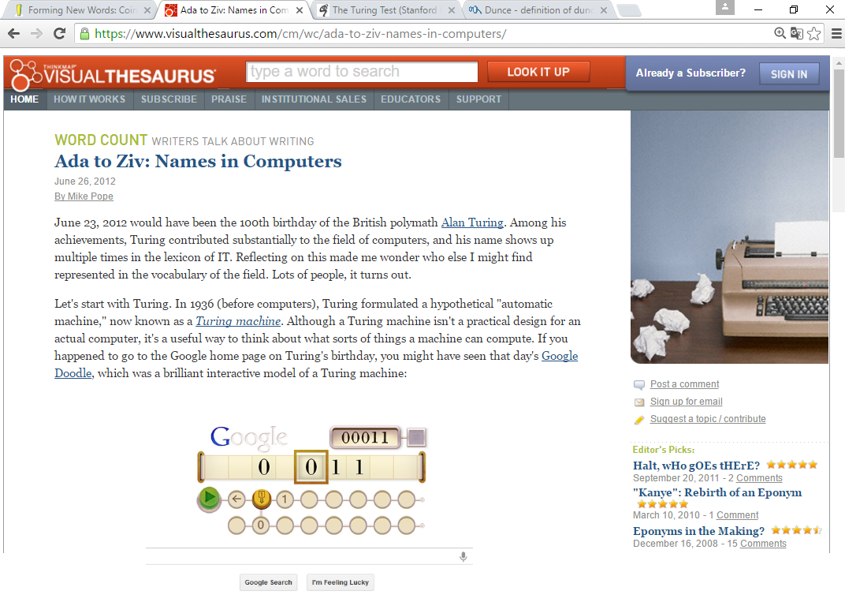

(Someone has also built a Turing machine out of LEGO.)
Along these lines, a computer or computer language is said to be Turing complete if it can theoretically compute any algorithm. These days, not only is your desktop computer Turing complete, but so is your phone. Turing also left us the Turing test, which tries to distinguish humans from computers, as I mentioned in the article about CAPTCHAs.
Many computer languages are named for people. The language Ada honors Ada Lovelace, a 19th-century mathematician (and the daughter of Lord Byron) who worked with Charles Babbage on an early mechanical computer. The computer scientist Niklaus Wirth created two languages named for people: Pascal for Blaise Pascal, and Euler for the mathematician Leonhard Euler. The language Haskell is named for the American mathematician Haskell Curry, Erlang is named for the Danish mathematician Agner Krarup Erlang, and Gödel is named for the logician Kurt Gödel. There's even a language named for the artist M. C. Escher. (If you're familiar with Escher's work, you might be able to imagine why it would inspire computer scientists.) In a less formal process, the name of the operating system Linux arose as a combination of the originator's first name (Linus Torvald) and Unix, which was the name of the system he was copying.
The computer industry is rich in "laws" and principles, some of which you might know, that are named after people. In 1965, Intel's Gordon Moore observed that the capacity of computer chips seemed to double every year. Moore's Law, as it was eventually called, was prescient: although he only looked forward to 1970, his law has described computer chip technology for nearly 50 years, which enabled the kind of miniaturization that lets you carry a computer (i.e., a smartphone) in your pocket.Many people have probably heard, and possibly suffered, some variation of Brooks's Law ("Adding manpower to a late software project makes it later"), which comes from Fred Brooks's legendary 1975 book The Mythical Man-Month. Linus's Law, named in honor of Linus Torvald, says that "given enough eyeballs, all bugs are shallow," which is a kind of programmer version of the proverb "many hands make work light." An important design principle in software is Postel's Prescription, named for Jon Postel, which states that designs should be "conservative in what they send, liberal in what they accept," a maxim that sounds nearly Biblical in its wisdom. This principle has been critical for the development of the Internet; it's what makes it practical for us to request a web page that might live on an entirely different computer halfway around the world.
Certain programming techniques have their words as well. George Boole was an English logician who invented Boolean algebra. The logic in digital computers ultimately just consists of head-spinningly complex chains of Boolean tests (on/off, true/false) and of Boolean operators (AND, OR, and NOT). A more obscure programming technique is currying, which I mention only because it's a second thing in computers, in addition to the programming language, that's named for Haskell Curry. There are names pretty well hidden in the LZ compression algorithm, named for Abraham Lemper and Jacob Ziv, which you and I take advantage of every time we use .GIF or .PNG files.
(…) Most of these name-related terms aren't used much in everyday English, of course, although several (Turing test, Moore's Law, Linux) appear often in general-interest articles or books about computers. But it's pleasing that the everyday life of programmers does remember people who have contributed so much to our understanding of the field.
https://www.visualthesaurus.com/cm/wc/ada-to-ziv-names-in-computers/

- O texto fala de palavras relacionadas a internet e computação que foram feitas através do processo que nomeamos:
- Coinage
- Backformation
- Eponym
- Conversion

- A palavra theoretically retirada do texto foi feita pelo processo de:
- Acronym
- Prefixation
- Compunding
- Sufixation

- A palavra mathematician retirada do texto foi feita pelo processo de:
- Acronym
- Prefixation
- Compunding
- Sufixation

- Se a partir da palavra miniaturization surgisse o verbo miniaturize teremos então um processo de formação de palavras chamado:
- Backformation
- Conversion
- Clipping
- Blendin

- Observe o período abaixo e responda:
The computer industry is rich in "laws" and principles, some of which you might know, that are named after people. In 1965, Intel's Gordon Moore observed that the capacity of computer chips seemed to double every year. Moore's Law, as it was eventually called, was prescient: although he only looked forward to 1970, his Law has described computer chip technology for nearly 50 years, which enabled the kind of miniaturization that lets you carry a computer (i.e., a smartphone) in your pocket.
Escreva os referentes das palavras em destaque:
YOU (1ª LINHA) _____________________________________________________________________
IT (2ª LINHA) _______________________________________________________________________
HE e HIS (3ª LINHA) __________________________________________________________________
YOU e YOUR (4ª LINHA) ______________________________________________________________

- Observe o período abaixo:
An important design principle in software is Postel's Prescription, named for Jon Postel, which states that designs should be "conservative in what they send, liberal in what they accept," a maxim that sounds nearly Biblical in its wisdom. This principle has been critical for the development of the Internet; it's what makes it practical for us to request a web page that might live on an entirely different computer halfway around the world.
Escreva os referentes das palavras em destaque:
THEY (2ª LINHA) ____________________________________________________________________
ITS (2ª LINHA) ______________________________________________________________________
THIS (2ª LINHA) _____________________________________________________________________
IT’S (3ª LINHA) ______________________________________________________________________
US (3ª LINHA) ______________________________________________________________________

- O trecho abaixo:
(…) Most of these name-related terms aren't used much in everyday English, of course, although several (Turing test, Moore's Law, Linux) appear often in general-interest articles or books about computers. But it's pleasing that the everyday life of programmers does remember people who have contributed so much to our understanding of the field.
- Fala da importância de se estudar computação nos dias atuais conhecendo estas nomenclaturas específicas.
- Fala que estes nomes que vieram de pessoas que são usados na informática são desnecessários hoje em dia.
- Comenta que no dia-dia estes nomes realmente são lembrados e contribuíram muito para o nosso entendimento na área.
- Diz que no dia-dia de pessoas comuns isso não é importante apesar desses personagens terem contribuído bastante no entendimento da área.

- Relacione as colunas de acordo com cada processo de formação das palavras retiradas dos dois textos:

- Network ( ) CLIPPING
- Traditional ( ) ACRONYM
- Telegenic ( ) EPONYM
- L.A ( ) PREFIXATION
- Skype ( ) SUFIXATION
- a billion ( ) COMPOUNDING
- televise ( ) BLENDING
- Techno ( ) COINAGE
- Turing Machine ( ) CONVERSION
- Disadvantage ( ) BACKFORMATION

- Utilize o modal adequado a frase e a figura:
 | She _______________ have English Test tomorrow. |  | He ________________ see a doctor.
 | It ________________ have occurred an accident. |  | They ________________ be girlfriends.
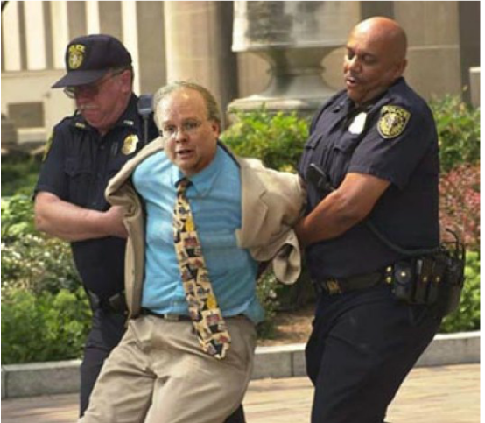 | He _______________ have robbed a bank. |  | They ________________ go to a job interview.
 | He ________________ be worried about English Test. |  | They ________________ be fighting.

- Utilize as linking words adequadas à frase (sem repetir).

despite | but | in contrast | furthermore | in spite of
on the contrary | although | nevertheless | while | not only that

- The team haven't been playing too well. ________________, they are expected to win this afternoon.
- ________________ in nearly every country in the world they drive on the right, in England they insist on driving on the left.
- ________________ to the north, which will remain warm and sunny, the south will become cloudy during the early morning.
- He couldn't get the machine to work ________________ following the instructions carefully.
- I'm not tired at all. ________________, I'm feeling full of energy.
- ________________ the computer had recently been repaired, it still kept crashing.
- I know we agreed to raise the issue at the next meeting ________________ we simply won't have the time to discuss it.
- The man was arrested ________________ claiming to have been nowhere near the scene of the crime.
- I overslept this morning. ________________, my car ran out of petrol on the way to work.
- The report is expected to be critical of the industry. ________________, it is likely to recommend extensive changes to production.

