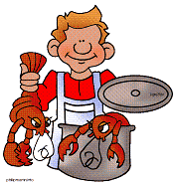
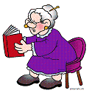
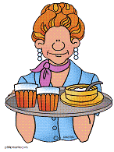
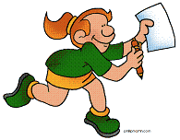
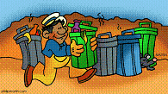



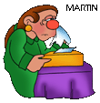
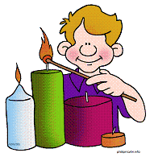
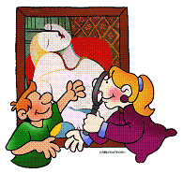
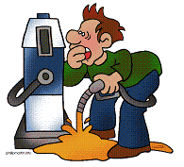
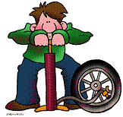

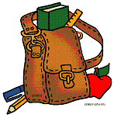

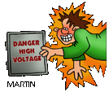
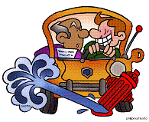
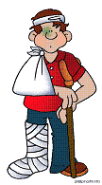
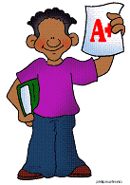
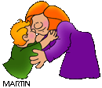
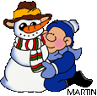
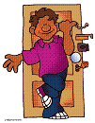
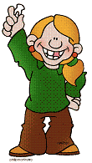
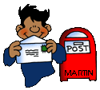
Past Perfect Tense
1) Fred was shocked after the prices had gone up.
2) _____ the kids _______________ the museum before they had lunch?
3) Robert ran out of money after he _____________________ that computer.
4) My son ________________________ the candles before it got dark.
5) Dan cooked the lobsters he ________________________ before.
6) _____ Granny _______________ a book before we arrived?
7) I couldn’t ride a bike because he ________________________ it.
8) Joan caught a cold after she ________________________ on warm clothes.
9) After we ________________________ the rubbish, it was taken to the garbage dump.
10) I ________________________ the school bag before my mum warned me.
11) _____ Gavin __________ the race before I got there?
12) After Helen ________________________ the meal, the waitress had served her.
13) After Emily ______________________ a report in the student newspaper, she went home.
14) _____ Bob ___________________ a beautiful picture before the sun set?
15) Nina ______________________ a bear before she went to the zoo in May.
1
A) buy
B) empty
C) fish
D) go
G) not pack
J) read
M) visit
E) not light
F) order
H) paint
I) not put
L) not see
K) not repair
N) win
O) write
© Susan V Toth
1) After Alex had sent a letter to his granny, he went to the playground.
2) Mr K wanted to sell the watches he ________________________ before.
3) After John ________________________ an A+ in English, his parents praised him.
4) Tom broke his leg after he ________________________ through a rock.
5) _____ Mum __________ little Ben before she had lunch?
6) After you _________________ an electric shock, you were taken to hospital.
7) Why _____ Jason __________ the front door before he went to bed?
8) Hank started dieting after he _____________________ too much apple pie.
9) Marty met his friends after he ________________________ his homework.
10) _____ the students ____________ bingo before they wrote a test?
11) _____ Jim _______________ the driving exam before he passed it at last?
12) After Mary ________________________ out the coupons from the newspaper, she did the shopping.
13) After Jillian ________________________ her tooth, she got something from the tooth fairy.
14) After Hugh _____________________ a snowman, he put a hat on its head.
15) Before Jack went to bed, he ________________________ his mum.
K) lock
A) build
H) get
J) kiss
N) send
L) lose
O) steal
E) fail
B) cut
D) eat
I) get
C) do
F) fall
G) feed
M) play

1
I - Fill in the sentences with the correct form (Past Perfect Tense) of the appropriate verb, and then match the sentences to the pictures.

II - Fill in the sentences with the correct form (Past Perfect Tense) of the appropriate verb, and then match the sentences to the pictures.

KEY
I  1) After Alex had sent a letter to his granny, he went to the playground. (N)  2) Mr K wanted to sell the watches he had stolen before. (O)  3) After John had got an A+ in English, his parents praised him. (H/I)  4) Tom broke his leg after he had fallen through a rock. (F)  5) Had Mum fed little Ben before she had lunch? (G)  6) After you had got an electric shock, you were taken to hospital. (H/I)  7) Why had Jason locked the front door before he went to bed? (K)  8) Hank started dieting after he had eaten too much apple pie. (D)  9) Marty met his friends after he had done his homework. (C)  10) Had the students played bingo before they wrote an English test? (M)  11) Had Jim failed the driving exam before he passed it at last? (E)  12) After Mary had cut out the coupons from the newspaper, she did the shopping. (B)  13) After Jillian had lost her tooth, she got something from the tooth fairy. (L)  14) After Hugh had built a snowman, he put a hat on its head. (A)  15) Before Jack went to bed, he had kissed his mum. (J) | 9 | 6 | 2
 | 5 | 8 | 11
 | 10 | 15 | 12
 | 4 | 14 | 7
 | 3 | 13 | 1
II  1) Fred was shocked after the prices had gone up. (D)  2) Had the kids visited the Picasso exhibition before they had lunch? (M)  3) Robert ran out of money after he had bought that computer. (A)  4) My son hadn’t lit the candles before it got dark. (E)  5) Dan cooked the lobsters he had fished before. (C)  6) Had Granny read a book before we arrived? (J)  7) I couldn’t ride a bike because he hadn’t repaired it. (K)  8) Joan caught a cold after she hadn’t put on warm clothes. (I)  9) After we had emptied the rubbish, it was taken to the garbage dump. (B)  10) I hadn’t packed the school bag before my mum warned me. (G)  11) Had Gavin won the race before I got there? (N)  12) After Helen had ordered the meal, the waitress had served her. (F)  13) After Emily had written a report in the student newspaper, she went home. (O)  14) Had Bob painted a beautiful picture before the sun set? (H)  15) Nina hadn’t seen a bear before she went to the zoo in May. (L) | 5 | 6 | 12
 | 13 | 9 | 11
 | 15 | 4 | 2
 | 14 | 1 | 7
 | 8 | 3 | 10

The pics are from: http://www.phillipmartin.info/clipart/homepage.htm

