
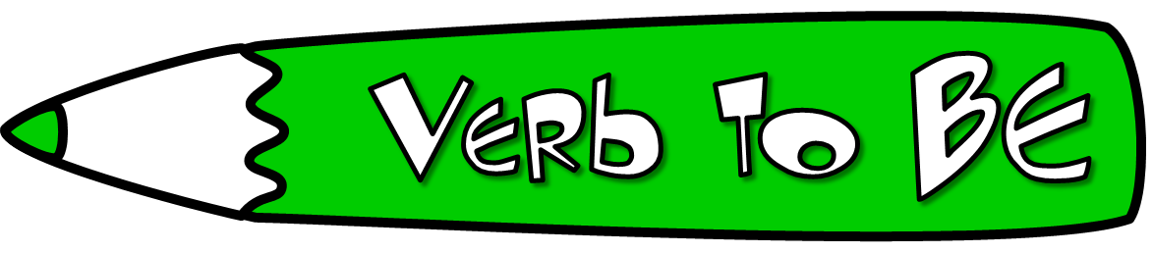
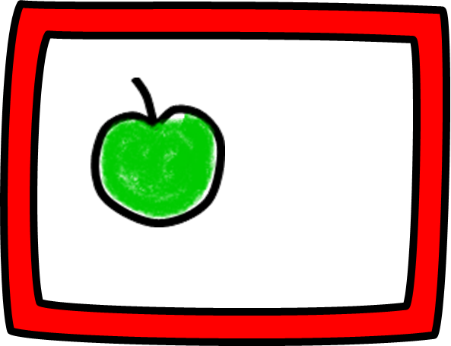
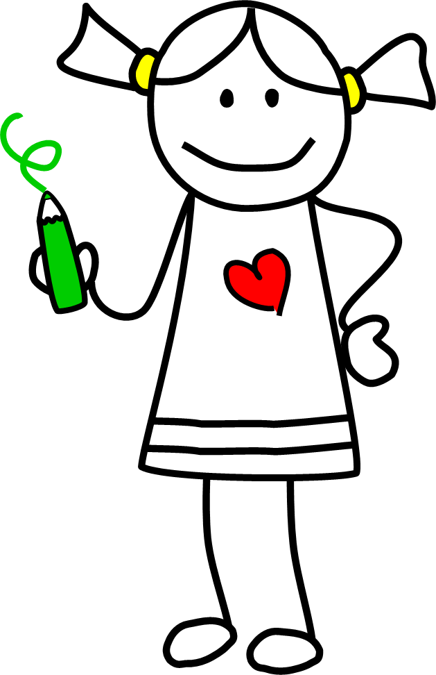



Complete the sentences with the
past form of the verb to be.
Mike ______ at the zoo last week.
Dad and I ______ in the garden
when it started raining.
Who ______ with you when I saw you in the street?
My dog ______ never bored.
We ______ at the circus last Friday, we are going this week.
Bill ______ very tired yesterday. He
went to bed early.
The shoes Emma was wearing ______ too small for her.
‘Why ______ Sue at the party?’
‘She had to study for her Maths exam.’
Where ______ you on holiday?
The French test ______ easy for me. I could answer all the questions.
Answer the questions.
Where was your mum yesterday at 7? _____________________________
How old was your dad when you were
born? ________________________
Was your grandma an only child? ______________________________
Were you at home last night? _____________________________
What was your favourite toy when you were three? ______________________
How many paintings were there in the museum?________________________


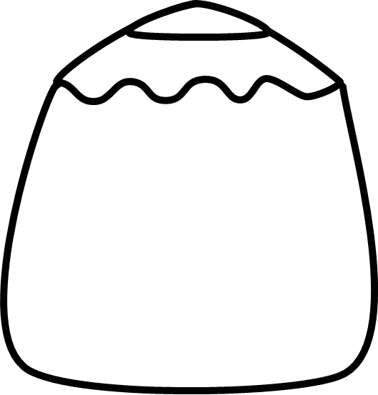

I was
You were
He
She was
It
We
You were
They




Rewrite using the short forms.
The kids were not sleepy.
______________________________
I was not at school yesterday.
______________________________
We were not at the supermarket.
______________________________
My granddad was not a pilot.
______________________________
You were not late for work.
______________________________


I was not
You were not
He
She was not
It
We
You were not
They
Correct mistakes.
There were some butter left. ______________________________
Susan and I was both bored.
______________________________
The letter were from my aunt.
______________________________
Where was your parents yesterday?
______________________________



Choose the correct answer.
Dennis ____ in the bedroom now, he _____ in
the dining room.
a) was/wasn’tb) wasn’t/wasc) wasn’t/were
Mr McDonald and Mrs Smith ____ neighbours.
a) wasn’t b) wasc) weren’t
Helen and I ____ best friends.
a) wereb) was notc) was
Pamela ____ Mr. Peterson’s granddaughter.
a) wasb) werec) weren’t
They ____ very friendly. Everybody liked them.
a) wasb) weren’tc) were

Was I ?
Were you ?
he ?
Was she ?
it ?
we ?
Were you ?
they ?



