1.3 A Description of Matter

LEARNING OBJECTIVE
- To classify matter.
Chemists study the structures, physical properties, and chemical properties of material substances. These consist of matter, which is anything that occupies space and has mass. Gold and iridium are matter, as are peanuts, people, and postage stamps. Smoke, smog, and laughing gas are matter. Energy, light, and sound, however, are not matter; ideas and emotions are also not matter.
The mass of an object is the quantity of matter it contains. Do not confuse an object’s mass with its weight, which is a force caused by the gravitational attraction that operates on the object. Mass is a fundamental property of an object that does not depend on its location.In physical terms, the mass of an object is directly proportional to the force required to change its speed or direction. A more detailed discussion of the differences between weight and mass and the units used to measure them is included in Essential Skills 1 (Section 1.9 "Essential Skills 1"). Weight, on the other hand, depends on the location of an object. An astronaut whose mass is 95 kg weighs about 210 lb on Earth but only about 35 lb on the moon because the gravitational force he or she experiences on the moon is approximately one-sixth the force experienced on Earth. For practical purposes, weight and mass are often used interchangeably in laboratories. Because the force of gravity is considered to be the same everywhere on Earth’s surface, 2.2 lb (a weight) equals 1.0 kg (a mass), regardless of the location of the laboratory on Earth.
Under normal conditions, there are three distinct states of matter: solids, liquids, and gases (Figure 1.6 "The Three States of Matter"). Solids are relatively rigid and have fixed shapes and volumes. A rock, for example, is a solid. In contrast, liquids have fixed volumes but flow to assume the shape of their containers, such as a beverage in a can. Gases, such as air in an automobile tire, have neither fixed shapes nor fixed volumes and expand to completely fill their containers. Whereas the volume of gases strongly depends on their temperature and pressure (the amount of force exerted on a given area), the volumes of liquids and solids are virtually independent of temperature and pressure. Matter can often change from one physical state to another in a process called a physical change. For example, liquid water can be heated to form a gas called steam, or steam can be cooled to form liquid water. However, such changes of state do not affect the chemical composition of the substance.
Solids have a defined shape and volume. Liquids have a fixed volume but flow to assume the shape of their containers. Gases completely fill their containers, regardless of volume.

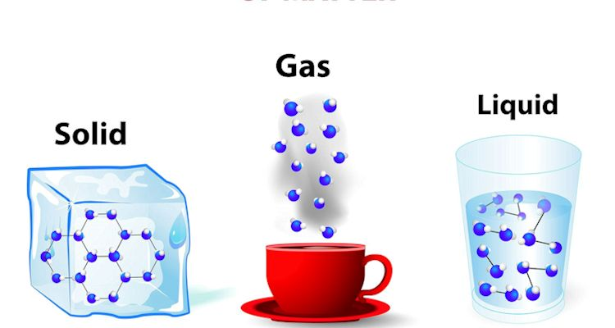
Pure Substances and Mixtures
A pure chemical substance is any matter that has a fixed chemical composition and characteristic properties. Oxygen, for example, is a pure chemical substance that is a colorless, odorless gas at 25°C. Very few samples of matter consist of pure substances; instead, most are mixtures, which are combinations of two or more pure substances in variable proportions in which the individual substances retain their identity. Air, tap water, milk, blue cheese, bread, and dirt are all mixtures. If all portions of a material are in the same state, have no visible boundaries, and are uniform throughout, then the material is homogeneous. Examples of homogeneous mixtures are the air we breathe and the tap water we drink. Homogeneous mixtures are also called solutions. Thus air is a solution of nitrogen, oxygen, water vapor, carbon dioxide, and several other gases; tap water is a solution of small amounts of several substances in water. The specific compositions of both of these solutions are not fixed, however, but depend on both source and location; for example, the composition of tap water in Boise, Idaho, is not the same as the composition of tap water in Buffalo, New York. Although most solutions we encounter are liquid, solutions can also be solid. The gray substance still used by some dentists to fill tooth cavities is a complex solid solution that contains 50% mercury and 50% of a powder that contains mostly silver, tin, and copper, with small amounts of zinc and mercury. Solid solutions of two or more metals are commonly called alloys.
Figure 1.6 The Three States of Matter
If the composition of a material is not completely uniform, then it is heterogeneous (e.g., chocolate chip cookie dough, blue cheese, and dirt). Mixtures that appear to be homogeneous are often found to be heterogeneous after microscopic examination. Milk, for example, appears to be homogeneous, but when examined under a microscope, it clearly consists of tiny globules of fat and protein dispersed in water (Figure 1.7 "A Heterogeneous Mixture"). The components of heterogeneous mixtures can usually be separated by simple means. Solid-liquid mixtures such as sand in water or tea leaves in tea are readily separated by filtration, which consists of passing the mixture through a barrier, such as a strainer, with holes or pores that are smaller than the solid particles. In principle, mixtures of two or more solids, such as sugar and salt, can be separated by microscopic inspection and sorting. More complex operations are usually necessary, though, such as when separating gold nuggets from river gravel by panning. First solid material is filtered from river water; then the solids are separated by inspection. If gold is embedded in rock, it may have to be isolated using chemical methods.
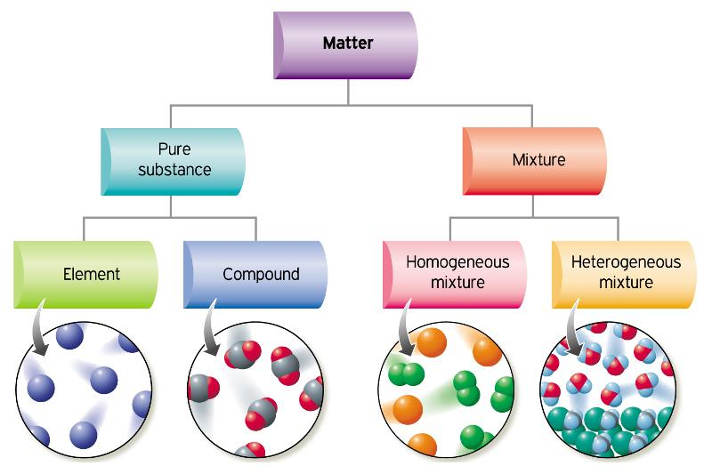
Under a microscope, whole milk is actually a heterogeneous mixture composed of globules of fat and protein dispersed in water.

Homogeneous mixtures (solutions) can be separated into their component substances by physical processes that rely on differences in some physical property, such as differences in their boiling points. Two of these separation methods are distillation and crystallization. Distillationmakes use of differences in volatility, a measure of how easily a substance is converted to a gas at a given temperature. Figure 1.8 "The Distillation of a Solution of Table Salt in Water" shows a simple distillation apparatus for separating a mixture of substances, at least one of which is a liquid. The most volatile component boils first and is condensed back to a liquid in the water-cooled condenser, from which it flows into the receiving flask. If a solution of salt and water is distilled, for example, the more volatile component, pure water, collects in the receiving flask, while the salt remains in the distillation flask.
Figure 1.7 A Heterogeneous Mixture
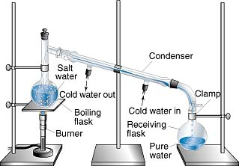
The solution of salt in water is heated in the distilling flask until it boils. The resulting vapor is enriched in the more volatile component (water), which condenses to a liquid in the cold condenser and is then collected in the receiving flask.

Mixtures of two or more liquids with different boiling points can be separated with a more complex distillation apparatus. One example is the refining of crude petroleum into a range of useful products: aviation fuel, gasoline, kerosene, diesel fuel, and lubricating oil (in the approximate order of decreasing volatility). Another example is the distillation of alcoholic spirits such as brandy or whiskey. This relatively simple procedure caused more than a few headaches for federal authorities in the 1920s during the era of Prohibition, when illegal stills proliferated in remote regions of the United States.
Figure 1.8 The Distillation of a Solution of Table Salt in Water
Crystallization separates mixtures based on differences in solubility, a measure of how much solid substance remains dissolved in a given amount of a specified liquid. Most substances are more soluble at higher temperatures, so a mixture of two or more substances can be dissolved at an elevated temperature and then allowed to cool slowly. Alternatively, the liquid, called the solvent, may be allowed to evaporate. In either case, the least soluble of the dissolved substances, the one that is least likely to remain in solution, usually forms crystals first, and these crystals can be removed from the remaining solution by filtration. Figure 1.9 "The Crystallization of Sodium Acetate from a Concentrated Solution of Sodium Acetate in Water" dramatically illustrates the process of crystallization.
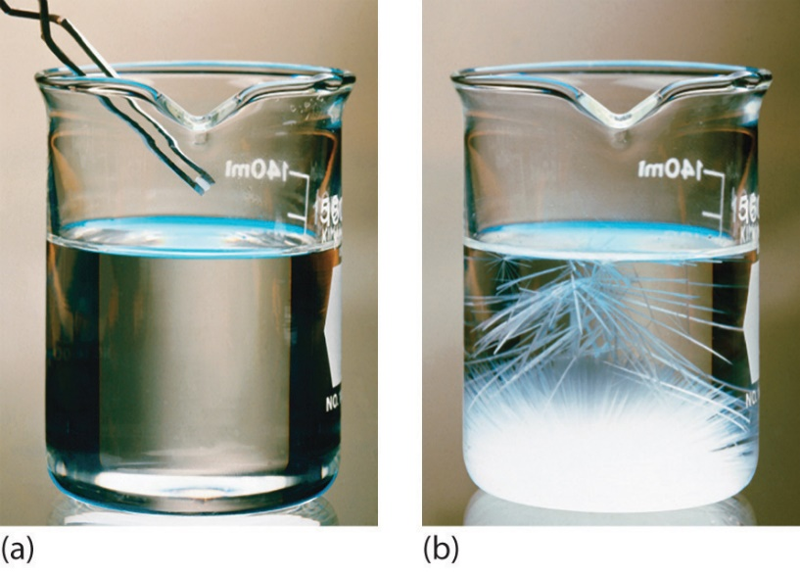
The addition of a small “seed” crystal (a) causes the compound to form white crystals, which grow and eventually occupy most of the flask (b).
Figure 1.9 The Crystallization of Sodium Acetate from a Concentrated Solution of Sodium Acetate in Water

Most mixtures can be separated into pure substances, which may be either elements or compounds. An element, such as gray, metallic sodium, is a substance that cannot be broken down into simpler ones by chemical changes; a compound, such as white, crystalline sodium chloride, contains two or more elements and has chemical and physical properties that are usually different from those of the elements of which it is composed. With only a few exceptions, a particular compound has the same elemental composition (the same elements in the same proportions) regardless of its source or history. The chemical composition of a substance is altered in a process called a chemical change. The conversion of two or more elements, such as sodium and chlorine, to a chemical compound, sodium chloride, is an example of a chemical change, often called a chemical reaction. Currently, about 115 elements are known, but millions of chemical compounds have been prepared from these 115 elements. The known elements are listed in the periodic table (see Chapter 32 "Appendix H: Periodic Table of Elements").
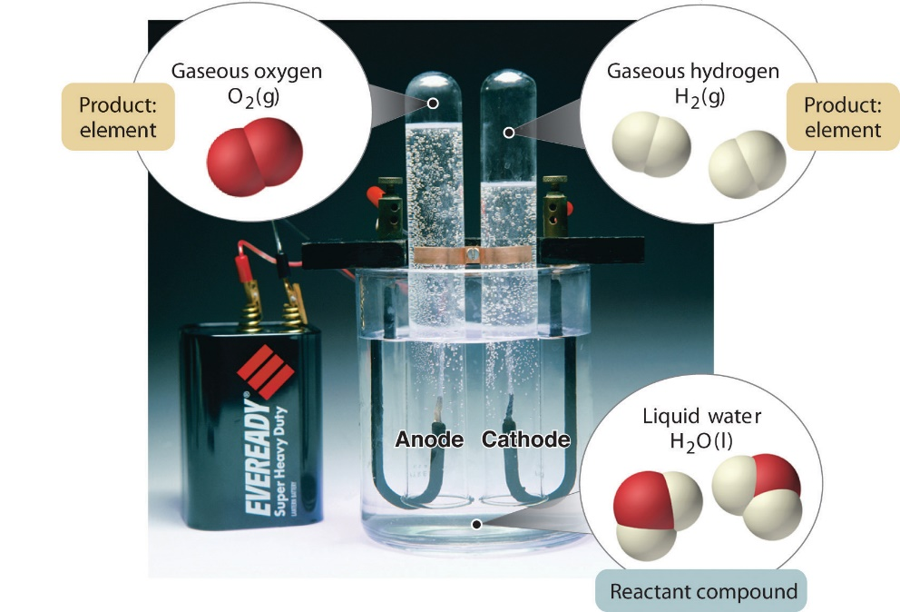
In general, a reverse chemical process breaks down compounds into their elements. For example, water (a compound) can be decomposed into hydrogen and oxygen (both elements) by a process called electrolysis. In electrolysis, electricity provides the energy needed to separate a compound into its constituent elements (Figure 1.10 "The Decomposition of Water to Hydrogen and Oxygen by Electrolysis"). A similar technique is used on a vast scale to obtain pure aluminum, an element, from its ores, which are mixtures of compounds. Because a great deal of energy is required for electrolysis, the cost of electricity is by far the greatest expense incurred in manufacturing pure aluminum. Thus recycling aluminum is both cost-effective and ecologically sound.
Figure 1.10 The Decomposition of Water to Hydrogen and Oxygen by Electrolysis

Water is a chemical compound; hydrogen and oxygen are elements.

The overall organization of matter and the methods used to separate mixtures are summarized in Figure 1.11 "Relationships between the Types of Matter and the Methods Used to Separate Mixtures".
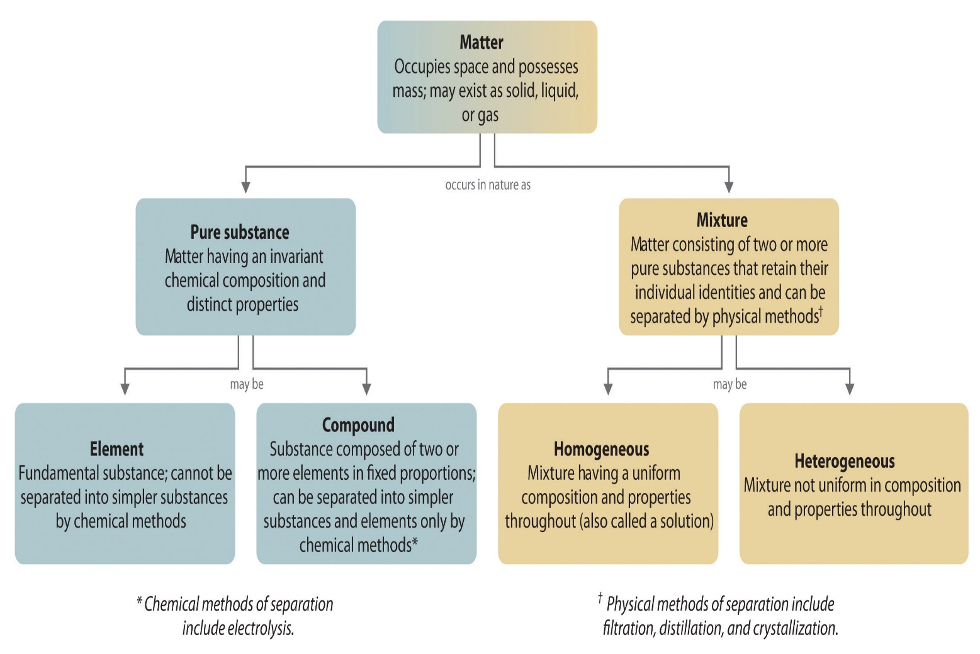
Figure 1.11 Relationships between the Types of Matter and the Methods Used to Separate Mixtures

Properties of Matter
All matter has physical and chemical properties. Physical properties are characteristics that scientists can measure without changing the composition of the sample under study, such as mass, color, and volume (the amount of space occupied by a sample). Chemical properties describe the characteristic ability of a substance to react to form new substances; they include its flammability and susceptibility to corrosion. All samples of a pure substance have the same chemical and physical properties. For example, pure copper is always a reddish-brown solid (a physical property) and always dissolves in dilute nitric acid to produce a blue solution and a brown gas (a chemical property).
Physical properties can be extensive or intensive. Extensive properties vary with the amount of the substance and include mass, weight, and volume. Intensive properties, in contrast, do not depend on the amount of the substance; they include color, melting point, boiling point, electrical conductivity, and physical state at a given temperature. For example, elemental sulfur is a yellow crystalline solid that does not conduct electricity and has a melting point of 115.2°C, no matter what amount is examined (Figure 1.12 "The Difference between Extensive and Intensive Properties of Matter"). Scientists commonly measure intensive properties to determine a substance’s identity, whereas extensive properties convey information about the amount of the substance in a sample.
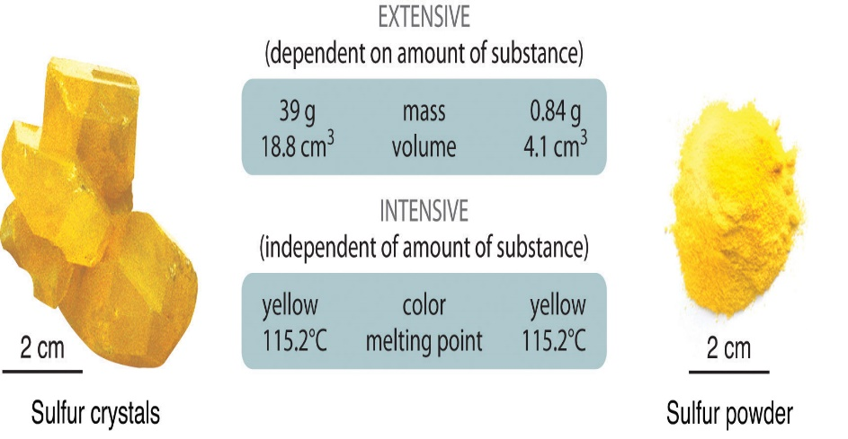
Because they differ in size, the two samples of sulfur have different extensive properties, such as mass and volume. In contrast, their intensive properties, including color, melting point, and electrical conductivity, are identical.

Although mass and volume are both extensive properties, their ratio is an important intensive property called density (d). Density is defined as mass per unit volume and is usually expressed in grams per cubic centimeter (g/cm³). As mass increases in a given volume, density also increases. For example, lead, with its greater mass, has a far greater density than the same volume of air, just as a brick has a greater density than the same volume of Styrofoam. At a given temperature and pressure, the density of a pure substance is a constant:
Figure 1.12 The Difference between Extensive and Intensive Properties of Matter
Equation 1.1
density =massvolume⇒d=mv
Pure water, for example, has a density of 0.998 g/cm³ at 25°C.
The average densities of some common substances are in Table 1.1 "Densities of Common Substances". Notice that corn oil has a lower mass to volume ratio than water. This means that when added to water, corn oil will “float.” Example 3 shows how density measurements can be used to identify pure substances.
Table 1.1 Densities of Common Substances
Substance | Density at 25°C (g/cm³) | Substance | Density at 25°C (g/cm³)
blood | 1.035 | corn oil | 0.922
body fat | 0.918 | mayonnaise | 0.910
whole milk | 1.030 | honey | 1.420

Summary
Matter is anything that occupies space and has mass. The three states of matter are solid, liquid, and gas. A physical change involves the conversion of a substance from one state of matter to another, without changing its chemical composition. Most matter consists of mixtures of pure substances, which can be homogeneous (uniform in composition) or heterogeneous (different regions possess different compositions and properties). Pure substances can be either chemical compounds or elements. Compounds can be broken down into elements by chemical reactions, but elements cannot be separated into simpler substances by chemical means. The properties of substances can be classified as either physical or chemical. Scientists can observe physical properties without changing the composition of the substance, whereas chemical properties describe the tendency of a substance to undergo chemical changes (chemical reactions) that change its chemical composition. Physical properties can be intensive or extensive. Intensive properties are the same for all samples; do not depend on sample size; and include, for example, color, physical state, and melting and boiling points. Extensive properties depend on the amount of material and include mass and volume. The ratio of two extensive properties, mass and volume, is an important intensive property called density.

KEY TAKEAWAY
- Matter can be classified according to physical and chemical properties.

