MINISTÉRIO DA EDUCAÇÃO
INSTITUTO FEDERAL DE EDUCAÇÃO, CIÊNCIA E TECNOLOGIA DO RIO GRANDE DO NORTE
Criado pela Lei 11.892, de 29.12.2008, em decorrência da transformação Institucional do Centro Federal de Educação Tecnológica do Rio Grande do Norte
DISCIPLINA: LÍNGUA INGLESA TURMA: TECNOLOGIA EM ALIMENTOS
ALUNO: ____________________________________________________
DATA: 03/08/2017
PROVA FINAL

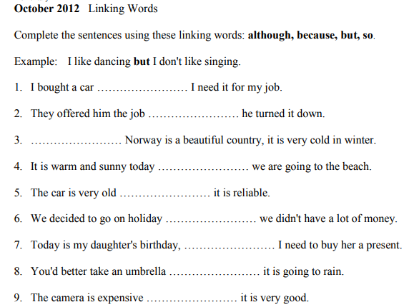
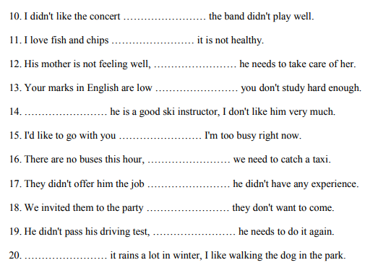
As frases abaixo precisam ser completadas com o tempo verbal adequado. Marque a opção que completa corretamente cada uma delas.

1. (rain) When I left the house this morning, it ________.
a) is raining
b) was raining
c) rains

2. (have) I didn’t take a vacation because I ________ any money.
a) didn’t have
b) have
c) will have

3. (win) Who ________ in the next election?
a) won
b) wins
c) will win

4. (rise) The sun ________ at 06:38 yesterday morning.
a) rose
b) is rising
c) will rise

5. (live) They ________ in an apartment temporarily because they can´t find an inexpensive house.
a) live
b) are living
c) will live

6. (eat) I ________ Italian food only once in a while.
a) ate
b) eat
c) will eat

7. (ring) The bell ________ and the class began.
a) rang
b) is ringing
c) rings

8. (blow) A hard wind ________ while we were climbing the mountain.
a) blows
b) will blow
c) blew

9. (understand) He ________ anything at the last meeting.
a) doesn’t understand
b) won’t understand
c) didn’t understand

10. (enter) Who ________ the university next September?
a) enters
b) entered
c) will enter

11. (talk) When I came into the room, everyone ________ about me.
a) talked
b) talks
c) is talking

12. (give) How often does your teacher ________ the class a quiz?
a) gave
b) give
c) is giving

13. (go) We ________ anywhere in particular next weekend.
a) won’t go
b) don’t go
c) didn’t go

14. (fight) We ________ our enemy until our last man falls.
a) fight
b) are fighting
c) will fight

15. (talk) My secretary ________ on the phone right now.
a) is talking
b) talks
c) will talk

16. (begin) The movie ________ soon.
a) begun
b) is beginning
c) will begin

17. (take) When he goes on a business trip, he usually ________ his wife.
a) is taking
b) took
c) takes

18. (set) The sun never ________ in the east.
a) is setting
b) sets
c) set

19. (set) The sun ________ at 05:48 tomorrow afternoon.
a) will set
b) is setting
c) sets

20. (enter) The patient ________ the operating room at this very moment.
a) enters
b) is entering
c) will enter

21. (fall) Our little girl ________ down and hurt herself seriously.
a) fell
b) is falling
c) falls

22. (take) Who ________ care of your children now?
a) is taking
b) takes
c) will take

23. (speak) I ________ to anyone on the phone last night.
a) won’t speak
b) don’t speak
c) didn’t speak

24. (make) I ________ a few mistakes on the last examination.
a) make
b) made
c) am making

25. (shine) When I get up tomorrow morning, the sun ________.
a) will shine
b) is shining
c) shone

26. (be) The assassination of President Kennedy ________ a shock to the world.
a) is
b) was
c) were

27. ( be) We ________ at the beginning of this book.
a) is
b) am
c) are

28. (live) Few people ________ in the Sahara Desert.
a) lives
b) live
c) lived

