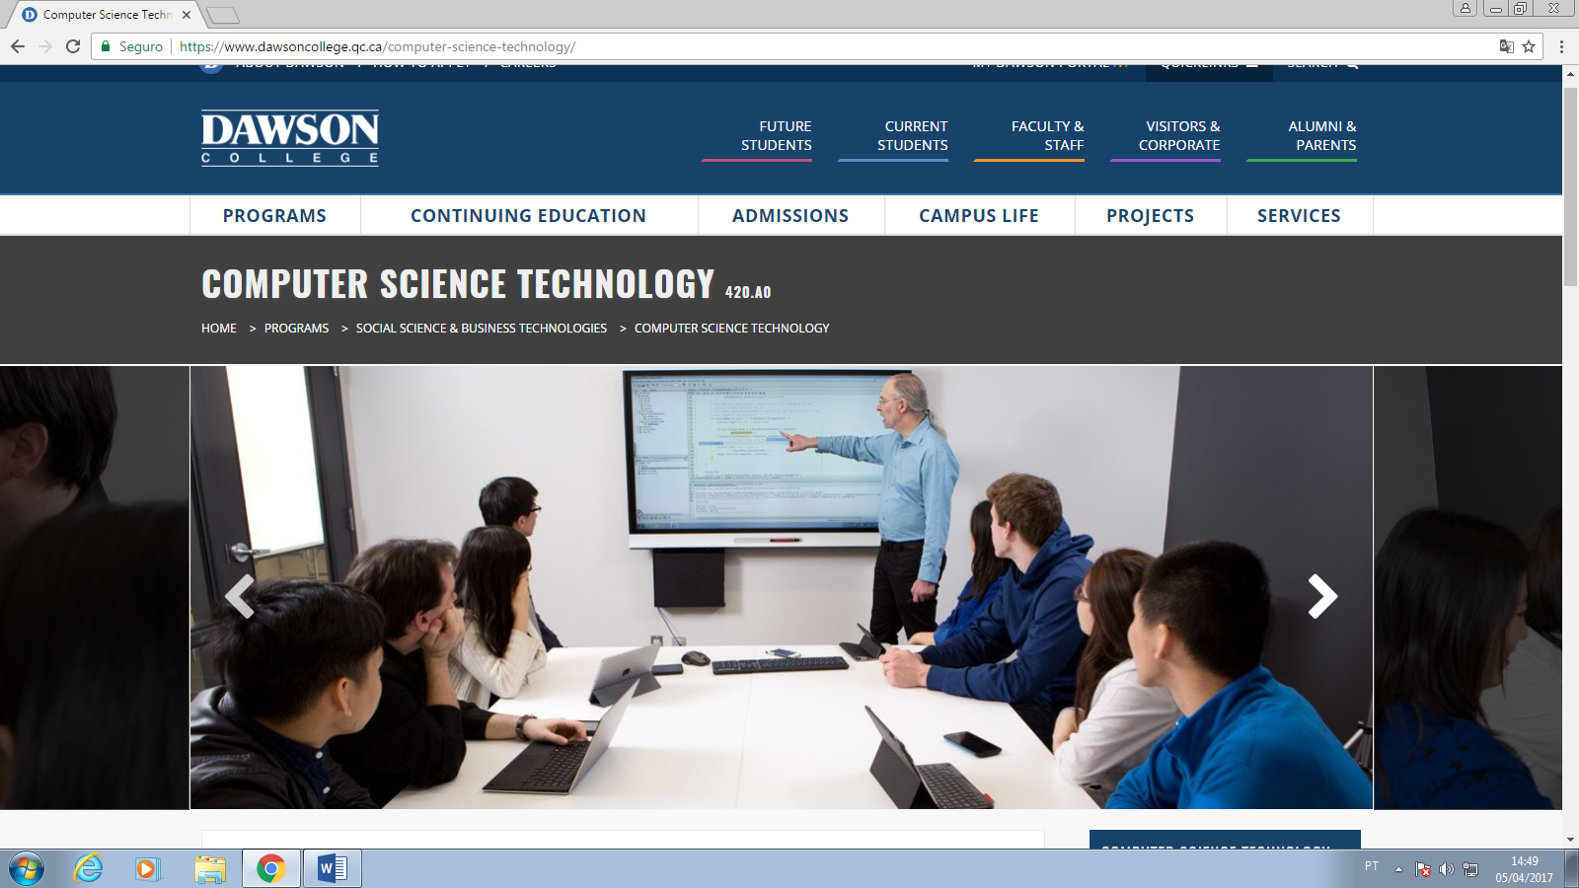

Program Information
Computer Science Technology is a three-year program that prepares a student to work as software developers in small, medium or large enterprises that use networks and the Internet to conduct their business.
Course content is constantly reviewed in consultation with the industry to ensure graduates are able to respond to changing market demands. The program encompasses two realms of programming: rapid application development (RAD) for desktop systems and web programming for dynamic e-commerce web sites and mobile device application development.
Through intensive theoretical and practical work in Computer Science subjects and by taking related courses in Business, Mathematics, and Psychology, the student will gain experience in creating state-of-the-art computer systems that support the needs and goals of modern businesses. Third-year students take part in an industrial internship where they gain valuable experience in the workplace. At various times during the program students are asked to prepare presentations enabling them to develop their communication and presentation skills.
The facilities for students in Computer Science at Dawson College are state-of-the-industry. From workstations to servers, all computers are networked and equipped with the software tools and components regularly found in the industry. Most of the software development tools used in the program, from compilers to operating systems, are also available to students for home use at no cost.
In the realm of RAD, the languages used are Java and C#. For web development, the languages are XHTML, Javascript, PHP, and Java. For mobile device development the language is Java. The database management systems (DBMS) Oracle and MySQL, commonly used in industry, are used to create client-server applications. To better understand the network/internet programming environments, topics such as data communications, operating systems (Windows, Windows Server, and Linux), and distributed systems (Internet/Intranet) are covered in depth.
To gain a better appreciation of the computer, there is a course in Computer Hardware and Software. Here our students will not only learn what a computer is made of but will also assemble a complete system from its parts and configure its software.
While the Computer Science Technology program prepares students to enter the work force immediately after graduation, many students pursue studies at university in various Computer Science degree programs, either full-time or part-time. Depending on the university, students may be granted credits towards their degree program (Dawson College and Concordia University have an agreement by which Computer Science Technology students may receive up to 13 credits in an undergraduate Computer Science program). You will be required to take some additional courses to enter university.

Career Opportunities
Some of the entry-level employment opportunities include application programmer, web designer and programmer and mobile programmer. Graduates are employed in financial, banking, transportation, manufacturing, insurance, health care, government, education and research environments. That is just about anywhere that a business develops computer software as part of their business model.

