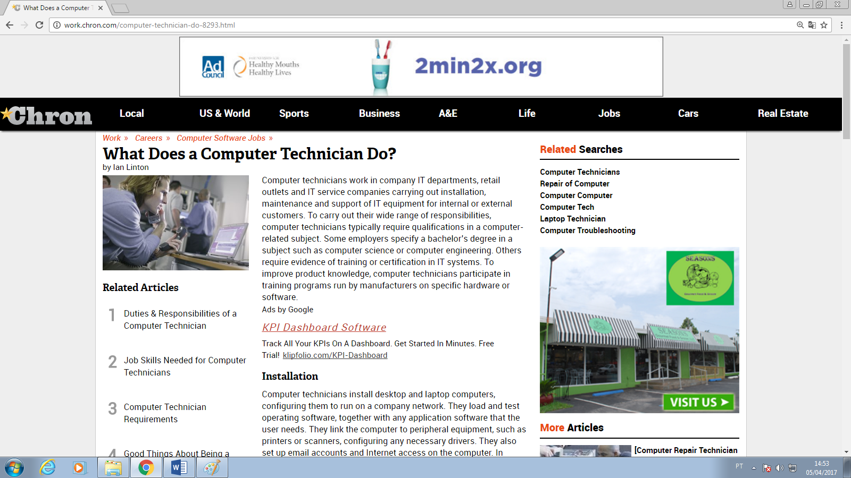

What Does a Computer Technician Do?
by Ian Linton

Related Articles

- 1Duties & Responsibilities of a Computer Technician
- 2Job Skills Needed for Computer Technicians
- 3Computer Technician Requirements
- 4Good Things About Being a Computer Technician

Computer technicians work in company IT departments, retail outlets and IT service companies carrying out installation, maintenance and support of IT equipment for internal or external customers. To carry out their wide range of responsibilities, computer technicians typically require qualifications in a computer-related subject. Some employers specify a bachelor’s degree in a subject such as computer science or computer engineering. Others require evidence of training or certification in IT systems. To improve product knowledge, computer technicians participate in training programs run by manufacturers on specific hardware or software.

Installation
Computer technicians install desktop and laptop computers, configuring them to run on a company network. They load and test operating software, together with any application software that the user needs. They link the computer to peripheral equipment, such as printers or scanners, configuring any necessary drivers. They also set up email accounts and Internet access on the computer. In addition to deploying user systems, computer technicians also may be responsible for installing servers and networking components.

Upgrades
When a company decides to upgrade its IT systems to take advantage of new operating system features or new versions of application software, computer technicians carry out upgrades to all computers. They must complete the upgrade within a short period of time to ensure that all computers are running compatible software. Computer technicians also upgrade individual computers, increasing memory, speed or hard drive capacity to suit users’ specific operating needs.

Troubleshooting
Computer technicians diagnose and resolve hardware problems. They use diagnostic tools to identify the cause of the problem and repair or replace any failed components. For serious problems where a user has lost data, the computer technician tries to recover and restore the data. Computer technicians also diagnose software issues, reinstalling programs if necessary. If a user experiences problems connecting to the Internet, technicians diagnose and re-establish connectivity, consulting network specialists if necessary.

Security
To strengthen IT security at the user level, computer technicians install and upgrade anti-virus software. They also diagnose and resolve any problems caused by computer viruses or malware. To reduce the risk of attack, they provide advice to users on security best practices and ensure that users are aware of company IT security policy.

Support
Computer technicians provide support and advice to computer users. Following a new installation or upgrade program, they explain and demonstrate new features to users and provide brief training to ensure a successful deployment. They also provide ongoing support when users report a problem. Computer technicians may provide support remotely by working on a help desk and resolving issues by telephone. They visit users to deal with problems that cannot be resolved by telephone.
Ads by Google

