MINISTÉRIO DA EDUCAÇÃO
INSTITUTO FEDERAL DE EDUCAÇÃO, CIÊNCIA E TECNOLOGIA DO RIO GRANDE DO NORTE
Criado pela Lei 11.892, de 29.12.2008, em decorrência da transformação Institucional do Centro Federal de Educação Tecnológica do Rio Grande do Norte
DISCIPLINA: LÍNGUA INGLESA TURMA: TECNOLOGIA EM SIST. INTENET
ALUNO: ____________________________________________________
DATA: 03/08/2017
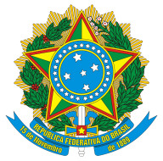
PROVA FINAL

Global cyberattack: What you need to know
By Selena Larson and Jethro Mullen @CNNMoney
June 28, 2017: 6:46 AM ET

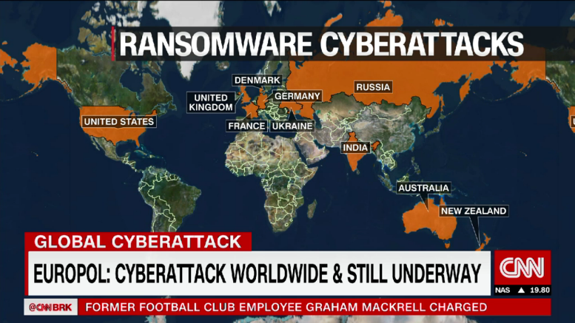
A massive ransomware attack has hit businesses around the world, causing major companies to shut down their computer systems.

Researchers are still investigating the software behind the attack, warning that it's more sophisticated than the WannaCry worm that struck hundreds of thousands of computers across the globe last month.
"WannaCry was a tremendous failure. It was a lot of noise, very little money, and everyone noticed it," said Craig Williams, an expert at cybersecurity firm Cisco Talos. "What we're seeing today is a much more intelligent worm."
Big global brands -- like Mondelez (MDLZ), the maker of Oreos, and British advertising giant WPP (WPPGF) -- say their IT systems are experiencing problems.
What does it do?
The ransomware infects computers and locks down their hard drives. It demands a $300 ransom in the anonymous digital currency Bitcoin.
The email account associated with the ransomware has been blocked, so even if victims pay, they won't get their files back.
Law enforcement and cybersecurity experts agree that victims should never pay ransoms for such attacks.

How does it spread?
Researchers say the ransomware virus is a worm that infects networks by moving from computer to computer.
It uses a hacking tool called EternalBlue, which takes advantage of a weakness in Microsoft Windows. Microsoft (MSFT, Tech30) released a patch for the flaw in March, but not all companies have used it.
EternalBlue was in a batch of hacking tools leaked earlier this year that are believed to have belonged to the U.S. National Security Agency.

Who's been hit?
Top international businesses headquartered in Europe and the U.S. have come under attack. They include Russian oil and gas giant Rosneft, Danish shipping firm Maersk, U.S.-based pharmaceutical company Merck and law firm DLA Piper. French retailer Auchan Group and the real estate division of BNP Paribas were also affected.
Ukrainian organizations took a particularly heavy blow. Banks, government offices, the postal service and Kiev's metro system were experiencing problems, officials said. The ransomware also caused problems with the monitoring system of the Chernobyl nuclear power plant.

It's not yet clear if companies in the Asia-Pacific region have been seriously affected.
Mondelez said its five manufacturing facilities in Australia and New Zealand had all been hit but some of them were still able to carry out limited production. And a Maersk facility for shipping containers in the Indian port city of Mumbai was shut down.
"There obviously are companies that will have been affected by this in Asia," said Michael Gazeley, managing director of Hong Kong-based cybersecurity provider Network Box. "But the success levels are lower, as they're attacking the same vulnerabilities as WannaCry."

Am I vulnerable?
Regular consumers who have up-to-date Windows computers are safe from this attack, experts say. However, if there's one out-of-date machine on a company's network, it could infect other connected computers.

Where did it start?
Researchers are still figuring out exactly what happened. But Cisco Talos says one way the ransomware got into computer systems was through software in Ukraine, a country that was hit especially hard by the attacks.
A Ukrainian company called MeDoc sent out a compromised update to its tax software that contained the malware, infecting computers that were running it, said Williams, the security expert at Cisco Talos.
Ukrainian officials confirmed a possible link to MeDoc. But the company denied its software spread the infection, saying in a Facebook post that the update was sent out last week and was free of viruses.

Who's behind it?
It's still too early to say who might be responsible for unleashing the virus.
Intelligence agencies and security researchers have linked last month's WannaCry attack to a group associated with North Korea. But it's unclear if the new ransomware worm is connected.

How is this different from WannaCry?
Like WannaCry, the new ransomware attack uses the EternalBlue tool to spread. But researchers say it also uses other parts of Windows to infect computers, including seizing user credentials.
Unlike WannaCry, it locks down a computer's entire hard drive instead of just the files. And it didn't shoot across the internet the way WannaCry did -- instead, it spreads inside company networks.
"It seems that the ones in charge of this campaign have learned quite a lot from the WannaCry campaign," said Itay Glick, the CEO of Israeli cybersecurity company Votiro.
-- Alec Macfarlane, Omar Khan, Anish Gawande, Victoria Butenko and Bex Wright contributed to this report.
CNNMoney (San Francisco) First published June 28, 2017: 2:00 AM ET

http://money.cnn.com/2017/06/28/technology/ransomware-attack-petya-what-you-need-to-know/index.html

Leia o texto e responda:
- Sobre o que fala?
- Quem é o principal suspeito?
- Onde ocorreram estes “ataques”?
- Como se chama este “worm”?
- Como se espalha?
- Quem está vulnerável?

Retire do texto
- 20 palavras cognatas.
- 5 Falsos cognatos.
- Uma atividade rotineira ou uma verdade geral.
- Um fato que aconteceu num dado momento no passado.
- Uma previsão futura.
- Uma ação no passado que não se sabe precisamente quando ocorreu.
- Uma ação no passado que está incompleta ou foi interrompida.
- Um fato no passado que ocorreu antes do outro fato (também no passado).
- 2 verbos modais.
- Uma informação de dados (nomes, valores, etc).

As frases abaixo precisam ser completadas com o tempo verbal adequado. Marque a opção que completa corretamente cada uma delas.

1. (rain) When I left the house this morning, it ________.
a) is raining
b) was raining
c) rains

2. (have) I didn’t take a vacation because I ________ any money.
a) didn’t have
b) have
c) will have

3. (win) Who ________ in the next election?
a) won
b) wins
c) will win

4. (rise) The sun ________ at 06:38 yesterday morning.
a) rose
b) is rising
c) will rise

5. (live) They ________ in an apartment temporarily because they can´t find an inexpensive house.
a) live
b) are living
c) will live

6. (eat) I ________ Italian food only once in a while.
a) ate
b) eat
c) will eat

7. (ring) The bell ________ and the class began.
a) rang
b) is ringing
c) rings

8. (blow) A hard wind ________ while we were climbing the mountain.
a) blows
b) will blow
c) blew

9. (understand) He ________ anything at the last meeting.
a) doesn’t understand
b) won’t understand
c) didn’t understand

10. (enter) Who ________ the university next September?
a) enters
b) entered
c) will enter

11. (talk) When I came into the room, everyone ________ about me.
a) talked
b) talks
c) is talking

12. (give) How often does your teacher ________ the class a quiz?
a) gave
b) give
c) is giving

13. (go) We ________ anywhere in particular next weekend.
a) won’t go
b) don’t go
c) didn’t go

14. (fight) We ________ our enemy until our last man falls.
a) fight
b) are fighting
c) will fight

15. (talk) My secretary ________ on the phone right now.
a) is talking
b) talks
c) will talk

16. (begin) The movie ________ soon.
a) begun
b) is beginning
c) will begin

17. (take) When he goes on a business trip, he usually ________ his wife.
a) is taking
b) took
c) takes

18. (set) The sun never ________ in the east.
a) is setting
b) sets
c) set

19. (set) The sun ________ at 05:48 tomorrow afternoon.
a) will set
b) is setting
c) sets

20. (enter) The patient ________ the operating room at this very moment.
a) enters
b) is entering
c) will enter

21. (fall) Our little girl ________ down and hurt herself seriously.
a) fell
b) is falling
c) falls

22. (take) Who ________ care of your children now?
a) is taking
b) takes
c) will take

23. (speak) I ________ to anyone on the phone last night.
a) won’t speak
b) don’t speak
c) didn’t speak

24. (make) I ________ a few mistakes on the last examination.
a) make
b) made
c) am making

25. (shine) When I get up tomorrow morning, the sun ________.
a) will shine
b) is shining
c) shone

26. (be) The assassination of President Kennedy ________ a shock to the world.
a) is
b) was
c) were

27. ( be) We ________ at the beginning of this book.
a) is
b) am
c) are

28. (live) Few people ________ in the Sahara Desert.
a) lives
b) live
c) lived

