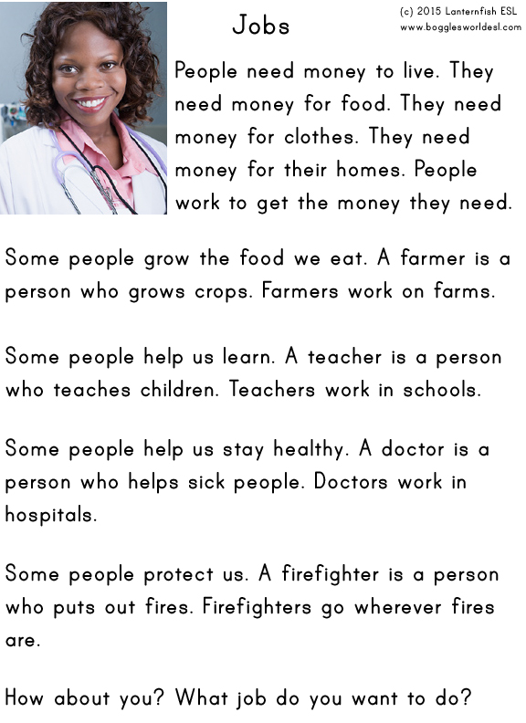
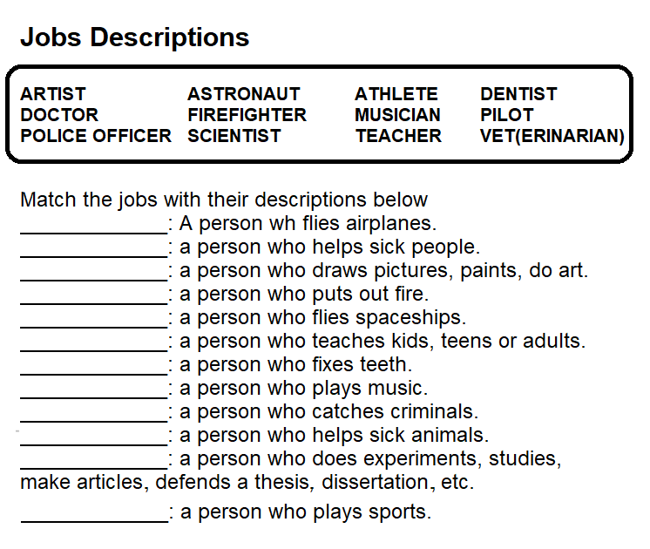

- Write the definitions of the jobs below
Architect
Cashier
Construction worker
Flight attendant
Truck driver
Professor
Farmer
Surgeon

- Write the professions related to the definitions.
- A person who helps a doctor. __________________________
- Someone who grows crops. _____________________
- Someone who delivers mail. __________________________
- A person who serves food. __________________________
- Someone who fixes cars. __________________________
- Someone who digs for metal ore in the ground. __________________________
- Someone who stars in a movie. __________________________
- A person who sings songs. __________________________
- Someone who cooks food. __________________________
- A person who paints pictures. __________________________
- A person who protects a country. __________________________
- Someone who cleans buildings. __________________________
- A person who makes computer games. __________________________
- A person who tells us the news. __________________________

