



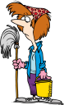





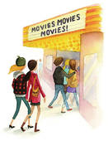

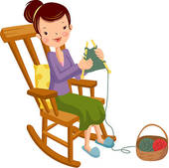







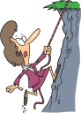


PAST CONTINUOUS TENSE
Yesterday was Sunday and everybody was doing something. Fill in the blanks with Past Continuous Tense. Then, match the sentences with the pictures.

- Mrs. White ------------------ ( do ) shopping.
- My mother ----------------- ( cook ).
- Selim and Selen ---------------- ( do ) shopping.
- Nesrin ------------------ ( clean ) the house.
- Ayşegül ------------------ ( climb ) the mountain.
- Tahsin ------------------ ( play ) computer games.
- Gülnihal ------------------ ( knit ) a scarf for her mother.
- Muhammet ------------- ( ride ) a horse.
- We ------------------ ( go ) to the cinema.
- Esra ------------------ ( organize ) a birthday party.
- Kaan ------------------ ( go ) fishing with his friends.
- Abdullah ------------------ (run ).
- Şafak ------------------ ( play ) football.
- Yaren ------------------ ( stay ) in bed as she was ill.
- Emine ------------------ ( water ) the flowers.
- Emre ------------------ ( watch ) TV.
- My father and his friends ------------------------ ( play ) the guitar.
- We ------------------- ( have ) picnic.
- Deniz ------------------- ( dance ).
- Ilkim ----------------- ( read ) a book.
- Özcan -------------- ( do ) his homework.
- Ethem -------------- ( feed ) the baby.
- Saime -------------- ( listen ) to music.

