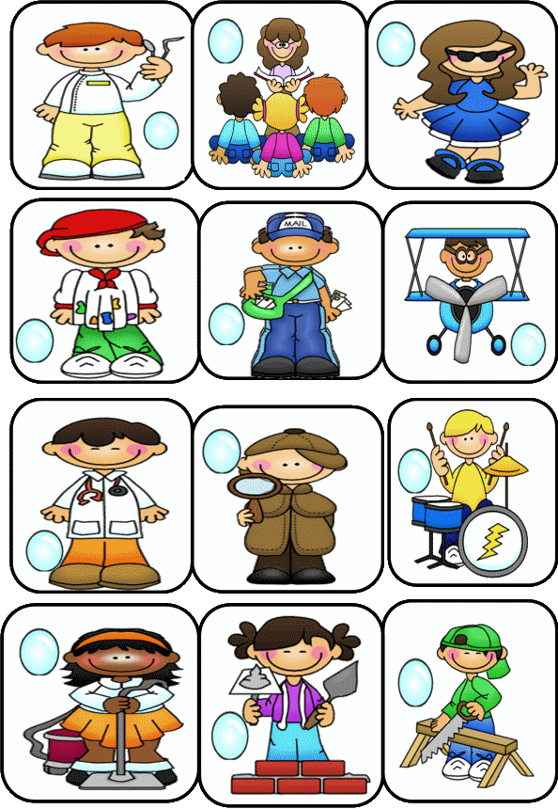



Write the past tense of the underlined verb in the space provided, as shown in the example. Then match each picture with the correct sentence.

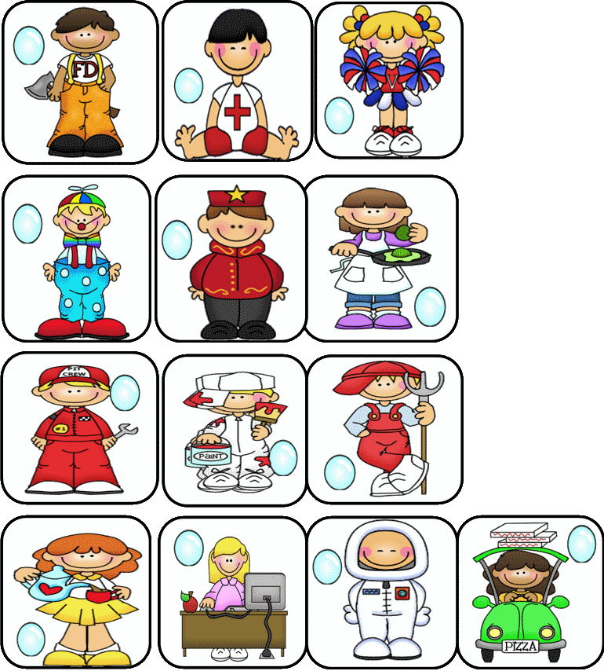
9. Mike saws wood for a fireplace.
4. Sherlock Holmes investigates the crime.
6. The usher seats guests at the theatre.
8. The students listen quietly to the story.
22. In spring the farmer plants corn.
7. We construct a new wall around the garden.
2. The pilot often travels to Miami Florida.
3. The lifeguard rescues drowning people.
5. Mark delivers the package to my front door.
15. Clowns attend many birthday parties.
10. Dr. Charles practices dentistry in the USA.
14. Fran stars in a popular television show.
11. Maggie surfs the internet while at work.
12. Tom pounds loudly on his new drum set.
13. Marco’s pizza taste delicious!
21. The cleaner vacuums on Wednesdays.
16. Mr. James paints his house red and white.
20. Mom cooks eggs and waffles for breakfast.
17. ‘Go Team’, shouts the cheerleaders.
18. Jan pours herbal tea into the fine china.
19. Neil Armstrong explores outer space.
23. The artist’s work shows his creativity.
24. Mike repairs cars for a living.
1. The doctor examines his patients.

examined
1

