Future (WALL-E)
A. ANTES DE VER A CENA DO FILME ESCREVA PARA CADA QUESTÃO ABAIXO UMA RESPOSTA:
1) What's your opinion about living in a time in which all your activities were performed by robots and machines?
2) Would you like to have machines do all of your physical activities for you?
3) What would the consequences be if people didn't have to exercise at all during the whole day?
4) Would life be better or worse if you had robots to do everything for you? Explain it.
5) Do you think life in 2642 will be better or worse? Justify your answer.
B. AGORA ASSISTA A CENA DO FILME E ESCREVA ABAIXO COMO A VIDA SERÁ DIFERENTE NO FUTURO DE ACORDO COM O FILME WALL-E.
Escreva pelo menos 10 frases descrevendo o que as pessoas irão fazer no futuro e como será a vida delas de acordo com o filme. Observe as palavras abaixo e as utilize nas suas frases.
FLOATING ARMCHAIRS | COMMUNICATION | ROBOTS
MEANS OF TRANSPORTATION | SCHOOL | LUNCH TIME
BEAUTY PARLORS | CLOTHES | LEISURE TIME

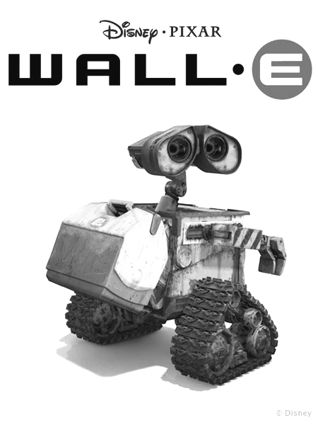
Ex: People will move around in floating armchairs.

