ENVIRONMENT

Ikea's "fast food of the future" includes worm balls, bug burgers and algae hot dogs
Rich Haridy
March 14th, 2018

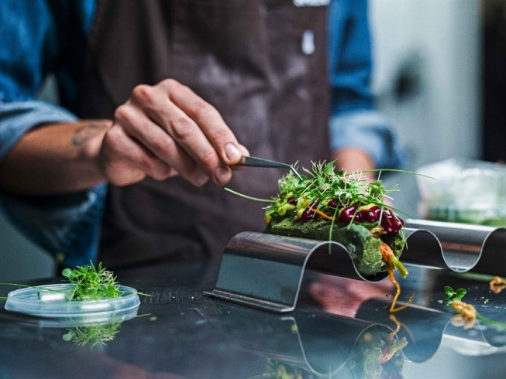
Space10 is Ikea's research hub and innovation lab, devoted to developing bold and sustainable new business models. The latest project to come out of the lab is a selection of five iconic fast food dishes, reinterpreted with unconventional, yet healthy and sustainable, ingredients.

The Space10 experiments incorporate modern unconventional ingredients such as spirulina or mealworms into classic dishes like hot dogs and burgers. The idea is to transform people's attitudes surrounding confronting ingredients that can be potentially healthier and more sustainable than what we currently eat.

Front and center, the star of the show is the Dogless Hotdog, a vegetarian twist on the American classic filled with herbs, onions, baby carrots, cucumber salad and a beet & berry ketchup. The starkly green bun is what truly takes this odd creation to a new level. It's made with a micro-algae called spirulina, which contains 50 times more iron than spinach as well as extraordinarily high levels of beta-carotene.

"Spirulina is astonishing to bake with," explains Simon Perez, the chef in residence at Space10. "It makes the dough look incredible, and you end up with a hotdog that contains zero meat but is packed with more protein than a regular 'dog'. It's fun, thought-provoking and better for people and the planet."

The Bug Burger is the team's spin on a classic hamburger with a patty made out of beetroot, parsnip, potato and mealworm. That last ingredient, the larval form of a darkling beetle, comprises about 20 percent of the total patty.

The Neatball takes the same elements used in the burger patties, with one version composed of a variety of root vegetables while another variation is made entirely with mealworms. Other experimental dishes from the group include a series of salads created with hydroponically grown greens and four different herb based ice creams, made with notably low levels of sugar.

There is no indication that these extraordinary recipes will actually move out of the lab and into an Ikea cafe. The whole enterprise seems valiantly conceptual at this stage, but Göran Nilsson, IKEA's Concept Innovation Manager does insist the whole point of Space10 is, "about exploring new ways to enable a better and more sustainable life for many people."

Source: Medium - Space10 Link: https://newatlas.com/ikea-future-fast-food-spirulina-insects/53796/

Rich is based in Melbourne, Australia and has strong interests in film, new media, and the new wave of psychedelic science. He has written for a number of online and print publications over the last decade while also acting as film critic for several radio broadcasters and podcasts. Rich was Chair of the Australian Film Critics Association for two years (2013-2015) and completed a Masters degree at the University of Melbourne. Since joining the New Atlas team three years ago Rich’s interests have considerably broadened to examine the era-defining effects of new technology on culture and life in the 21st century. https://newatlas.com/author/rich-haridy/
BIOLOGY
Creating a broccoli for all seasons to hedge against climate change
Lisa-Ann Lee
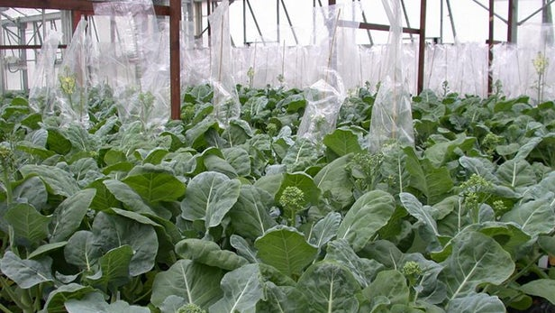
February 22nd, 2017
The last time food was rationed in England, Winston Churchill was still prime minister of the country. Earlier this month, however, Britons experienced a blast from the past as bad weather in Spain caused a severe vegetable shortage in the UK, leading some supermarkets to ration the number of greens that customers could buy. But could creating a new line of broccoli for all seasons help avert another veggie crisis, the next time the rain in Spain becomes a pain?
Scientists at UK's John Innes Center are growing broccoli that doesn't require a period of cold weather to produce flowers(Credit: Judith Irwin, Andrew Davis / JIC)

Though it might not look like it, the part of the broccoli plant we eat is actually a flower structure. In order for the plant to reach this flowering stage, the temperature has to be just right, and key to this part of its growth cycle is a process known as vernalization. Put simply, some plants need to undergo a period of cold weather before they can flower, and broccoli is one of them. If it doesn't get cold enough, it flowers late, or worse, not at all, making it a high-risk crop for farmers.

It therefore goes without saying that erratic weather patterns are bad news for broccoli growers who can't predict how much cold weather they are going to get each year. And because farmers have no idea when the plants will flower, this in turn creates a problem for crop scheduling.

To address this problem, crop geneticist and lead researcher Judith Irwin developed a new line of broccoli that is not only fast-growing – it goes from seed to harvest in just around two months – but is also resistant to the climatic whims of the season, since it can be grown all year round in protected conditions.

Based on past research conducted by John Innes plant biologist Caroline Dean, the road leading to this development involved crossing different lines together to find the gene responsible for flowering time (or "heading date" as it is known in the horticultural industry). In the course of their studies, Dean and her team found that small changes in a gene known as FCL result in a range of heading dates found in different broccoli varieties.

"We harnessed our knowledge of how plants regulate the flowering process to remove the requirement for a period of cold temperature and bring this new broccoli line to harvest faster," explains Irwin. "This means growers could turn around two field-based crops in one season, or if the broccoli is grown in protected conditions, four to five crops in a year."

Given that the UK grows only 23 percent of its own food, this new development could help address the problem of seasonality and the country's dependence on imported crops by allowing broccoli to be grown year round in contained horticultural production systems such as greenhouses or vertical farms.

"This is a very exciting development as it has the potential to remove our exposure to seasonal weather fluctuations from crop production," she adds. "This could mean broccoli – and in future other vegetables where the flower is eaten, for example, cauliflowers – can be grown anywhere at any time enabling continuous production and supply of fresh local produce."

That said, speed of growth is one thing, flavor is another. When asked about the taste profile of this new line of broccoli, Irwin would only tell us that nutritional and flavor tests will form the next phase of research. Nevertheless, the researchers at the John Innes Centre are aiming to provide pre-breeding material (i.e. plant lines with specific traits) to plant breeders and growers for year-round scheduling of Brassica vegetables.

Further testing is being conducted under true protected and field commercial growing conditions to prepare this new line for commercialization.

Source: John Innes Centre Link: https://newatlas.com/new-broccoli-line-john-innes/48040/

New Brunswick - Lisa Ann Lee passed away peacefully in her sleep on Tuesday, April 24, 2018. She was born on July 16, 1965 in New Brunswick, New Jersey. She will be missed by all who loved and knew her. A viewing will begin 9am on Wednesday May 2, 2018 at the Sharon Baptist Church 25 Howard St. New Brunswick, NJ 08901 with a funeral service to follow at 11am. Funeral arrangements entrusted to Buckland Funeral Home Somerville, NJ.

Published in Home News Tribune on May 1, 2018 Link: https://www.legacy.com/obituaries/mycentraljersey/obituary.aspx?n=lisa-ann-lee&pid=188883353&fhid=40176

