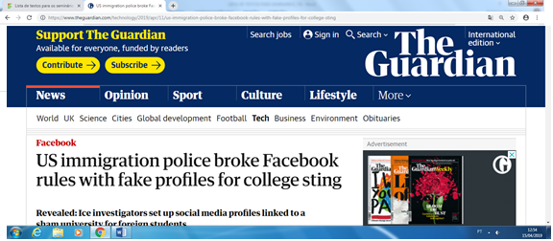
Revealed: Ice investigators set up social media profiles linked to a sham university for foreign students
Amanda Holpuch
@holpuch
Thu 11 Apr 2019 07.00 BST
Last modified on Thu 11 Apr 2019 07.02 BST

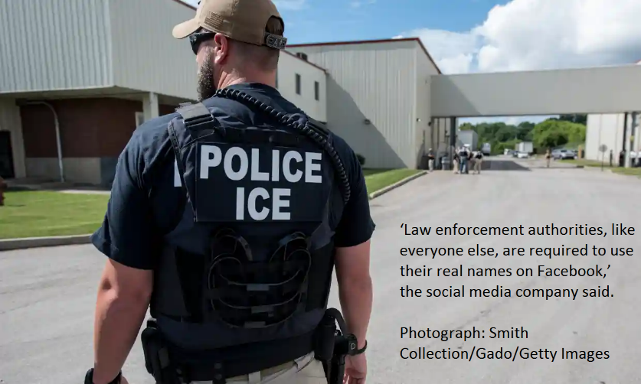
US Immigration and Customs Enforcement (Ice) violated Facebook policy by creating fake social media profiles tied to the University of Farmington, a sham university it created to identify people committing immigration fraud.
More than 600 students, nearly all Indian citizens, were caught up in the scheme, which the Guardian has found included fake Facebook profiles created by the nation’s second largest federal investigative agency, Ice’s Homeland Security Investigations (HSI) division.
“Law enforcement authorities, like everyone else, are required to use their real names on Facebook and we make this policy clear on our public-facing Law Enforcement Guidelines page,” a Facebook representative told the Guardian. “Operating fake accounts is not allowed, and we will act on any violating accounts.”
Starting in 2015, undercover agents built the Michigan school’s facade, with a fake website, government documents that confirmed it was eligible to enroll foreign students and fake Facebook accounts, including supposed staff members. In a January indictment, the government accused students of enrolling in the school to stay in the country illegally, knowing that the institution was a sham.
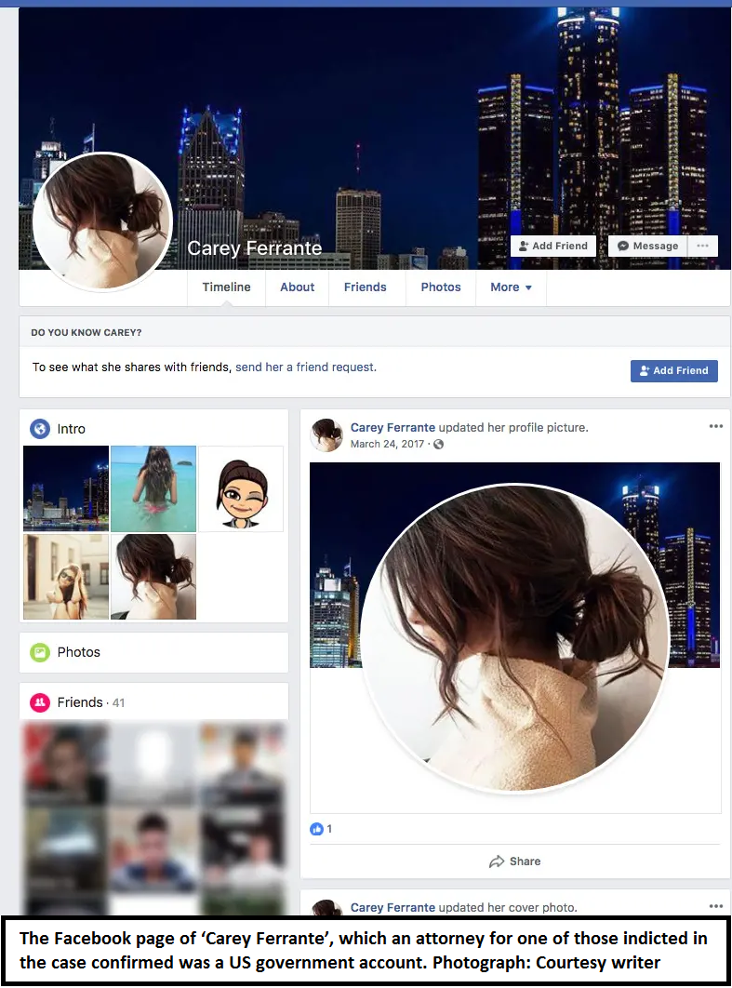
In a network of suspicious Facebook accounts linked to the University of Farmington, the college’s alleged president, Ali “AJ” Milani, liked the Michigan Jaguars sports club and had a 51-person friend list that was mostly people from south Asia, despite Milani ostensibly living in Detroit. Carey Ferrante, who did not list any link to the school but had interactions with persons interested in it, posted three photos of herself that were actually stock photos, including one of a faceless woman in a bikini, and sent Facebook messages to at least one person.
These two accounts were friends with several other people whose Facebook albums were filled with stock photos and whose friends’ lists were overwhelmingly people from south Asia.
Edward Bajoka, an attorney for one of the eight people criminally indicted in the case, Avinash Thakkalapalli, confirmed the government owned Ali “AJ” Milani and Carey Ferrante’s accounts.
Ice’s north-east regional communications director, Khaalid Walls, declined to comment on the Facebook accounts, citing the ongoing investigation. He said 172 students have been arrested for civil immigration violations in the case.
Facebook has long stood by its policy that allows people to use only their “authentic” name on the site.
But fraudulent accounts persist – and sometimes they are operated by law enforcement agencies.
Police departments in Ohio, New York, Georgia and Nebraska have previously admitted they have policies allowing investigators to use aliases and undercover profiles on social media. And in 2015, HSI said it had created an undercover Facebook account for a 15-year-old girl to lure in a person suspected of recruiting teenagers to become prostitutes.
Facebook has admonished law enforcement for having fake accounts in the past.
In September 2018, Facebook wrote to the Memphis police department, informing them that law enforcement officials are subject to the same prohibitions on creating fake accounts as normal users and to cease its activities on Facebook that involve fake accounts. In 2014, Facebook told the US Drug Enforcement Administration to stop impersonating a user.
Facebook removed the University of Farmington accounts shortly after being contacted by the Guardian and a representative said it contacted the Department of Homeland Security about its policy on fake accounts.
Dave Maass, senior investigative researcher at the Electronic Frontier Foundation (EFF), said that there were many ways law enforcement can create fake accounts, from simply setting them up to purchasing these accounts from fake account mills.
“Facebook has ratcheted up a little bit of the pressure the last few years and has sent letters to agencies when they’ve behaved badly,” Maass said. “And, also removed some of these accounts, but oftentimes they don’t find these accounts or remove these accounts until it’s far too late.”
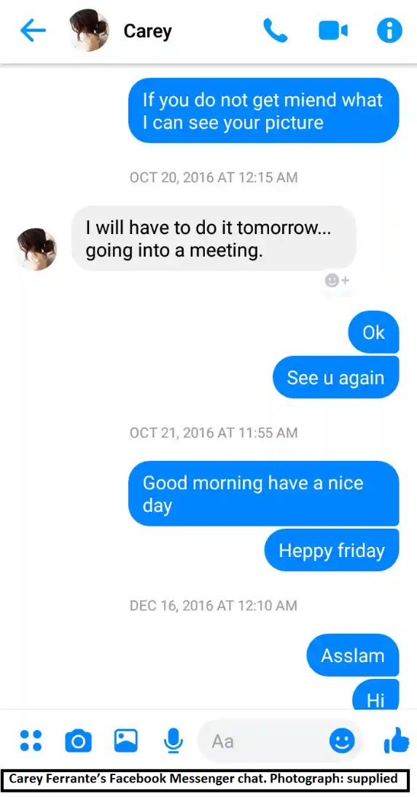
Maass said Facebook should be more transparent by posting a list of law enforcement entities caught violating the site’s policy by using fake accounts.
The extent to which Ice used these accounts to lure students to the University of Farmington is not yet clear. The Carey Ferrante account exchanged direct messages with at least one person contacted by the Guardian – a Pakistani man who was not involved with the university but had become Facebook friends with Ferrante and provided screenshots of their conversation to the Guardian. They last spoke in October 2016, when Ferrante said she would send photos of herself to the user.
The Ali “AJ” Milani account shares a name with the person listed as the University of Farmington’s president on LinkedIn. He also exchanged emails with students, according to the Detroit Free Press.
Milani was Facebook friends with Ferrante, as well as three other suspicious accounts that appeared to be fake. One of those accounts featured a picture from inside the University of Farmington with one like – from Carey Ferrante. The three suspicious accounts, as well as Milani’s and Ferrante’s, were taken offline after the Guardian approached Facebook for comment.
These Facebook profiles were just one part of the University of Farmington’s illusion. The school was listed as legitimate in government documents, and at the school’s physical address was an office with a University of Farmington logo mounted on the wall.
In the indictment, the government said: “Each student knew that the University’s program was not approved by the United States Department of Homeland Security, was illegal, and that discretion should be used when discussing the program with others.”
But attorneys for the students facing civil immigration charges and civil rights experts have questioned this characterization.
Prashanthi Reddy, an attorney in New York City who offered pro bono help to some of the students, said most people she helped chose to leave the US voluntarily instead of facing immigration court.
“They are kids and they’ve never had a traffic offense before,” Reddy said. “They are relatively new to the country and from small towns back in India.”
Reddy said some of the students she spoke to attempted to transfer out of the school when they realized classes were not being held, but couldn’t get a school official to approve the transfer. Others were suspicious about the lack of classes, she said, but had more of a “wait and see” mentality.
This is the second known sham university created by Ice. In 2016, the agency announced 20 brokers were arrested for recruiting students to the University of Northern New Jersey, a fake school. The alleged school president there also used Facebook to post updates about the school, as well as his personal life.
Rachel Levinson-Waldman, senior counsel to the Brennan Center’s Liberty and National Security Program, said courts so far have seen the use of undercover social media accounts as similar to face-to-face undercover operations. “They haven’t seen the use of undercover accounts online as inappropriate, to the contrary, they have by and large blessed that,” Levinson-Waldman said.
https://www.theguardian.com/technology/2019/apr/11/us-immigration-police-broke-facebook-rules-with-fake-profiles-for-college-sting

EXERCÍCIO:
- Qual é o assunto do texto?
- Busque 10 informações que você acha que são importantes que o texto traz?
- Encontre 10 falsos cognatos.
- Em qual/quais tempo/s verbais o texto está?
- Destaque 20 pronomes no texto e indique seus referentes.
- Encontre exemplos de palavras cujos processos de formação estão abaixo:

- PREFIXATION
- SUFIXATION
- COMPOUNDING
- BLENDING
- CLIPPING
- ACRONYM
- BACKFORMATION
- EPÓNYM
- BORROWING
- COINAGE

