Activity 314 – the boxtrolls
present and past modals for advice and regrets

I. Work in pairs:

1 - What would you recommend someone if you knew he/she were going to a formal party, but he/she doesn't know anywhere there?

2 - What about an informal party? Would your recommendation change?

3 - Have you ever done something in a party that you regretted having done? Talk about it.

4 - What is something someone should NEVER do during a party?

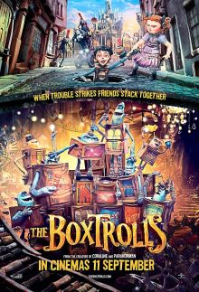

II. Watch the movie segment and complete the chart. Write 5 pieces of advice that were given to Egg.

1 ___________________________________________
2 ___________________________________________
3 ___________________________________________
4 ___________________________________________
5 ___________________________________________

III. Work in groups. Talk about the mistakes Egg made during the party.
1 - What shouldn't Egg have done, but he did? Mention as many things you can remember.

1 - What shouldn't Egg have done, but he did? Mention as many things you can remember.

IV. Imagine Egg is going to the following places. Make a list of social etiquette recommendations he should follow, according to your own culture.
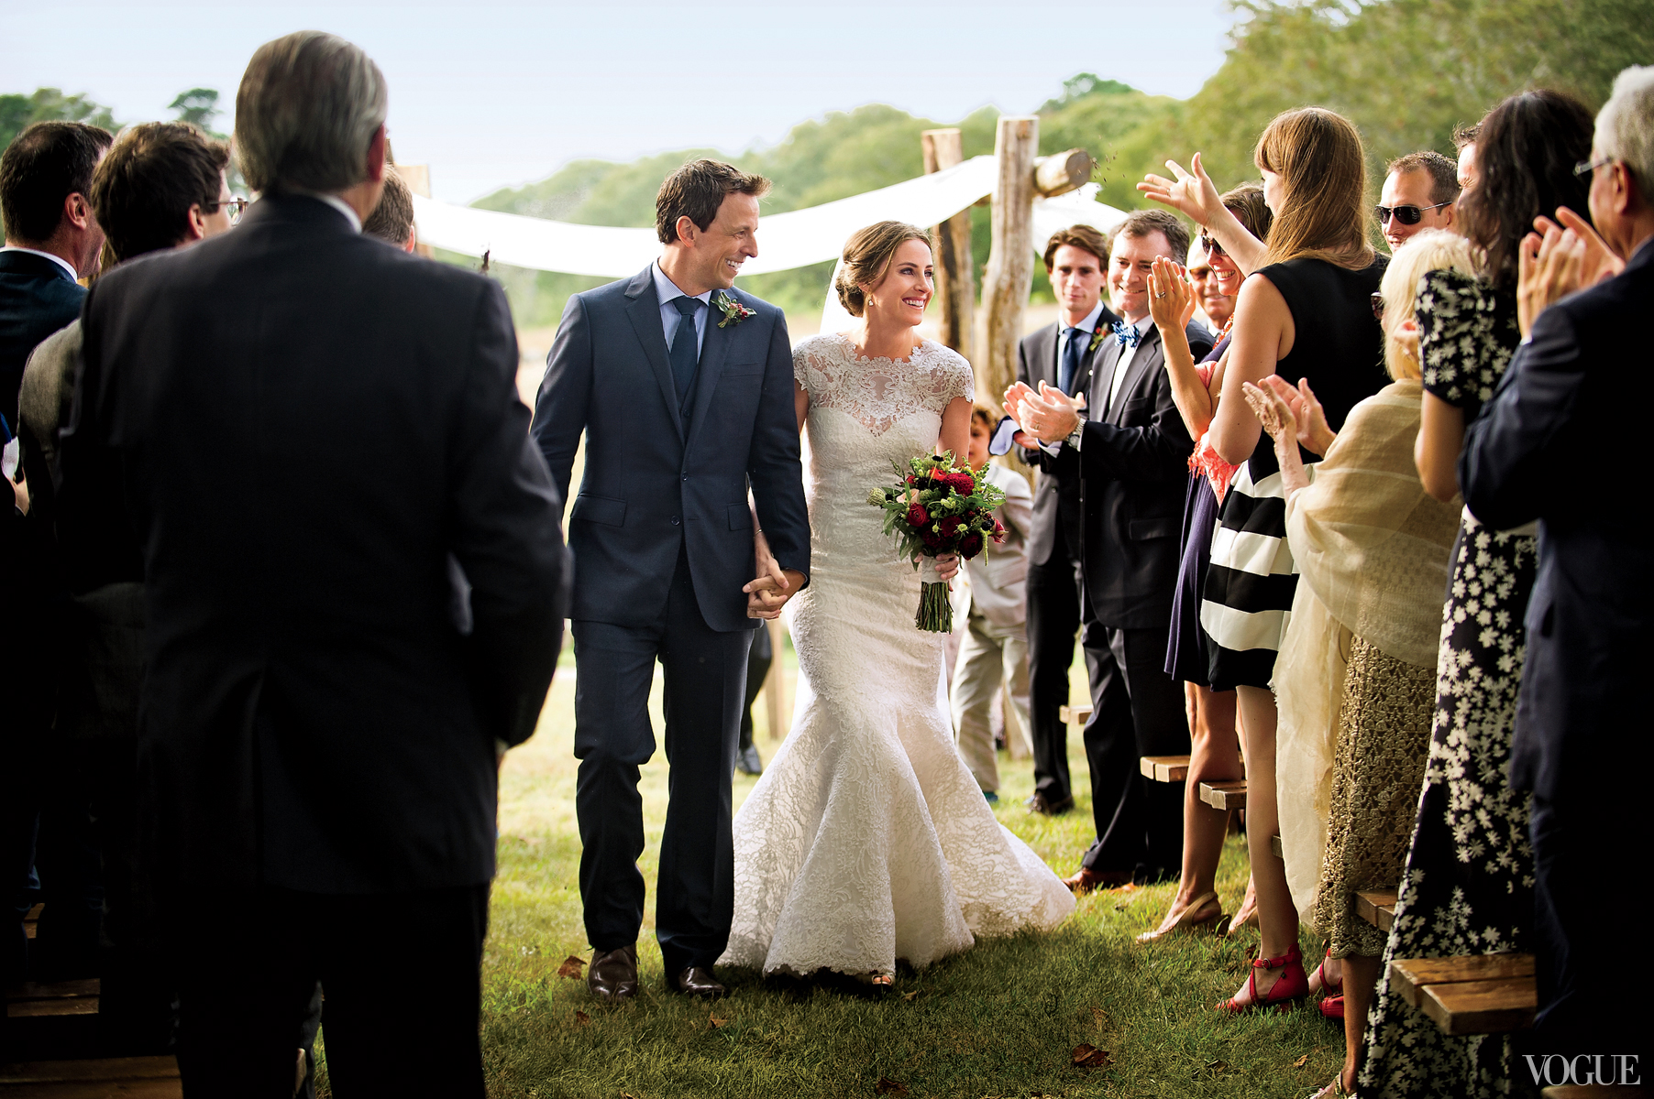
A Wedding


A funeral


Church


A Christmas Dinner

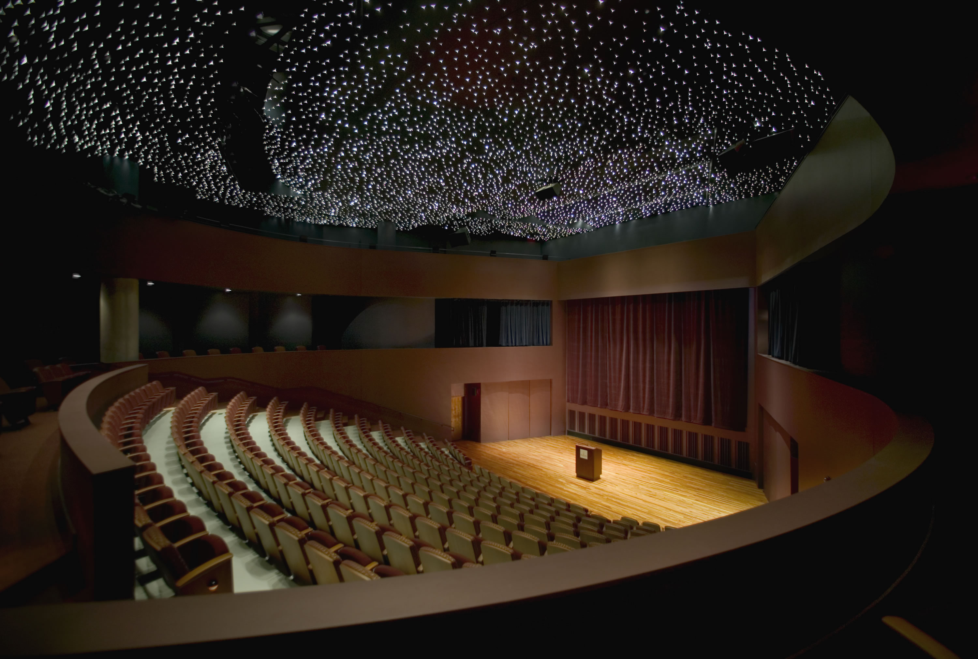
theater


a plane trip

