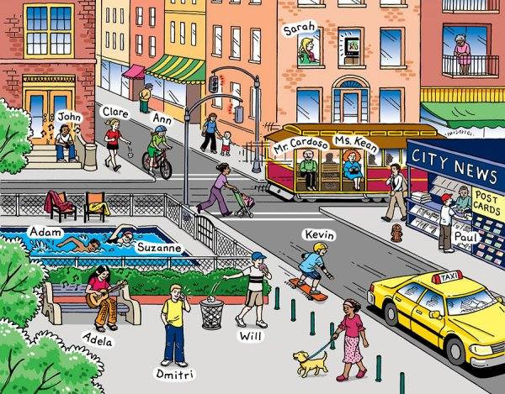
a
Put the verbs in the past simple tense because this is what they did yesterday.
It _ _ _ _ _ (is) a nice day in town yesterday. Adela _ _ _ _ _ (sit) on a bench and _ _ _ _ _ (play) her guitar. Adam and Suzanne _ _ _ _ _ (swim) twenty lengths in the outdoor pool. Paul _ _ _ _ _ (buy) a postcard to send to his friend in England. John __ _ _ _ (listen) to music. Kevin _ _ _ _ _ (go) skateboarding. Mr Cardoso and Ms Kean _ _ _ _ _ (take) the tram. Ann _ _ _ _ _ (ride) her bike. A lady dressed in pink _ _ _ _ _ (walk) her dog. Sarah _ _ _ _ _ (watch) TV. Will _ _ _ _ _ (eat) a cake and _ _ _ _ _ (put) the wrapper in the bin. Dmitri _ _ _ _ _ (phone) his friend and he _ _ _ _ _ (ask) him to come and pick him up. The old lady
_ _ _ _ _ (stand) on her balcony and she _ _ _ _ _ (watch) everyone.
_ _ _ _
Answer in FULL SENTENCES. Don’t repeat the names: use he/she/they.
1) What did Will do? 9) What did Sarah do?
2) What did Adela do? 10) What did the lady in pink do?
3) What did Anne do? 11) Look at the old lady. She is
4) What did Adam and Suzanne do? also wearing pink. What did she
5) What did Paul do? do? How do you think she felt?
6) What did Dmitri do and why?
7) What did John do?
8) What did Mr Cardoso and Ms Kean do?

