Inglês II
Profª Cristiane de Brito Cruz
Atividade Avaliativa da 1ª Etapa
Turma: 2° de Informática VESP
Alunos: Álvaro Henrique, Carlos Roberto e David Gabriel

Miami murder true story
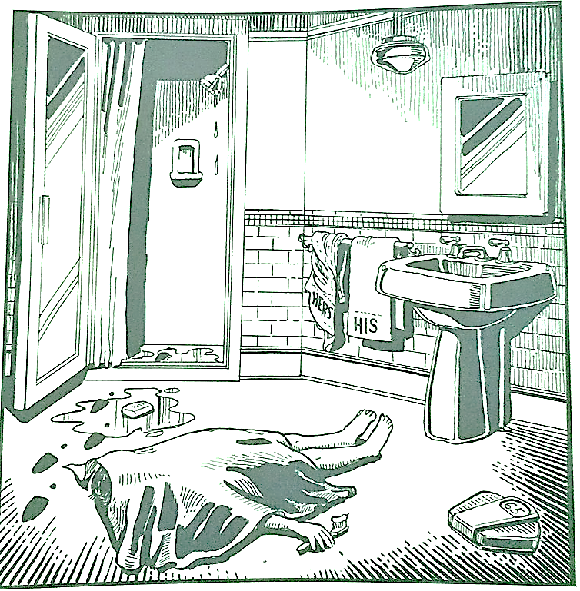
Last night Lewis Meyer died at his home in Miami. Phil Fork, a police detective, was the first person to arrive at the house after Mr. Meyer died. This is what he found:

Mr. Meyer’s wife, Margo, told Fork: “It was an accident. My husband took a shower at about 10h p.m. After his shower, he slipped on a piece of soap and fell down.”

Mr. Meyer was trying to brush his teeth when his wife hit him over the head. She took a shower and get out the box when he was not paying attention, she attacked him from behind. To kill him she used a balance that were in the bathroom. The balance broke when she hit him.

She let her husband body on the bathroom floor and went to the couple room to get dressed. She put on a beautiful dress, did a nice make up and got her nicest high heels. To make sure the police would not figure out what really happened she made up a fake scenario of him falling down after slipping on a soap and dying. She placed the soap on the floor and put water. She let the shower dripping, and when she was going out the bathroom box, she did not notice that she had let high heels steps on the floor.

The police detective Phil Fork talked to the forensics and realized she lied to him, so he arrested her for murdering her husband. At the police station, she confessed she had killed her husband because… he broke her car, because he destroyed her dress, Because they had an abusive relationship, Because she was beaten by her, Because she had trouble lying, because he beat her children, Because she wanted her husband's inheritance, Because she was having an affair with another man, and she didn't want a divorce to keep all the assets, she was hypnotized, margo found out that he was cheating on her with the neighbour, margo wanted Lewis’s salary just for her, because he was involved with the wrong things Why did she find out that he had contracted Corona virus, because he wanted to force her to have more children.

