Inglês II
Profª Cristiane de Brito Cruz
Atividade Avaliativa da 1ª Etapa
Turma:2° Informática – Vespertino
Alunos: Marcos Gabriel e David Eder

Miami murder true story
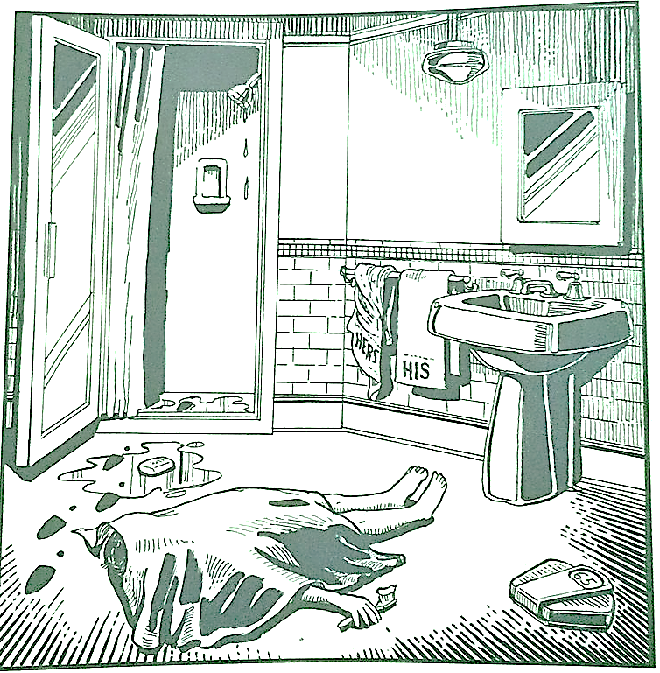
Last night Lewis Meyer died at his home in Miami. Phil Fork, a police detective, was the first person to arrive at the house after Mr. Meyer died. This is what he found:

Mr. Meyer’s wife, Margo, told Fork: “It was an accident. My husband took a shower at about 10h p.m. After his shower, he slipped on a piece of soap and fell down.”

Mr. Meyer was trying to brush his teeth when his wife hit him over the head. She took a shower and get out the box when he was not paying attention, she attacked him from behind. To kill him she used a balance that were in the bathroom. The balance broke when she hit him.

She let her husband body on the bathroom floor and went to the couple room to get dressed. She put on a beautiful dress, did a nice make up and got her nicest high heels. To make sure the police would not figure out what really happened she made up a fake scenario of him falling down after slipping on a soap and dying. She placed the soap on the floor and put water. She let the shower dripping, and when she was going out the bathroom box, she did not notice that she had let high heels steps on the floor.

The police detective Phil Fork talked to the forensics and realized she lied to him, so he arrested her for murdering her husband. At the police station, she confessed she had killed her husband because…

After a big interview with his wife, it was discovered that the couple were constantly fighting, fights that started by a quarrel in Minecraft, the husband had mined the Diamond with the Stone Pickaxe. The fights only got worse when her husband, in an attitude of fury, stopped washing the dishes and prevented her from playing League of Legends.

Obviously, these fights only made the distance between them increase, he tried to rebel against by stopped washing the dishes and left used drinks out of the fridge. Wanting to get close to her husband, she ended up comparing 3 presents for her: a Lego set, which he threw on the floor; a new cell phone, which he did not remove the plastic from the front; and a pizza, which he refused to eat the cheese crusts. Those were the last drops, later she would decide to kill him to escape with her lover from Dubai.

