Inglês II
Profª Cristiane de Brito Cruz
Atividade Avaliativa da 1ª Etapa
Turma: 2º Informática Vespertino
Alunos: Fernanda Moreira e Giliardo Júlio

Miami murder true story
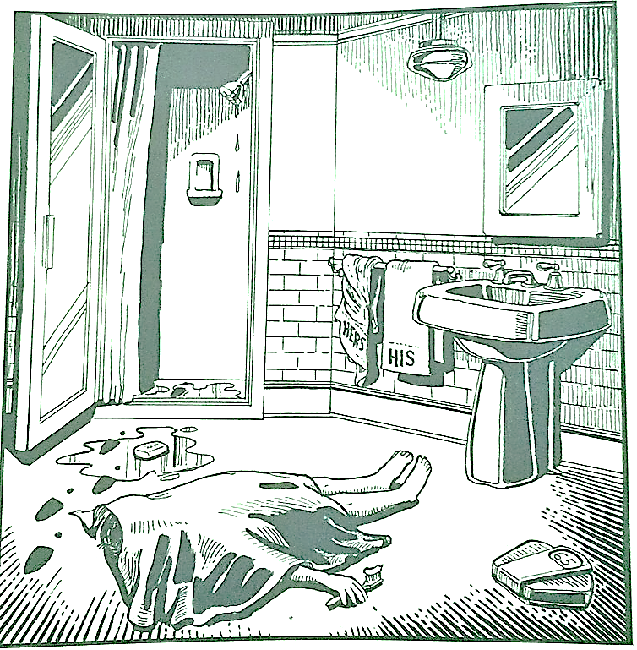
Last night Lewis Meyer died at his home in Miami. Phil Fork, a police detective, was the first person to arrive at the house after Mr. Meyer died. This is what he found:

Mr. Meyer’s wife, Margo, told Fork: “It was an accident. My husband took a shower at about 10h p.m. After his shower, he slipped on a piece of soap and fell down.”

Mr. Meyer was trying to brush his teeth when his wife hit him over the head. She took a shower and get out the box when he was not paying attention, she attacked him from behind. To kill him she used a balance that were in the bathroom. The balance broke when she hit him.

She let her husband body on the bathroom floor and went to the couple room to get dressed. She put on a beautiful dress, did a nice make up and got her nicest high heels. To make sure the police would not figure out what really happened she made up a fake scenario of him falling down after slipping on a soap and dying. She placed the soap on the floor and put water. She let the shower dripping, and when she was going out the bathroom box, she did not notice that she had let high heels steps on the floor.

The police detective Phil Fork talked to the forensics and realized she lied to him, so he arrested her for murdering her husband. At the police station, she confessed she had killed her husband because…

She loved he a lot, but he traveled a lot for work, and she stayed home alone, one day he came home from traveling and didn't treat she well anymore, said he didn't want to have any more children with her, being that it was her dream, she was discouraged and the other day she found out that he cheated on her, she ended up meeting Jeff who became her lover, Meyer was just going out with friends and didn't call her anymore, now she doesn't want him anymore and wants to live with her lover, she thought about divorce, but the divorce would divide the assets, so she thought that killing him would be a good idea, staying with all his assets and being able to live peacefully with her lover

