Inglês II
Profª Cristiane de Brito Cruz
Atividade Avaliativa da 1ª Etapa
Turma: Informática 2º Vespertino
Alunos: José Felipe da Costa Neto e Maria Vitória Ramos Yamashiro da Costa
Miami murder true story
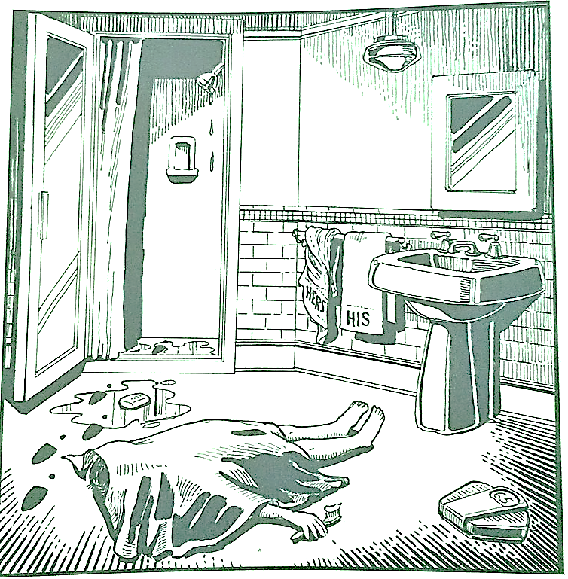
Last night Lewis Meyer died at his home in Miami. Phil Fork, a police detective, was the first person to arrive at the house after Mr. Meyer died. This is what he found:

Mr. Meyer’s wife, Margo, told Fork: “It was an accident. My husband took a shower at about 10h p.m. After his shower, he slipped on a piece of soap and fell down.”

Mr. Meyer was trying to brush his teeth when his wife hit him over the head. She took a shower and get out the box when he was not paying attention, she attacked him from behind. To kill him she used a balance that were in the bathroom. The balance broke when she hit him.

She let her husband body on the bathroom floor and went to the couple room to get dressed. She put on a beautiful dress, did a nice make up and got her nicest high heels. To make sure the police would not figure out what really happened she made up a fake scenario of him falling down after slipping on a soap and dying. She placed the soap on the floor and put water. She let the shower dripping, and when she was going out the bathroom box, she did not notice that she had let high heels steps on the floor.

The police detective Phil Fork talked to the forensics and realized she lied to him, so he arrested her for murdering her husband. At the police station, she confessed she had killed her husband because…

She killed her husband because she had an affair with another man and had no choice because she was obliged, after all she needed the money from a life insurance that her husband had in order to get away with her lover and start a new life.

There were several reasons why she would kill him. Among them is the fact that he did not help with the daily household chores. When she was at PMS he kept stressing her out. He ate her drumsticks and never shared his food. He pulled the sheet in the middle of the night, leaving her cold. He didn't give her food when she was sad.

