Inglês II
Profª Cristiane de Brito Cruz
Atividade Avaliativa da 1ª Etapa
Turma: Informática – 2º ano
Alunos: Ana Clara Medeiros, Anderson Felipe e Tamara Silva.

Miami murder true story
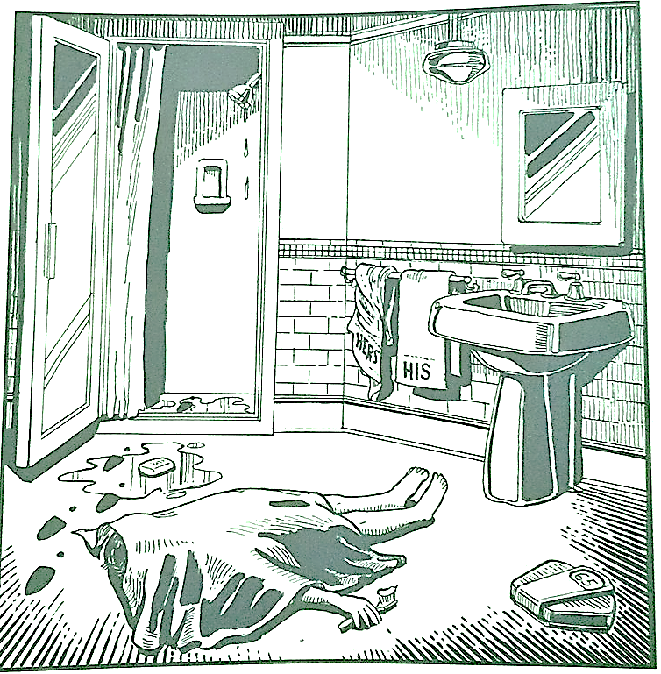
Last night Lewis Meyer died at his home in Miami. Phil Fork, a police detective, was the first person to arrive at the house after Mr. Meyer died. This is what he found:

Mr. Meyer’s wife, Margo, told Fork: “It was an accident. My husband took a shower at about 10h p.m. After his shower, he slipped on a piece of soap and fell down.”

Mr. Meyer was trying to brush his teeth when his wife hit him over the head. She took a shower and get out the box when he was not paying attention, she attacked him from behind. To kill him she used a balance that were in the bathroom. The balance broke when she hit him.

She let her husband body on the bathroom floor and went to the couple room to get dressed. She put on a beautiful dress, did a nice make up and got her nicest high heels. To make sure the police would not figure out what really happened she made up a fake scenario of him falling down after slipping on a soap and dying. She placed the soap on the floor and put water. She let the shower dripping, and when she was going out the bathroom box, she did not notice that she had let high heels steps on the floor.

The police detective Phil Fork talked to the forensics and realized she lied to him, so he arrested her for murdering her husband. At the police station, she confessed she had killed her husband because Mr. Meyer married Mrs. Meyer very early, as an arranged marriage.
A few years later, he began to show some aggressive behavior. One day she found out that Mr. Meyer cheated on her with a French woman, indignant went to ask him why all this, he said she had nowhere to go and depended on him, so she would have to put up with it. Disgusted with all this, she starts to hide out every night to plan something that would end this once and for all.In one of these escapes he ends up waking up and catching her in the act, loses control and starts hitting her a lot. After that night he doesn't let her go anywhere and keeps her trapped, if he finds himself without alternatives, he'll have to kill him.
On the day he decided to murder Mr. Meyer, he spent the whole night plotting the crime, and then he did it. She took the scale and broke her husband's head and, in order not to be accused, tried to create an accident scene, there were failures and the detective arrested her.

