Inglês II
Profª Cristiane de Brito Cruz
Atividade Avaliativa da 1ª Etapa
Turma: 2º de Informática
Alunos: Anthony Brian Medeiros da Silva e Lucas Vinicius Dantas de Medeiros

Miami murder true story
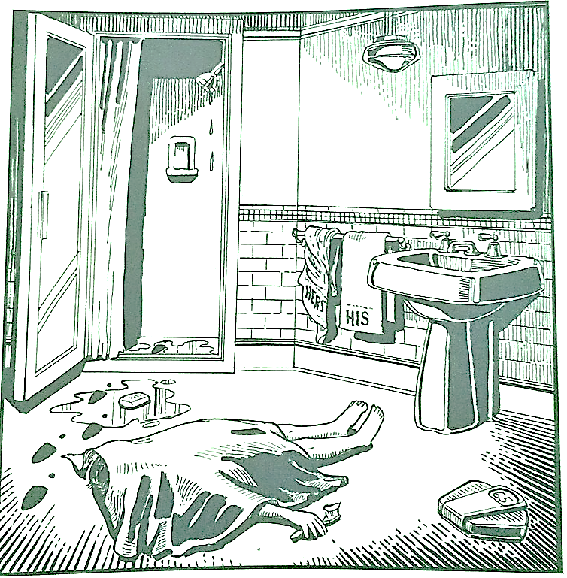
Last night Lewis Meyer died at his home in Miami. Phil Fork, a police detective, was the first person to arrive at the house after Mr. Meyer died. This is what he found:

Mr. Meyer’s wife, Margo, told Fork: “It was an accident. My husband took a shower at about 10h p.m. After his shower, he slipped on a piece of soap and fell down.”

Mr. Meyer was trying to brush his teeth when his wife hit him over the head. She took a shower and get out the box when he was not paying attention, she attacked him from behind. To kill him she used a balance that were in the bathroom. The balance broke when she hit him.

She let her husband body on the bathroom floor and went to the couple room to get dressed. She put on a beautiful dress, did a nice make up and got her nicest high heels. To make sure the police would not figure out what really happened she made up a fake scenario of him falling down after slipping on a soap and dying. She placed the soap on the floor and put water. She let the shower dripping, and when she was going out the bathroom box, she did not notice that she had let high heels steps on the floor.

The police detective Phil Fork talked to the forensics and realized she lied to him, so he arrested her for murdering her husband. At the police station, she confessed she had killed her husband because…

Margo's day starts with having to hear her husband say that she is very thin that she needed to put on weight while watching him use her towel to dry himself after showering, later discovered by his best friend that he was cheating on her with the neighbor. Before bed Mr. Meyer never brushed his teeth before bed and mistreated her in bed.
They were having an abusive relationship, for her Mr. Meyer was getting uglier as the years went by, he was no longer handsome, fighting every day for food, it seemed that he was hungry from so much fighting he was doing, he spoke badly about Margo's family saying they are very stallholders. All of this mixed with the TPM she was going through made her kill him.

