Inglês II
Profª Cristiane de Brito Cruz
Atividade Avaliativa da 1ª Etapa
Curso: Informática / Turma: 2019.1
Alunos: Caio Felipe e Lázaro Gabriel.

Miami murder true story

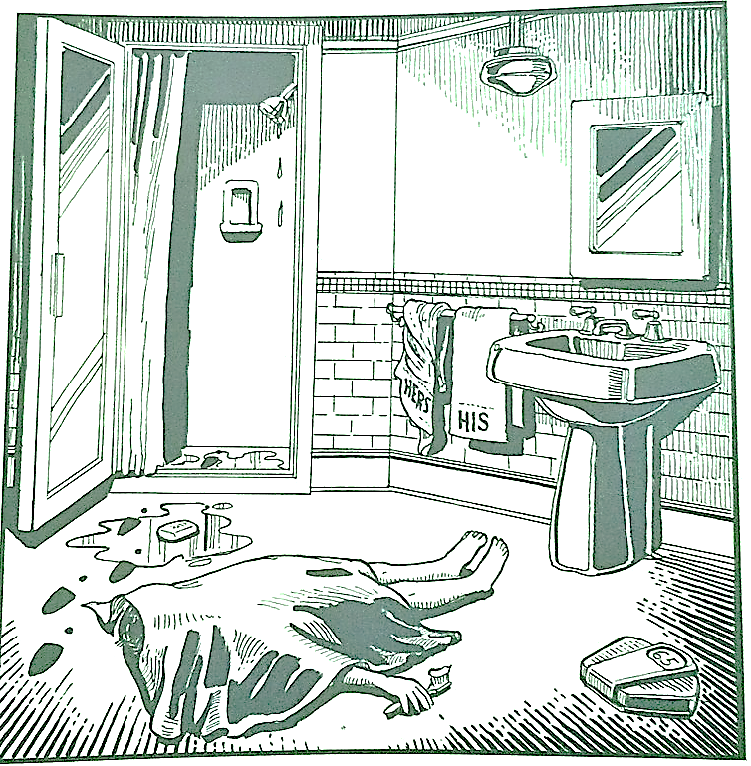
Last night Lewis Meyer died at his home in Miami. Phil Fork, a police detective, was the first person to arrive at the house after Mr. Meyer died. This is what he found:

Mr. Meyer’s wife, Margo, told Fork: “It was an accident. My husband took a shower at about 10h p.m. After his shower, he slipped on a piece of soap and fell down.”

Mr. Meyer was trying to brush his teeth when his wife hit him over the head. She took a shower and get out the box when he was not paying attention, she attacked him from behind. To kill him she used a balance that were in the bathroom. The balance broke when she hit him.

She let her husband body on the bathroom floor and went to the couple room to get dressed. She put on a beautiful dress, did a nice make up and got her nicest high heels. To make sure the police would not figure out what really happened she made up a fake scenario of him falling down after slipping on a soap and dying. She placed the soap on the floor and put water. She let the shower dripping, and when she was going out the bathroom box, she did not notice that she had let high heels steps on the floor.

The police detective Phil Fork talked to the forensics and realized she lied to him, so he arrested her for murdering her husband. At the police station, she confessed she had killed her husband because…

At the police station, she confessed to killing her husband because he was fed up. For days, the husband left the TOWEL wet in bed, Margo has OCD, Obsessive-Compulsive Disorder and that was a trigger for her outbreaks and crises. In addition, Lewis had already done several things to irritate her, but of minimal importance compared to leaving the towel on the bed WET! Lewis cheated on her with a man, but she didn't care much. He accidentally killed his parents while they showered in the pool. The old men died electroculted by their son-in-law. Once, he ate the food she had hidden in the refrigerator. Lewis took a hairdressing course, and while she slept, he used her as a guinea pig. When Margo woke up, he was bald. After watching 50 shades of gray, he beat her up, inspired by the movie. They went to Brazil at the time of Carnival, for the Carnival of Caicó, but Lewis went alone, left Margo locked up and even acquired herpes. He cursed her. She even found out that he was a Nazi. In the end, there were forgivable slips, but certainly the highlight was the towel. That was unacceptable, she wouldn't let it go, and she just waited for the right moment! After the shower, she showed him that he would never again leave a wet towel on his bed.

