Inglês II
Profª Cristiane de Brito Cruz
Atividade Avaliativa da 1ª Etapa
Turma:
Alunos: Camilly Suiane e Maria Vitoria Bruna

Miami murder true story
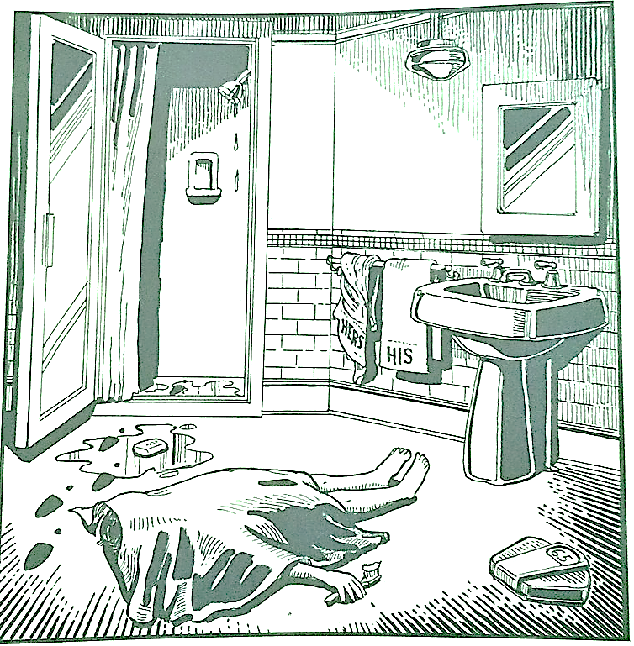
Last night Lewis Meyer died at his home in Miami. Phil Fork, a police detective, was the first person to arrive at the house after Mr. Meyer died. This is what he found:

Mr. Meyer’s wife, Margo, told Fork: “It was an accident. My husband took a shower at about 10h p.m. After his shower, he slipped on a piece of soap and fell down.”

Mr. Meyer was trying to brush his teeth when his wife hit him over the head. She took a shower and get out the box when he was not paying attention, she attacked him from behind. To kill him she used a balance that were in the bathroom. The balance broke when she hit him.

She let her husband body on the bathroom floor and went to the couple room to get dressed. She put on a beautiful dress, did a nice make up and got her nicest high heels. To make sure the police would not figure out what really happened she made up a fake scenario of him falling down after slipping on a soap and dying. She placed the soap on the floor and put water. She let the shower dripping, and when she was going out the bathroom box, she did not notice that she had let high heels steps on the floor.

The police detective Phil Fork talked to the forensics and realized she lied to him, so he arrested her for murdering her husband. At the police station, she confessed who was married for a long time when they married Mr. Meyer was very careful and attentive to his wife, but over the years Mr. Meyer was showing himself to be a man quite the opposite, a violent and rude man mainly with his wife, Mr. Meyer was an alcoholic guy and that when he drank he even beat his wife and mistreated her every day, she also discovered that he would have been betrayed. Exhausted from this life and knowing that her husband had a large sum of money and that she would be the only heir, she planned alone a way to get rid of her husband, and while he was getting ready to take his bath he was surprised by heavy blows on his face. head with the help of a scale by his wife, with the strong pains Mr. Meyer passed out and was immediately put to death.

