Tangled - When Will My Life Begin - Disney
7 AM, the usual morning lineup
Start on the chores and __________________ 'til the floor's all clean
__________________, __________________, and __________________ and __________________
Sweep again, and by then it's like 7:15

And so I'll __________________
Or maybe two or three
I'll add a few new paintings to my gallery
I'll __________________ and __________________
And __________________ and basically
Just wonder when will my life begin?

Then after lunch it's puzzles ( ) and darts ( ) and baking ( )
Paper mache ( ), a bit of ballet ( ) and chess ( )
Pottery ( ) and ventriloquy ( ), candle making ( )
Then I'll __________________, maybe __________________, __________________
__________________ a dress!

- BAKE
- DANCE
- DO
- MAKE
- PLAY

And I'll reread the books
If I have time to spare
I'll paint the walls some more
I'm sure there's room somewhere
And then I'll __________________ and __________________
and __________________ and __________________ my hair
Stuck in the same place I've always been

And I'll keep wonderin' and wonderin'
And wonderin' and wonderin'
When will my life begin?

And tomorrow night
Lights will appear
Just like they do on my birthday each year
What is it like
Out there where they glow?
Now that I'm older
Mother might just
Let me go

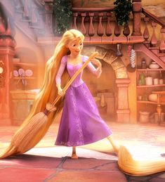

BRUSH MY HAIR |  | MOP |  | READ A BOOK |  | SKETCH
COOK |  | PAINT THE WALLS |  | SEW |  | STRETCH
DO LAUNDRY |  | PLAY GUITAR |  | SHINE UP |  | SWEEP
KNIT |  | POLISH AND WAX |  |  |  | TAKE A CLIMB

