Inglês II
Profª Cristiane de Brito Cruz
Atividade Avaliativa da 1ª Etapa
Turma: 4ª MSI
Alunos: Ana Clara Azevedo de Castro e Maria Eduarda de Carvalho Mélo

Miami murder true story

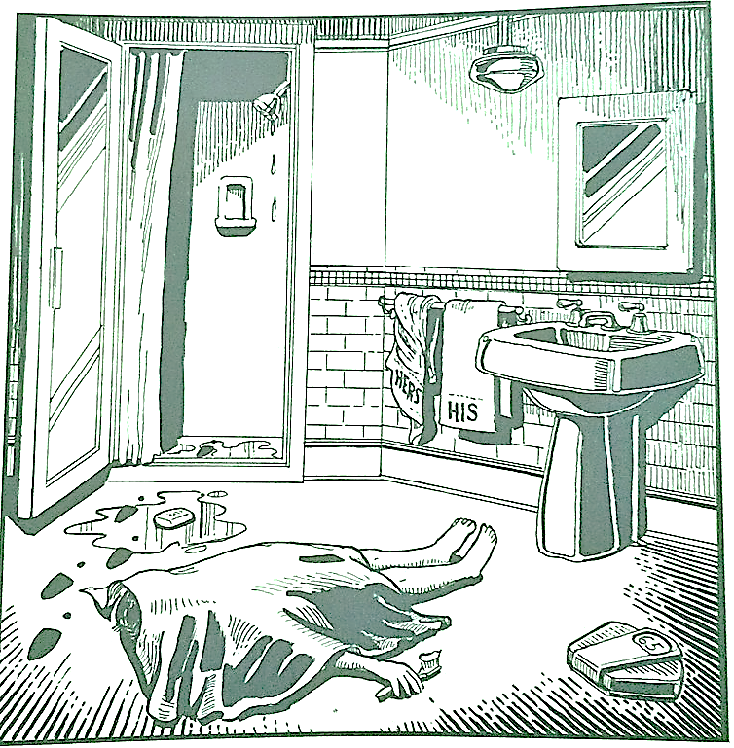
Last night Lewis Meyer died at his home in Miami. Phil Fork, a police detective, was the first person to arrive at the house after Mr. Meyer died. This is what he found:
Mr. Meyer’s wife, Margo, told Fork: “It was an accident. My husband took a shower at about 10h p.m. After his shower, he slipped on a piece of soap and fell down.”
Mr. Meyer was trying to brush his teeth when his wife hit him over the head. She took a shower and get out the box when he was not paying attention, she attacked him from behind. To kill him she used a balance that were in the bathroom. The balance broke when she hit him.
She let her husband body on the bathroom floor and went to the couple room to get dressed. She put on a beautiful dress, did a nice make up and got her nicest high heels. To make sure the police would not figure out what really happened she made up a fake scenario of him falling down after slipping on a soap and dying. She placed the soap on the floor and put water. She let the shower dripping, and when she was going out the bathroom box, she did not notice that she had let high heels steps on the floor.
The police detective Phil Fork talked to the forensics and realized she lied to him, so he arrested her for murdering her husband. At the police station, she confessed she had killed her husband because at a party organized by the company where she worked, Margo met a businessman, called John, who claimed to work in the same field as her. What Margo did not imagine is that the scenario of her story would change from heaven to hell. The two talked and left together, and soon became close friends. Then, after a few months, the two planned to take a trip together on their vacation.
Margo and John traveled to another country, with the intention of getting to know another culture and keeping good memories. However, when she got there Margo realized that she was in the hands of a maniac, she discovered this when she realized that he introduced her to other people as his wife, when checking her things she realized that her identity disappeared, and that John produced a false identity for the two. She did not speak the country's official language, so it took her a while to discover the scoundrel's disguise.
To save herself, Margo created a plan, she was in another country with a madman and without his documents. But she found a solution, difficult and risky. When she went to take a shower and when she saw that John was brushing his teeth, she took a scale and threw it at his head, so that he was knocked out and she managed to escape.

