Inglês II
Profª Cristiane de Brito Cruz
Atividade Avaliativa da 1ª Etapa
Turma: MSI 4° ANO
Alunos: Paulo Guilherme Silva de Araújo, Flávio Emanuel de Lima Silva, Ryan Alan Medeiros Barros

Miami murder true story
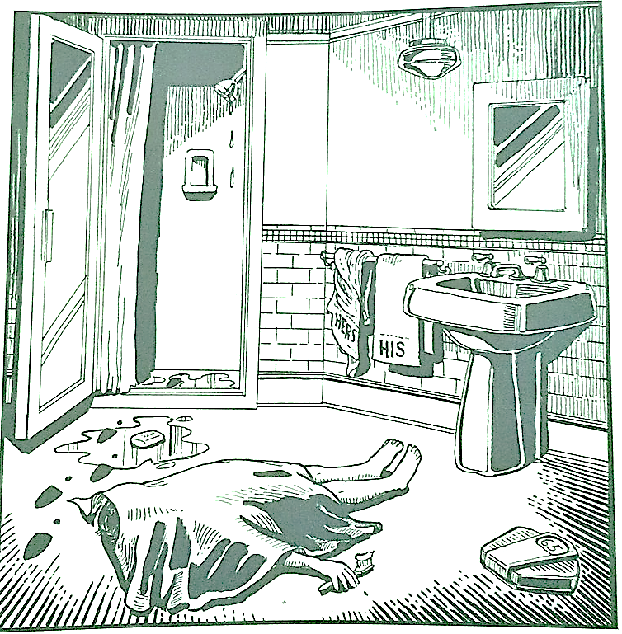
Last night Lewis Meyer died at his home in Miami. Phil Fork, a police detective, was the first person to arrive at the house after Mr. Meyer died. This is what he found:

Mr. Meyer’s wife, Margo, told Fork: “It was an accident. My husband took a shower at about 10h p.m. After his shower, he slipped on a piece of soap and fell down.”

Mr. Meyer was trying to brush his teeth when his wife hit him over the head. She took a shower and get out the box when he was not paying attention, she attacked him from behind. To kill him she used a balance that were in the bathroom. The balance broke when she hit him.

She let her husband body on the bathroom floor and went to the couple room to get dressed. She put on a beautiful dress, did a nice make up and got her nicest high heels. To make sure the police would not figure out what really happened she made up a fake scenario of him falling down after slipping on a soap and dying. She placed the soap on the floor and put water. She let the shower dripping, and when she was going out the bathroom box, she did not notice that she had let high heels steps on the floor.

The police detective Phil Fork talked to the forensics and realized she lied to him, so he arrested her for murdering her husband. At the police station, she confessed she had killed her husband because…

He was having an affair with the neighbour
He was hitting her every day
He was unemployed and broke
He was rich, and she wanted his money
She found out that he was an organ dealer
He ate the last piece of cake she wanted
He didn't like Game of Thrones
He didn't want to change the lamp in the room
He broke a crystal bowl from her
He snored every night
He stoled her cellphone
She is a serial killer
He said she was fat
He didn't shave
He killed her son

