Inglês II
Profª Cristiane de Brito Cruz
Atividade Avaliativa da 1ª Etapa
Turma: 4º MSI
Alunos: Matheus Weslley, Dyego Feijó e João Marcos.

Miami murder true story
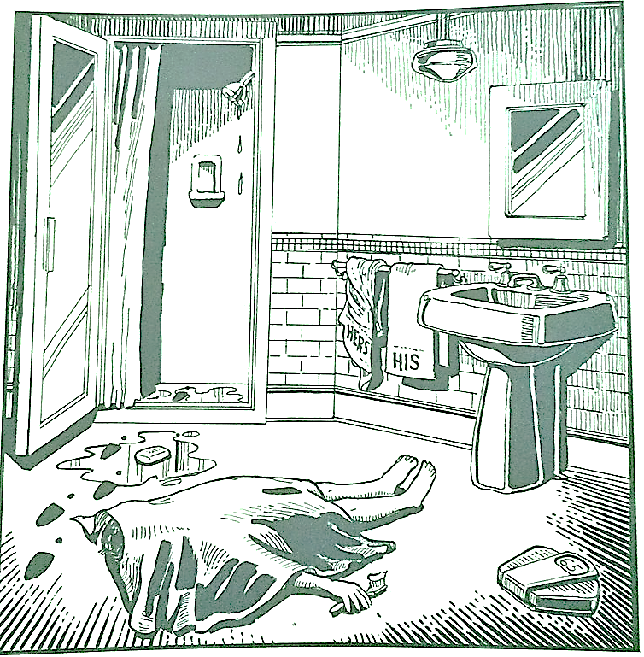
Last night Lewis Meyer died at his home in Miami. Phil Fork, a police detective, was the first person to arrive at the house after Mr. Meyer died. This is what he found:

Mr. Meyer’s wife, Margo, told Fork: “It was an accident. My husband took a shower at about 10h p.m. After his shower, he slipped on a piece of soap and fell down.”

Mr. Meyer was trying to brush his teeth when his wife hit him over the head. She took a shower and get out the box when he was not paying attention, she attacked him from behind. To kill him she used a balance that were in the bathroom. The balance broke when she hit him.

She let her husband body on the bathroom floor and went to the couple room to get dressed. She put on a beautiful dress, did a nice make up and got her nicest high heels. To make sure the police would not figure out what really happened she made up a fake scenario of him falling down after slipping on a soap and dying. She placed the soap on the floor and put water. She let the shower dripping, and when she was going out the bathroom box, she did not notice that she had let high heels steps on the floor.

The police detective Phil Fork talked to the forensics and realized she lied to him, so he arrested her for murdering her husband. At the police station, she confessed she had killed her husband because…

1- The position of the body indicates that it did not slip in the soap.
2- The footprints in the bathroom and the position of the body show that the man was killed even before taking a shower.
3- The position of the body and the brush well placed in your hand indicates that the scene of the body has been modified from the original.
4- The intact man's towel is another indication that he was not taking a shower.
5- The contorted woman's towel indicates that the woman was taking a shower and that she was in the bathroom.
6- When she left, she slipped on the soap.
7- The scale is broken because the woman was very heavy, the number 9 was inverted by 6, her original weight is 95 kilos.
8- As he slipped, she fell on top of him and killed him unintentionally.
9- For fear of being blamed for this, she manipulated the environment to try to prove her innocence.
10- The tracks are from her best friend, who was called in to help her disguise the place.
11- The shower is still dripping open because she had to wash the arm that had been injured in the fall.
12- Her best friend was called in to make up for the bruises on her body from the fall.
13- After using the soap to clean the blood, she put it back on the floor.
14- Below the soap is wet because she had to rub a lot to clean the blood.
15- So his wife was to blame, even if involuntarily.

