Inglês II
Profª Cristiane de Brito Cruz
Atividade Avaliativa da 1ª Etapa
Turma: MSI – 4° ano – matutino
Alunos: Andréia de Fátima e Anna Clara de Macêdo

Miami murder true story
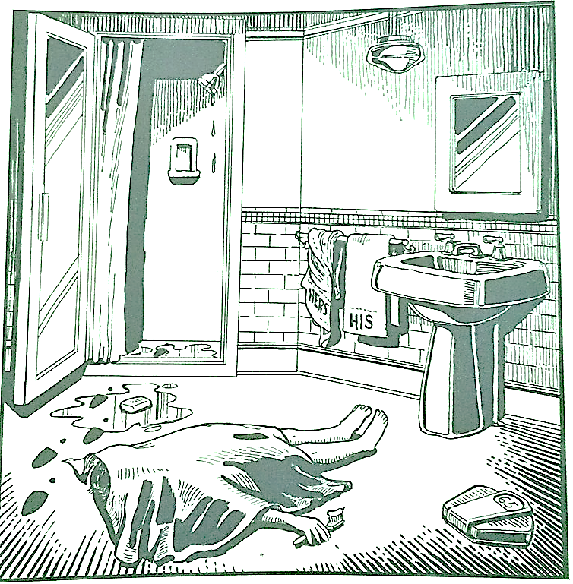
Last night Lewis Meyer died at his home in Miami. Phil Fork, a police detective, was the first person to arrive at the house after Mr. Meyer died. This is what he found:

Mr. Meyer’s wife, Margo, told Fork: “It was an accident. My husband took a shower at about 10h p.m. After his shower, he slipped on a piece of soap and fell down.”

Mr. Meyer was trying to brush his teeth when his wife hit him over the head. She took a shower and get out the box when he was not paying attention, she attacked him from behind. To kill him she used a balance that were in the bathroom. The balance broke when she hit him.

She let her husband body on the bathroom floor and went to the couple room to get dressed. She put on a beautiful dress, did a nice make up and got her nicest high heels. To make sure the police would not figure out what really happened she made up a fake scenario of him falling down after slipping on a soap and dying. She placed the soap on the floor and put water. She let the shower dripping, and when she was going out the bathroom box, she did not notice that she had let high heels steps on the floor.

The police detective Phil Fork talked to the forensics and realized she lied to him, so he arrested her for murdering her husband. At the police station, she confessed she had killed her husband because…
1 = Mrs Meyer killed mr. Meyer because he cheated on her.
2 = Mr. Meyer said the woman was fat and she killed him by hitting the scale on his head.
3= Mr. Mayer insulted Mrs. Meyer.
4 = Mrs. Meyer killed mr. Meyer because he spread false news about you.
5 = Mrs. Meyer Mrs. Mayer killed Mr. Meyer because he spoke ill of his family.
6 = Mr. Meyer left his towel wet on the bed, so Mrs. Meyer killed him.
7 = Mrs. Meyer killed mr. Meyer because he used the hot water in the shower.
8 = Mr. Meyer left the bathroom all wet and that was the end of the line for her.
9 = Mrs. Meyer wanted to end the relationship, but she couldn't, so she killed Mr. Meyer.
10= Mrs. Meyer killed Mr. Meyer because he was leaving the lid on the vase wet.

