Inglês II
Profª Cristiane de Brito Cruz
Atividade Avaliativa da 1ª Etapa
Turma: 4º MSI MATUTINO
Alunos: Artur Gustavo da Silva Erionaldo Alves de Freitas

Miami murder true story
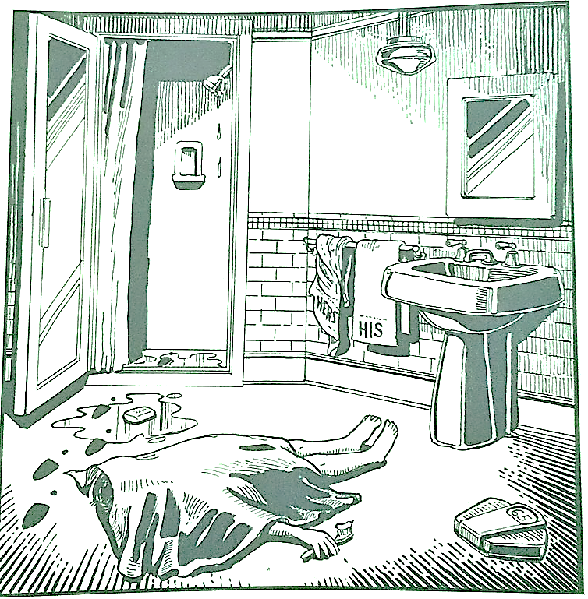
Last night Lewis Meyer died at his home in Miami. Phil Fork, a police detective, was the first person to arrive at the house after Mr. Meyer died. This is what he found:

Mr. Meyer’s wife, Margo, told Fork: “It was an accident. My husband took a shower at about 10h p.m. After his shower, he slipped on a piece of soap and fell down.”

Mr. Meyer was trying to brush his teeth when his wife hit him over the head. She took a shower and get out the box when he was not paying attention, she attacked him from behind. To kill him she used a balance that were in the bathroom. The balance broke when she hit him.

She let her husband body on the bathroom floor and went to the couple room to get dressed. She put on a beautiful dress, did a nice make up and got her nicest high heels. To make sure the police would not figure out what really happened she made up a fake scenario of him falling down after slipping on a soap and dying. She placed the soap on the floor and put water. She let the shower dripping, and when she was going out the bathroom box, she did not notice that she had let high heels steps on the floor.

The police detective Phil Fork talked to the forensics and realized she lied to him, so he arrested her for murdering her husband. At the police station, she confessed she had killed her husband because…

Mr. Meyer died after irritating his wife with PMS

Mr. Meyer died when he saw himself in the mirror

Mr. Meyer was murdered by his wife's lover

Mr. Meyer died when he felt the cold water in the shower

Mr. Meyer scared to death when he saw his weight on the scale

Mr. Meyer frightened when he saw his wife in the bathroom

Mr. Meyer was killed by his wife because he peed on the toilet lid

Mr. Meyer was killed because he didn't dry the bathroom after using it

Mr. Meyer died of trying so hard trying to get the rest of the toothpaste out of the jar

Mr. Meyer was killed by the woman because she wanted the inheritance

