DIRETORIA ACADÊMICA
INGLÊS TÉCNICO
ATIVIDADE 3
Estudante: __________________________________________________
DATA: 20/03/2021
Profª Me. Cristiane de Brito Cruz

Identifique os gêneros textuais dos textos de 1 a 15:

( ) Biography
( ) Blog personal report
( ) Encyclopedia
( ) Information text
( ) Job ad
( ) Joke
( ) Journalistic article
( ) Legend
( ) Mobile phone manual
( ) Opinion article
( ) Package insert
( ) Receipt
( ) Recipe
( ) Restaurant menu
( ) User guide

Obs: escreva o número do texto ao lado do gênero.

- BABY SITTER needed immediately for children ages 4 and 6. Call 305-7911785 or reply to with phone number to: PO box 224585. Tampa, Fl 33322.

- Energy from the sun
Almost all our energy originally came from the Sun. At the Sun’s centre, nuclear reactions give enormous amounts of energy which radiate from the surface as heat and light. There is enough nuclear energy left in the Sun to keep it shining for another 5,000 million years. On average, each square metre of the Earth’s surface receives the same energy from the Sun as it would do from a one-bar electric fire.

- Conference calling
Conference calling is a network service that allows up to four people to participate in the same call.
- Call the first participant.
- to call a new participant, press Options > New call, and enter the number or select it from the phone book.
- When the call is answered, press Options > Conference, to join the conference call.
- To add another participant, repeat steps 1 to 3.
To end the conference call, press End.

- – Why is psychoanalysis a lot quicker for men than for women?
– When it’s time to go back to his childhood, he’s already there.

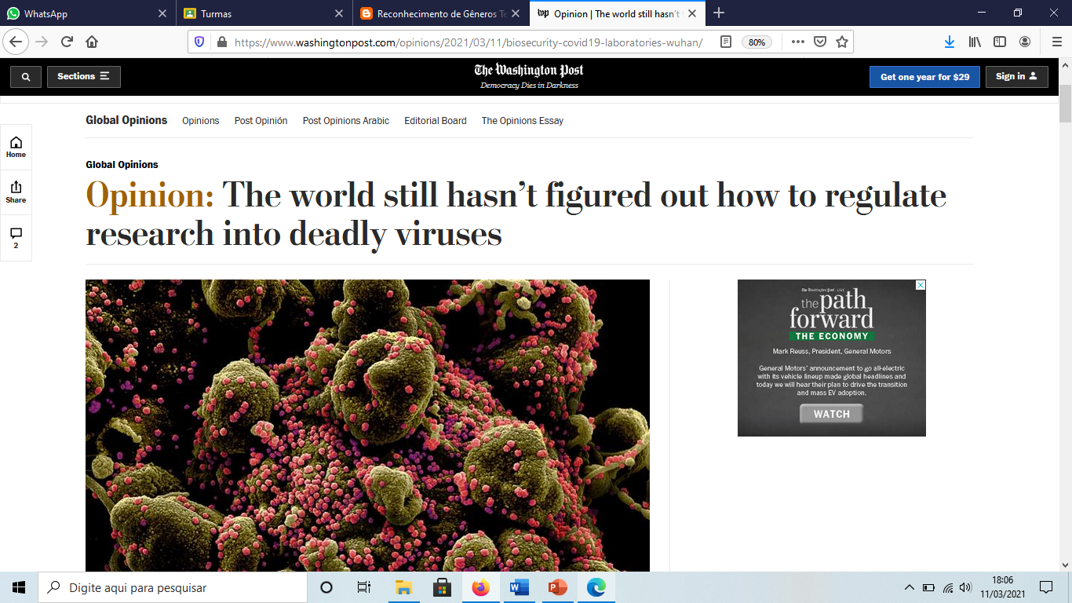

by
Brian Klaas
Global Opinions contributor
March 11, 2021 at 11:30 a.m. GMT-3
A year ago this month, much of the world went into lockdown. This spring, the world is mostly coming out of lockdown. Vaccinations are increasing. Infections, hospitalizations and deaths are decreasing. But once the public health emergency subsides and our lives slowly return to normal, there’s an urgent question that needs to be addressed: How can we make sure this doesn’t happen again?
To answer that question, we must understand how this pandemic began. Yet the origin story of covid-19 remains a mystery. China’s official explanation (which is also endorsed by many scientists) is that the novel coronavirus likely made the leap from animals to humans. That might be precisely what happened. Pathogens known as zoonotic diseases commonly spread that way. […]
https://www.washingtonpost.com/opinions/2021/03/11/biosecurity-covid19-laboratories-wuhan/

6)

How I Used App in the Air to Navigate Covid-19 Travel
Estimated Reading Time: 5 minutes

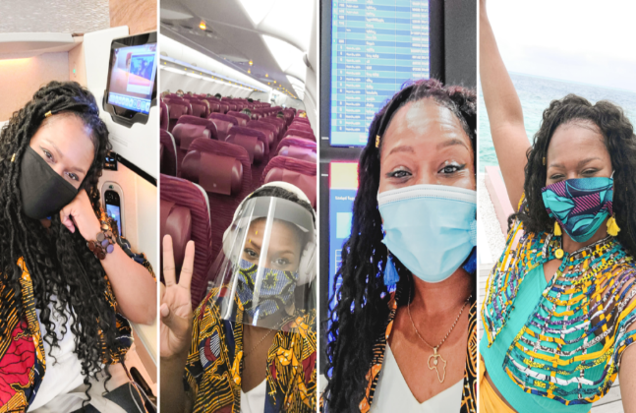
2020 is the year we couldn’t make up if we tried. But rather than lament at the restrictions, I’m learning to how to adapt and adjust.
The only thing constant in life is change, and after quarantining for 4 months straight in my apartment (leaving just 3x total), I was ready to see if a social-distanced trip was possible in the middle of the Indian Ocean.…
Read More
June 1, 2020 7 Comments 24646 views
http://theblogabroad.com/

07)
The Story of Sangkuriang and Tangkuban Perahu Mountain
Once, there was a kingdom in Priangan Land. Lived a happy family. They were a father in form of dog, his name is Tumang, a mother which was called is Dayang Sumbi, and a child which was called Sangkuriang. One day, Dayang Sumbi asked her son to go hunting with his lovely dog, Tumang. After hunting all day, Sangkuriang began desperate and worried because he hunted no deer. Then he thought to shot his own dog. Then he took the dog liver and carried home.
Soon Dayang Sumbi found out that it was not deer lever but Tumang's, his own dog. So, She was very angry and hit Sangkuriang's head. In that incident, Sangkuriang got wounded and scar then cast away from their home.
Years go bye, Sangkuriang had travel many places and finally arrived at a village. He met a beautiful woman and felt in love with her. When they were discussing their wedding plans, The woman looked at the wound in Sangkuriang's head. It matched to her son's wound who had left several years earlier. Soon she realized that she felt in love with her own son.
She couldn't marry him but how to say it. Then, she found the way. She needed a lake and a boat for celebrating their wedding day. Sangkuriang had to make them in one night. He built a lake. With a dawn just moment away and the boat was almost complete. Dayang Sumbi had to stop it. Then, she lit up the eastern horizon with flashes of light. It made the cock crowed for a new day.
Sangkuriang failed to marry her. She was very angry and kicked the boat. It felt over and became the mountain of Tangkuban Perahu Bandung.
http://understandingtext.blogspot.com/2020/08/10-examples-of-narrative-text-in-legend.html
08)
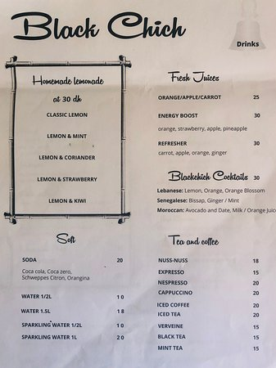
09)

Definition
The term “autism” refers to a cluster of conditions appearing early in childhood. All involve severe impairments in social interaction, communication, and patterns of rigid, repetitive behaviors. To be considered a manifestation of an autistic disorder, some of these impairments must be exhibited before the age of three.
The reference book used by mental health professionals to diagnose mental disorders is the Diagnostic and Statistical Manual of Mental Disorders, also known as the DSM. The 2000 edition of this reference book (the Fourth Edition Text Revision known as DSM-IV-TR) places autism in a category called pervasive developmental disorders. All of these disorders are characterized by ongoing problems with mutual social interaction and communication, or the presence of stereotyped, repetitive behaviors and unusual interests, and activities. People diagnosed with these disorders are affected in many ways for their entire lives.
https://www.encyclopedia.com/medicine/diseases-and-conditions/pathology/autism

10)

Oven-Roasted Asparagus
Rating: 4.79 stars 3,066 Ratings 1,922 Reviews 328 Photos
Salty and savory, the roasting method kills the natural bitterness of asparagus. Try it next to grilled fish or lamb.
By swedishmilk
Original recipe yields 4 servings
Ingredient Checklist
- 1 bunch thin asparagus spears, trimmed
- 3 tablespoons olive oil
- 1 ½ tablespoons grated Parmesan cheese (Optional)
- 1 clove garlic, minced (Optional)
- 1 teaspoon sea salt
- ½ teaspoon ground black pepper
- 1 tablespoon lemon juice (Optional)

Directions
Step 1
Preheat an oven to 425 degrees F (220 degrees C).
Step 2
Place the asparagus into a mixing bowl, and drizzle with the olive oil. Toss to coat the spears, then sprinkle with Parmesan cheese, garlic, salt, and pepper. Arrange the asparagus onto a baking sheet in a single layer.
Step 3
Bake in the preheated oven until just tender, 12 to 15 minutes depending on thickness. Sprinkle with lemon juice just before serving.
https://www.allrecipes.com/recipe/214931/oven-roasted-asparagus/

11)
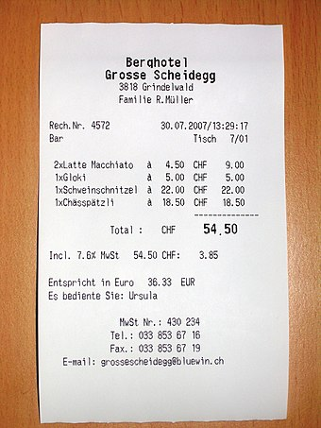
12)
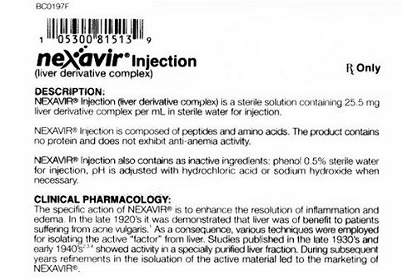

13)
Parte superior do formulário

Facebook’s news blockade in Australia shows how tech giants are swallowing the web
February 25, 2021 8.28am EST

Author
Jennifer Grygiel
Assistant Professor of Communications (Social Media) & Magazine, News and Digital Journalism, Syracuse University

Disclosure statement
Jennifer Grygiel owns a small number of shares in the following social media companies: Facebook, Google, Twitter, Alibaba, LinkedIn, YY, Snap, Amazon, and Netflix. Grygiel also owns nominal amounts of the following cryptocurrencies: Bitcoin, Litecoin and Ethereum.
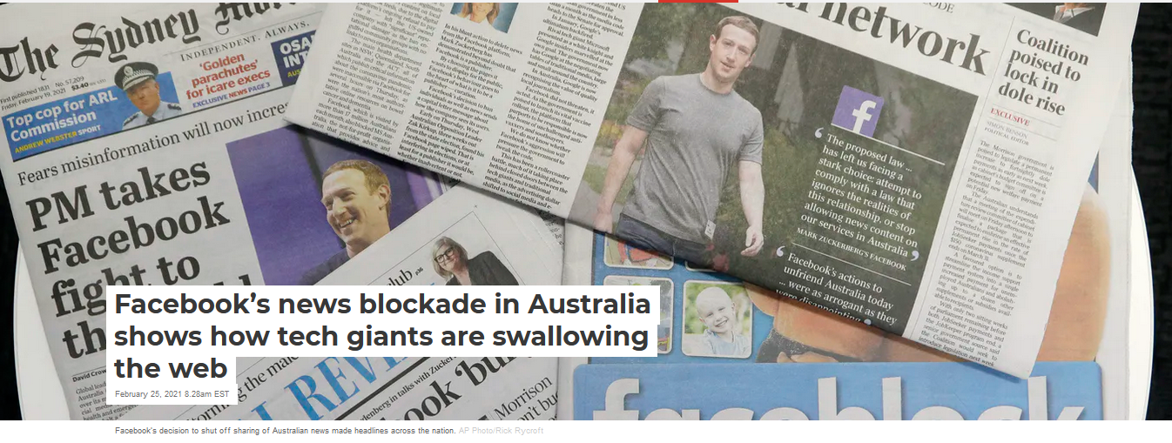
When Facebook disabled Australians’ access to news articles on its platform, and blocked sharing of articles from Australian news organizations, the company moved a step closer to killing the World Wide Web – the hyperlink-based system of freely connecting online sites created in 1989 by Sir Tim Berners-Lee.
Though the social media giant has said it will return to the negotiating table and restore news for now, the company has shown its hand – and how it is continuing to reshape the web.
As a social media scholar, I see clearly that the internet in 2021 is not the same open public sphere that Berners-Lee envisioned. Rather, it is a constellation of powerful corporate platforms that have come to dominate how people use the internet, what information they get and who is able to profit from it. […]
https://theconversation.com/facebooks-news-blockade-in-australia-shows-how-tech-giants-are-swallowing-the-web-155832

14)

Pope Francis (1936–)
Updated: Oct 22, 2020
Original: Apr 12, 2018
Jorge Mario Bergoglio was elected the 266th pope of the Roman Catholic Church in March 2013, becoming Pope Francis. He is the first pope from the Americas.

Who Is Pope Francis?
Jorge Mario Bergoglio became Pope Francis on March 13, 2013, when he was named the 266th pope of the Roman Catholic Church. Bergoglio, the first pope from the Americas, took his papal title after St. Francis of Assisi of Italy. Prior to his election as pope, Bergoglio served as archbishop of Buenos Aires from 1998 to 2013 (succeeding Antonio Quarracino), as cardinal of the Roman Catholic Church of Argentina from 2001 to 2013, and as president of the Bishops' Conference of Argentina from 2005 to 2011. Named Person of the Year by Time magazine in 2013, Pope Francis has embarked on a tenure characterized by humility and outspoken support of the world's poor and marginalized people and has been involved actively in areas of political diplomacy and environmental advocacy.

Early Life and Education
Bergoglio was born in Buenos Aires, Argentina, on December 17, 1936, to Italian immigrants. As a young man, Bergoglio underwent surgery to remove part of one of his lungs due to a serious infection. He graduated from a technical school as a chemical technician before beginning training at the Diocesan Seminary of Villa Devoto. In March 1958, he entered the novitiate of the Society of Jesus.
[…]
https://www.biography.com/religious-figure/pope-francis

15)
https://manual-user-guide.com/samsung-galaxy-a11-manual

Separe os textos do 1 ao 15 nos tipos de textos dispostos na tabela abaixo:
Obs: coloque os números dos textos abaixo do tipo.

The essay-argumentative text | The descriptive text | The narrative | Expository Text | Instructional Text

Escolha dois textos e responda abaixo:

  - Assunto principal (em português):
  - Palavras cognatas (basta em inglês):
  - Falsos cognatos (todos) (colocar em inglês e em português):
  - Palavra-chave (colocar em inglês e em português):
  - Palavras novas (colocar em inglês e em português):

Identifique nos abstracts abaixo:

ABSTRACT
Many have argued that interactive 3D virtual environments have great educational potential due to their ability to engage learners in the exploration, construction and manipulation of virtual objects, structures and metaphorical representations of ideas. Although learning benefits have been demonstrated in research settings, and substantial usage has occurred in workplace training contexts, there are few published evaluations of applications of such environments within university contexts. This article reports on studies exploring the effectiveness of a virtual environment based on a chemistry laboratory as a tool to prepare university chemistry students studying at a distance for their on-campus residential schools, in response to evidence suggesting that many of these students experienced a lack of confidence and a sense of anxiety approaching these sessions. In an experimental study it was found that the environment was able to be effective as a tool for familiarising students with the laboratory. However, when the resource was provided to distance students, less than half of the students chose to use it, possibly due to the fact that use of the resource was not required for the assessment in the subject. Questionnaire and interview data suggested that most of those who used the resource found that it was a valuable preparatory tool and would recommend its further use. For many students, however, a lack of familiarity with the laboratory was not seen as the major source of their anxiety and therefore a resource allowing them to become familiar with the laboratory did not have a major impact on their learning experience. Given that the ability to apply mathematical techniques and chemistry concepts within the practical sessions emerged as a major source of students’ anxiety, it is suggested that the incorporation of instruction or scaffolding for these aspects of the task can be provided, and would make a valuable enhancement to the virtual environment.
https://www.sciencedirect.com/science/article/abs/pii/S036013150900116X

Como resposta pinte da mesma cor do destaque as palavras abaixo:
( ) Background:
( ) Conclusion (implication):
( ) Methodology:
( ) Motivation:
( ) Objective:
( ) Problem:
( ) Result (product):
ABSTRACT
This article assesses the intention of chemistry teachers to integrate digital media in their classes. The evaluation was performed using a structured questionnaire after participation in two professional development actions. The formative sessions were designed with the aim of training the chemistry teachers for pedagogical integration of digital media in teaching chemistry in high school. The participants were 25 chemistry teachers from different regions of Brazil, who were participating in an international cooperation program for the professional development of teachers in Portugal. Data collection was conducted through questionnaires containing questions about the motivations for innovation in education, attitudes and beliefs in relation to the training actions and face the pedagogical integration of digital media in the chemistry discipline. The data analysis shows a remarkable behavioral intention of adopting the media which is positively correlated with the attitudes and perceptions of control and negatively with subjective norm. These results suggest that interventions focused on technical and pedagogical training centered on subject content are suitable for the professional development of teachers.
https://www.scielo.br/scielo.php?pid=S0100-40422017000100105&script=sci_arttext

Como resposta pinte da mesma cor do destaque as palavras abaixo:
( ) Background:
( ) Conclusion (implication):
( ) Methodology:
( ) Motivation:
( ) Objective:
( ) Problem:
( ) Result (product):

