The History of the Olympic Games

Origin of the Olympic Games
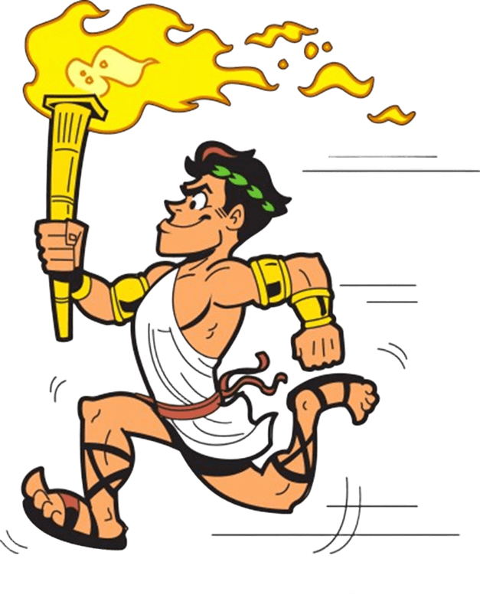
Once every four years, men from all over Greece came to compete in a great athletic festival in Elis, in western Greece (_____________ were not allowed to compete). This was called the Olympic games because the place was called Olympia. It was a religious festival to honor the Greek gods Zeus and Hera;
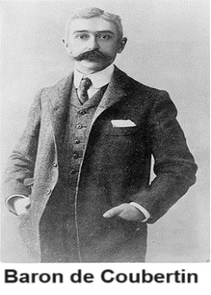
The Olympic games began in Olympia in 776 B.C. They took place from time to time until 393 B.C. then they stopped.
The Olympic Games are an international multisport event, occurring every four years, organized by the International Olympic Committee.
In these games we can observe thousands of athletes participate in a variety of competitions.
In 1894 a Frenchman, Baron de Coubertin, started modern Olympic games.
The Modern Olympic games took place in Athens in Greece.
Nearly all the Nations in the world take part in these games.

Olympic Flag
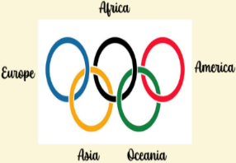
The design of the flag had been received by the French educator Pierre, Baron de Coubertin. ______________,______________, ______________,______________,______________, (represent all nations) and White background for peace. The rings are interlaced representing unity and meeting of athletes from all parts of the world.

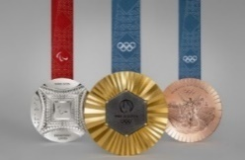
Some Olympic Symbols
Winer´s Medals:
Medals are awarded in each event, with _______________ medals for first place, _______________ for second and _______________ for third, a tradition that started in 1904.

Olympic Flame:
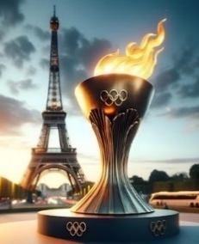
Months before each Games, the Olympic flame is _______________ in Olympia in a ceremony that reflects ancient Greek rituals.
At the beginning of Olympic games someone lights a torch.
The runners carry the Olympic flame to the _______________ where are the games are taking place.
“The Olympic flame” _______________ throughout the duration of the Olympic games.
The Olympic flame is _______________ when the games come to close.

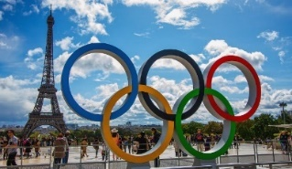
Olympics Paris 2024
The Olympic Games program in 2024 consisted of 32 different categories of sports.
Around 10,500 athletes marched in the Parade of Nations.
The athletes who won the matches, fights and competitions received _______________, _______________ and _______________ medals.
The competition lasted 16 days.
TEAM SPORTS:
 |  | 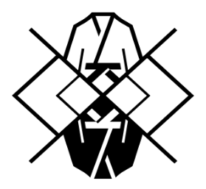 |  |  | 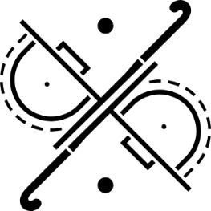
 | 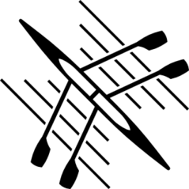 | 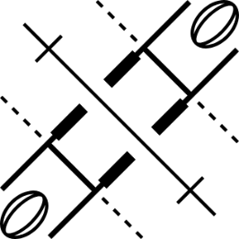 |  | 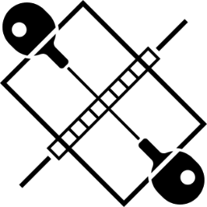 | 
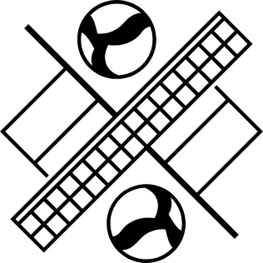 | 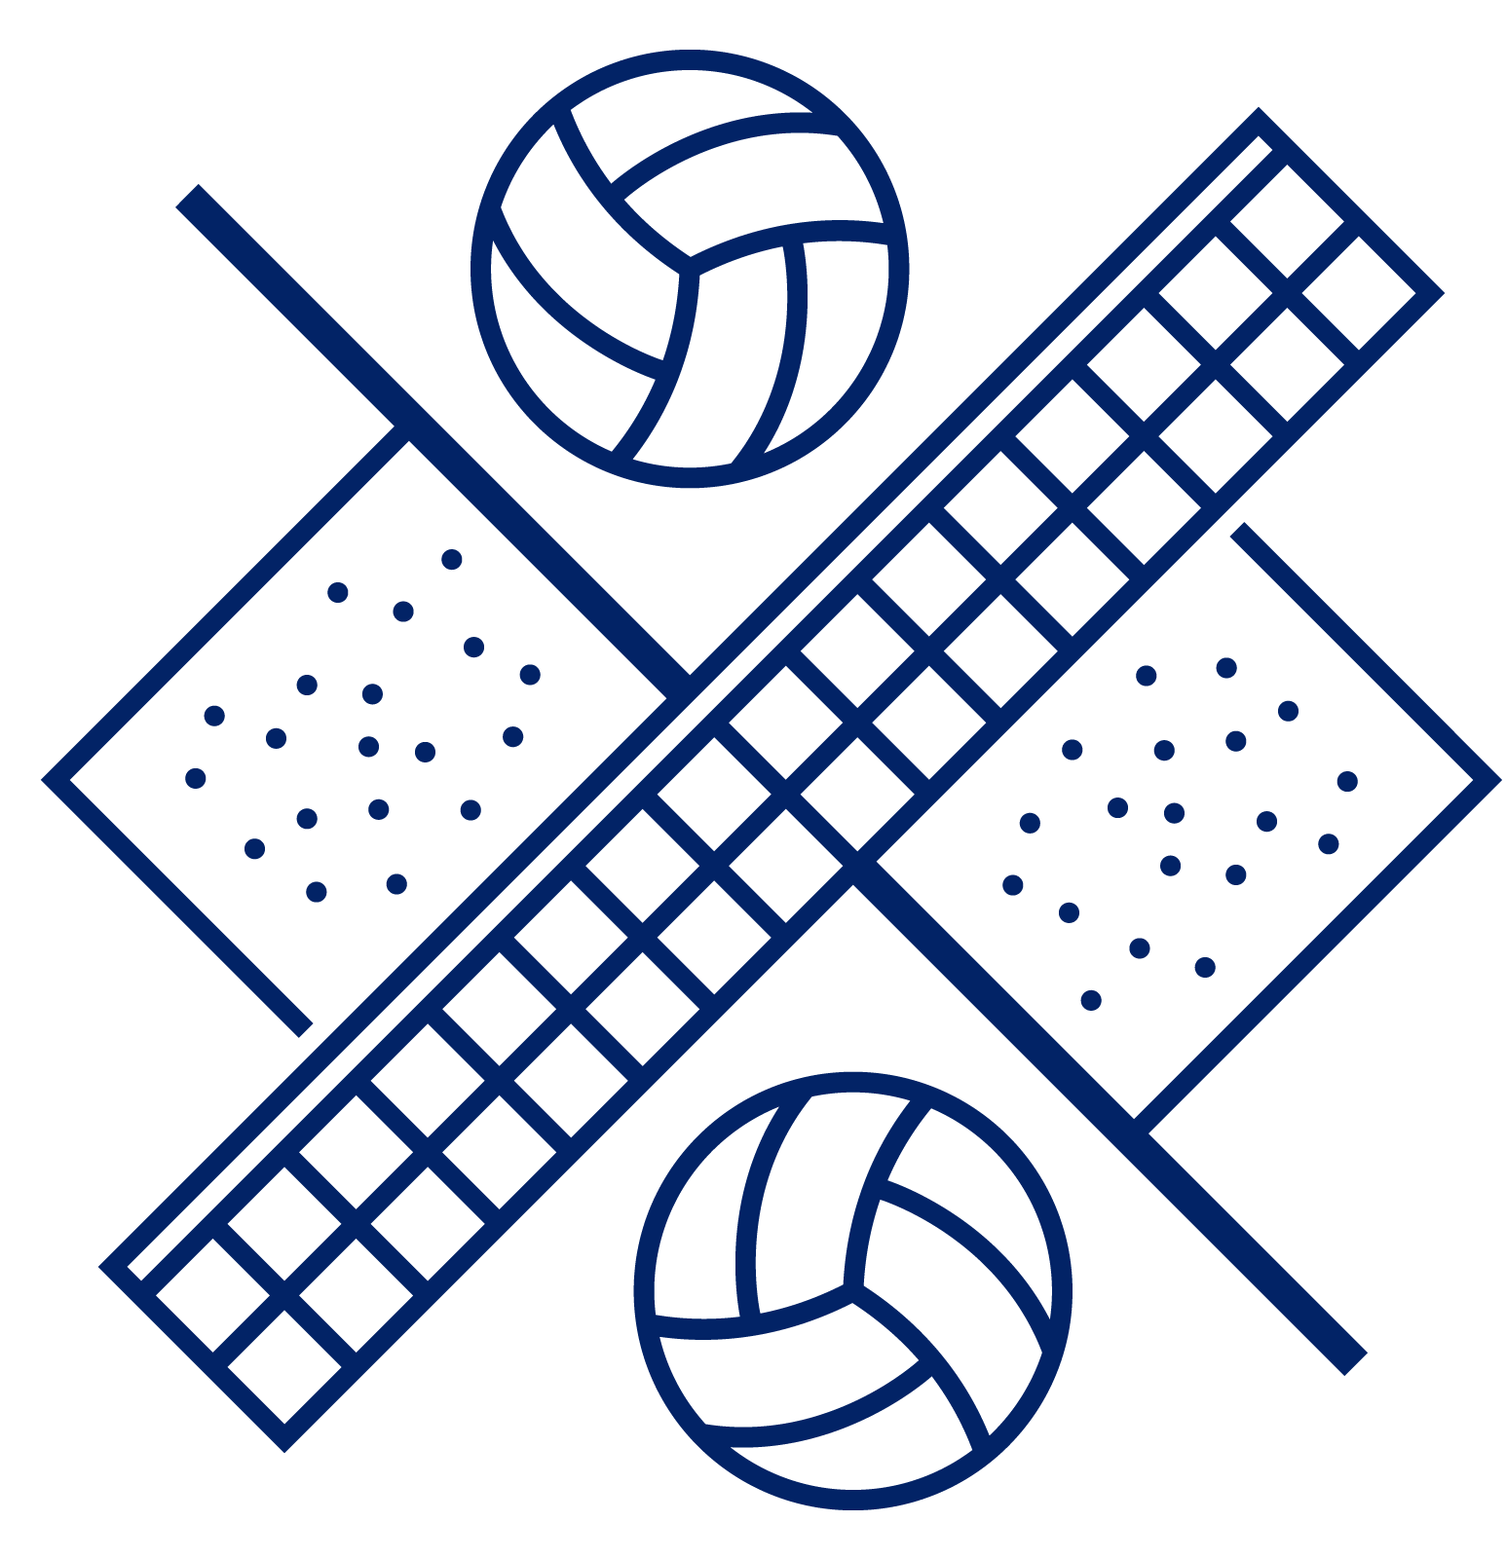 | 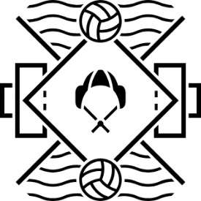

COMBAT SPORTS:
 | 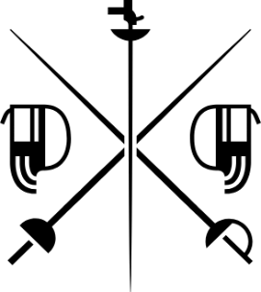 |  | 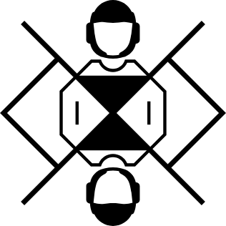 | 

WATER SPORTS:
 | 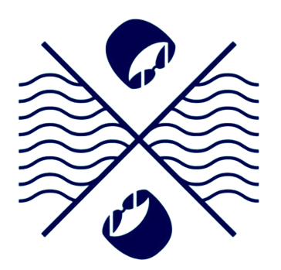 | 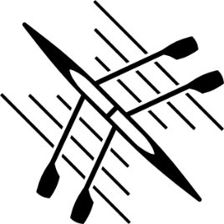 |  | 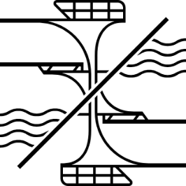
 | 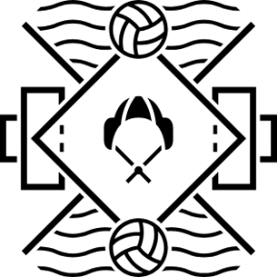 |  | 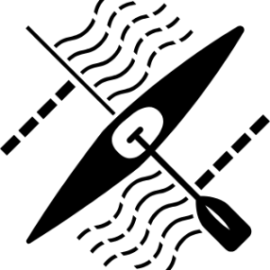

INDIVIDUAL SPORTS:
 |  | 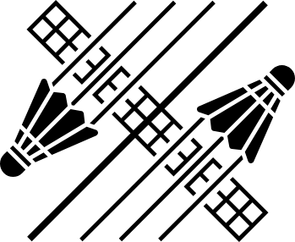 |  | 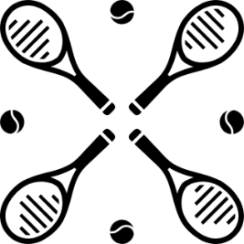
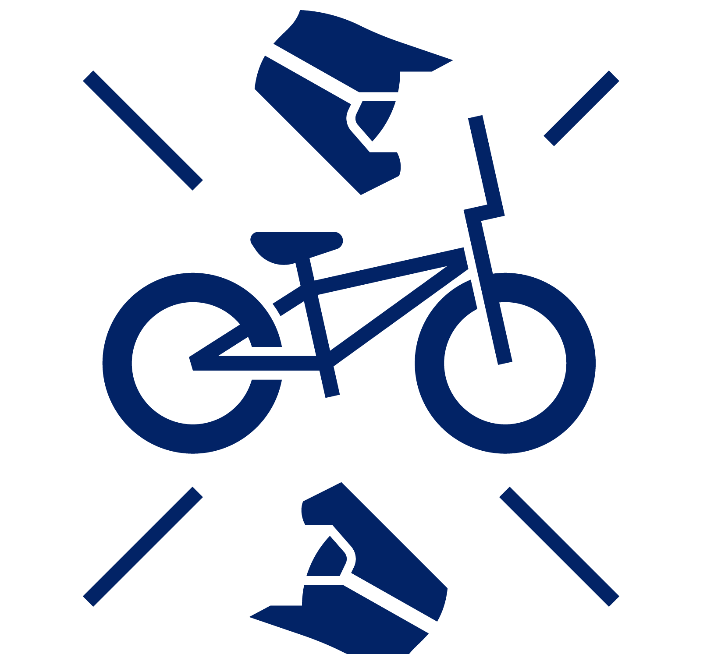 | 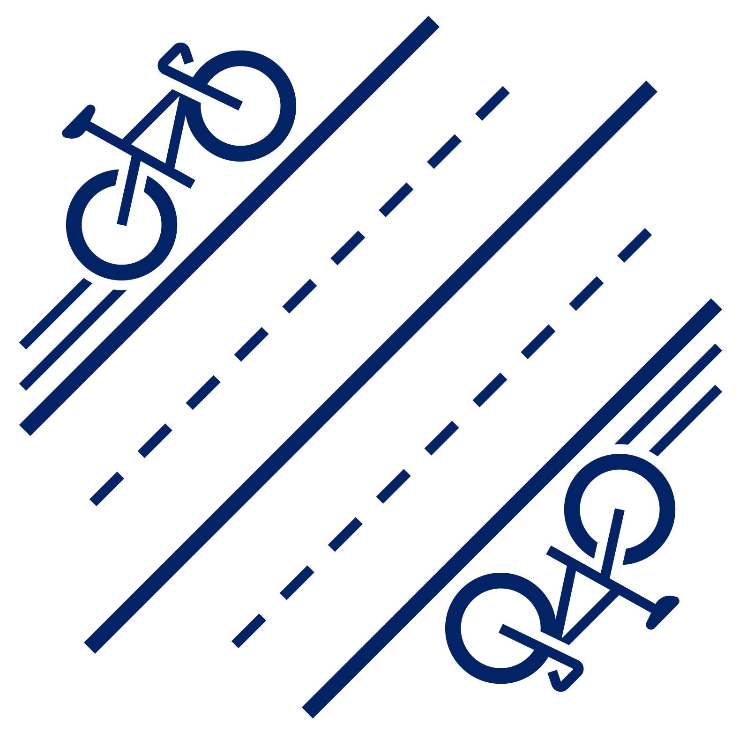 |  | 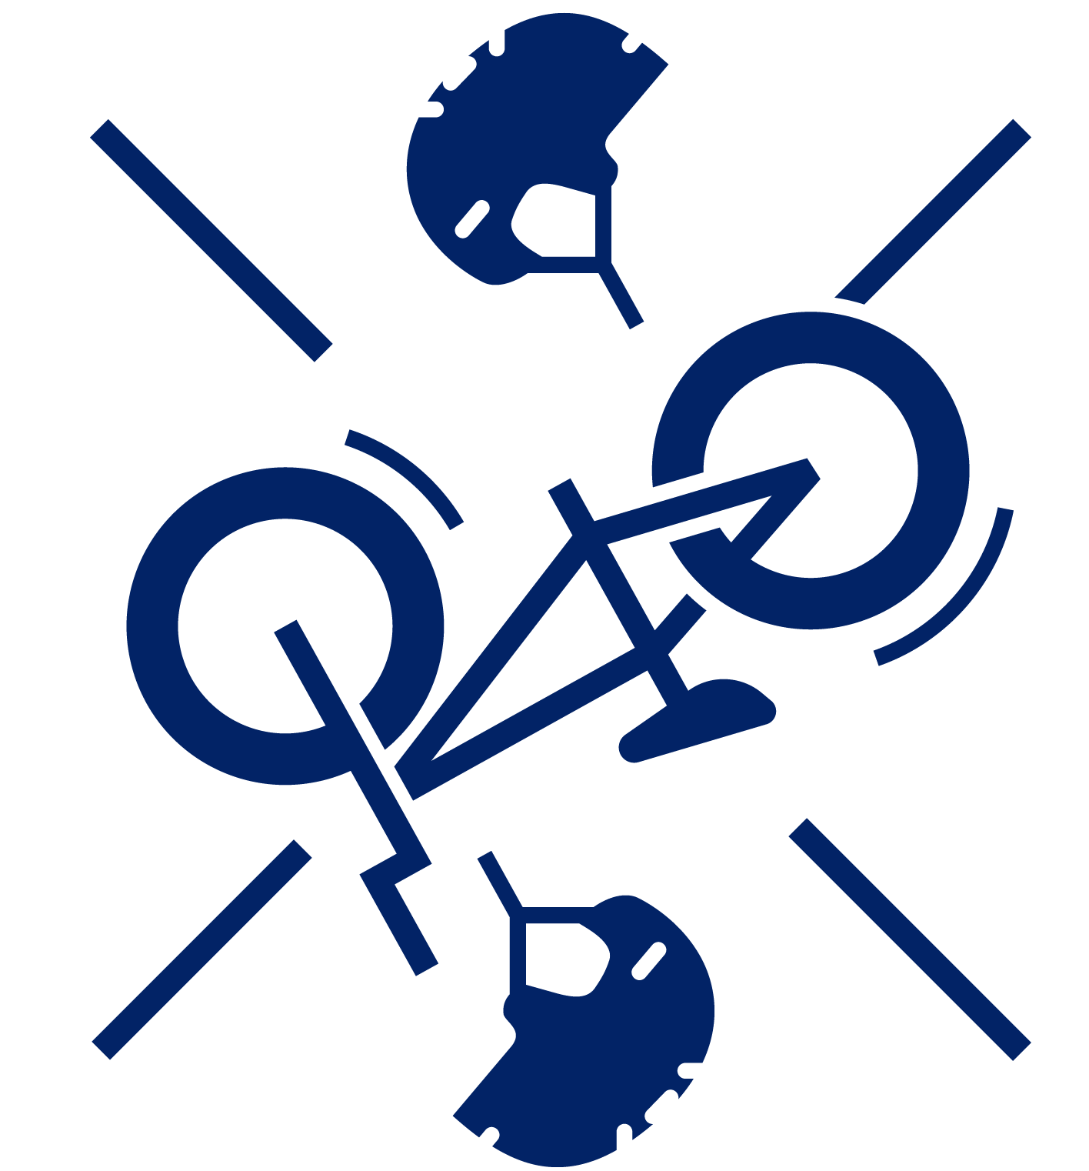 | 
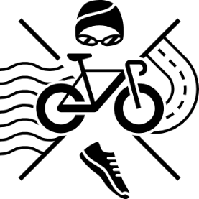 | 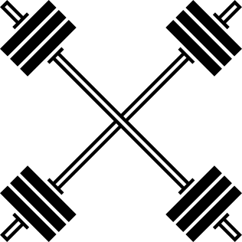 |  | 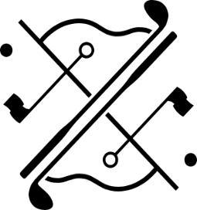 | 

INDIVIDUAL SPORTS:
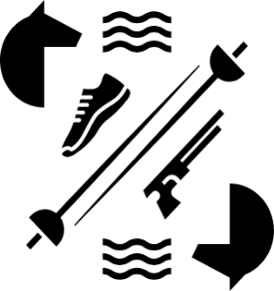 | 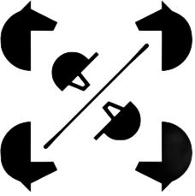 | 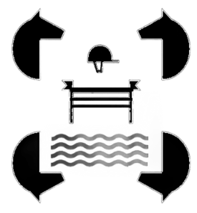 | 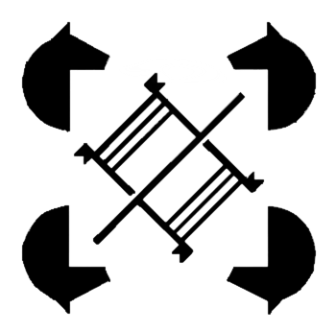

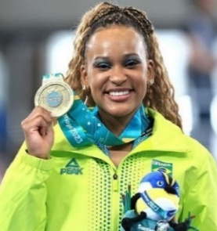
Women in Olympics
- The game is changing. For the first time in history, the Paris 2024 Olympic and Paralympic Games saw an equal number of _______________ and _______________ competing. This 50:50 representation of athletes makes the Summer Games the first to reach gender equality.
- The 1896 Summer Olympics were the first international Olympic Games held in Athens, Greece. No _______________ participated.
Women in the Olympics

Women competed for the first time at the 1900 Games in Paris. Of a total of 997 athletes, 22 women competed in five sports: tennis, sailing, croquet, equestrianism and golf.

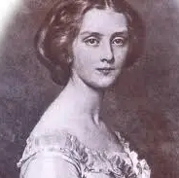
Hélène de Pourtalès was the first woman to compete at the Olympics. She was a Swiss sailor on the boat Lérina, which won the gold medal in the first race of the 1-2 ton class (which was part of the Olympic program) and silver medal in the second race of 1-2 ton class (part of the Expo program). Hélène was 32 at the time of the Olympics. Her husband Hermann and her husband's nephew Bernard were also crew members on the Lérina.
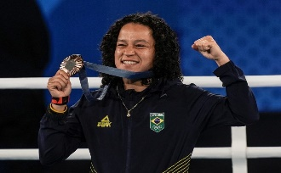
With the addition of women’s boxing to the Olympic programme, the 2012 Games in London were the first in which _______________ competed in all the sports on the programme. Since 1991, any new sport seeking to join the Olympic programme must have _______________’s competitions.
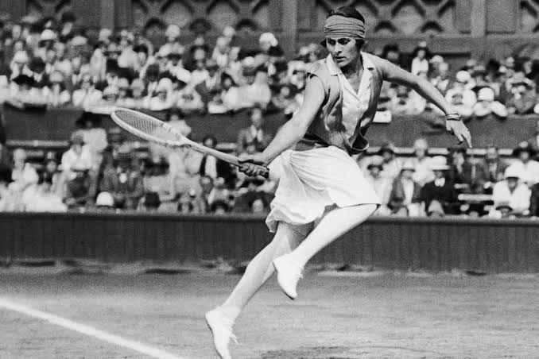
The first female Olympic Games gold medalist is commonly listed as England's Charlotte Cooper, who won the tennis singles event on July 11th, 1900. However, Hélène de Pourtalès won the gold medal prior to Cooper on May 22nd.
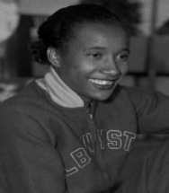
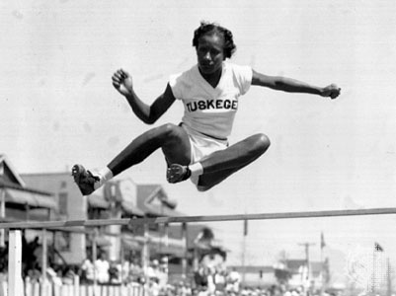
Alice Coachman was the first _______________ woman from any country to win an Olympic gold medal. Growing up in the segregated South, she overcame discrimination and unequal access to inspire generations of other _______________ athletes. She was born in 1923, in Albany, Georgia.
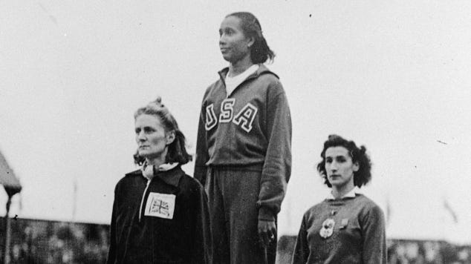
In 1948, Coachman competed for her Olympic gold in the high jump. She became the Gold Medalist when she cleared the 5 feet 6 1/8-inch bar on her first attempt. It was a new Olympic record. With this medal, Coachman became also the only American woman to win a gold medal at the 1948 Olympic Games.
Black people in the Olympics
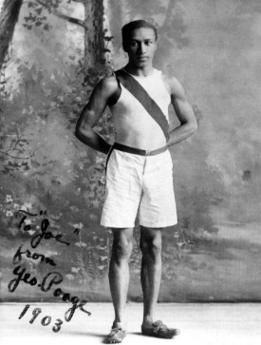
On January 1st in 1904, the first Black Olympic medal winner was crowned. George Coleman Poage won a bronze medal. With less than 12 nations there, they celebrated the centennial of the Louisiana Purchase and the World's Fair that same year amid an undercurrent of racial uneasiness. Black and _______________ exhibits were mounted separately, and "colored" areas were apart from the others. Many wanted Black athletes to boycott both the fair and the games, but Poage elected to participate. With less than 500 athletes participating in the games, Poage ran and won bronze medals for finishing third in the 200-meter and 400-meter hurdles that day.
The first Black Woman in Gymnastics
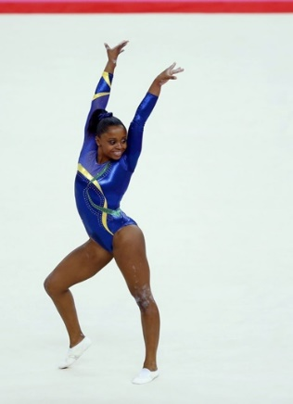
Daiane dos Santos can’t match Biles medal for medal, but her accomplishments are nothing to sneeze at. During her career, Daiane racked up 16 medals, 7 of which were gold. She also holds the distinction of being not only the first black gymnast to win an event at the World Championships but also the first Brazilian and South American to win the competition. In a recent interview, Daiane spoke about her experiences with _______________ while she was a member of Brazil’s national team. In one example, she remembers that some people even refused to use the same bathroom as her.

Olympics Curiosities
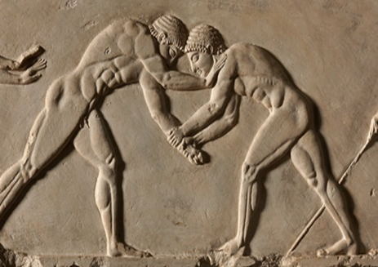 | 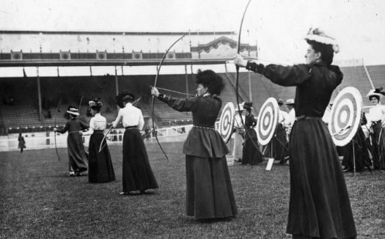
In ancient Greece, athletes competed _______________; The games lasted five or six months. | Women have been allowed to compete in the Olympics since _______________.
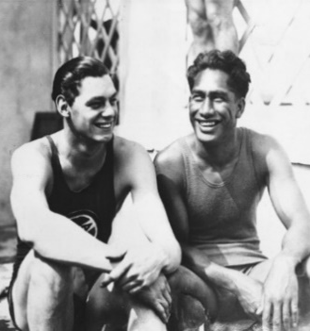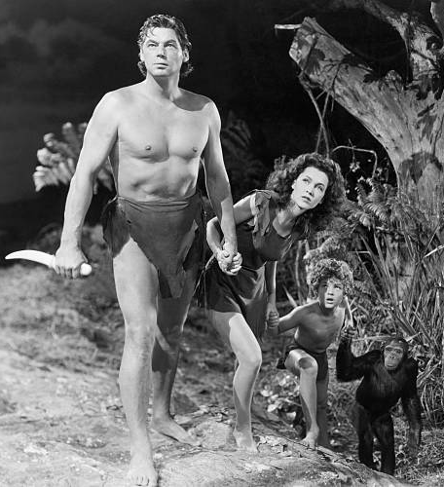 | Tarzan competed in the Olympics: Johnny Weissmuller, an athlete-turned-actor who played Tarzan in 12 movies, won five gold medals in swimming in the 1920s.
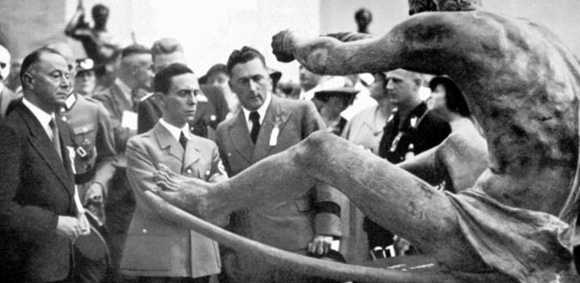 | Reich Minister for Propaganda Joseph Goebbels, second from left, visits the Olympic Art Exhibition at the Berlin Games in 1936 (Wilhelm Limpert).  From 1912-1948, artists participated in the Olympics: _______________, _______________, _______________, _______________, and _______________ competed for medals in their respective fields.

Olympics Mascot
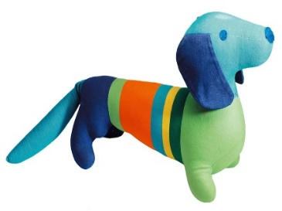
Waldi was the first official _______________ in the history of the Olympic Summer Games. It was presented at the Olympics in 1972. He is a dachshund, a very popular animal in Bavaria, famed for its endurance, tenacity and agility. The mascot features several different colours: its head and tail are light _______________, with a striped body featuring at least three of the six Olympic _______________.
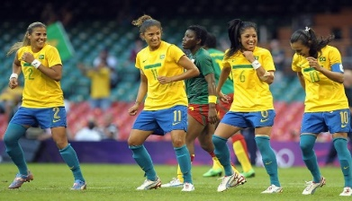
Olympics Countries
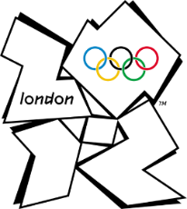
The 2012 London Games _______________ the first Olympics in which all participating countries sent _______________ athletes.
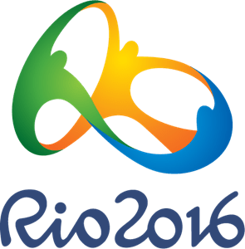
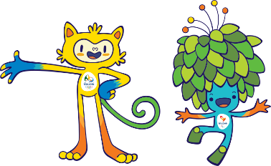
The 2016 Games in Rio marked the first time the Olympics were held in _______________ America.

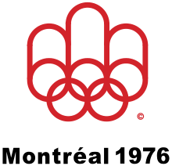
Olympics Boycotts
The 1976 Montreal Games were marred by an African boycott involving 22 countries. The boycott was _______________ by Tanzania to protest the fact that the New Zealand rugby team had toured Apartheid South Africa, and that New Zealand was scheduled to _______________ in the Olympic Games.
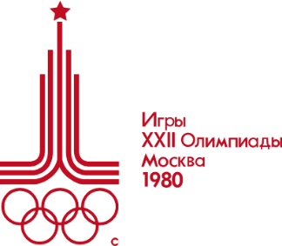
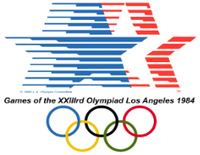
The Soviet Union’s invasion of Afghanistan in December 1979 led to the largest boycott in the history of the Olympic movement. The boycott of the 1980 Olympics was made by approximately 60 _______________ that joined the United States. Stayed out of the boycott Great Britain, France, Italy, and Sweden. In all, about 5,000 athletes representing 81 countries attended the Games.
Although a revenge _______________ of 16 countries led by the Soviet Union depleted the field in certain sports, in 1984 140 National Olympic Committees took part in Los Angeles Games, which was a record at the time.
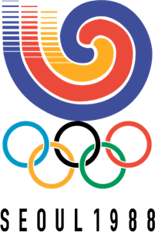
Violent student riots took place in Seoul in the months leading up to the Games in 1988. North Korea, still technically at war with South Korea, complained bitterly that it should have cohost status. The International Olympic Committee (IOC) made some concessions to North Korea, but it did not find them satisfactory and _______________; several other countries, notably Cuba and Ethiopia, stayed away from Seoul in solidarity. […] Nearly 8,500 athletes from 159 countries participated.
Olympics Tragedy
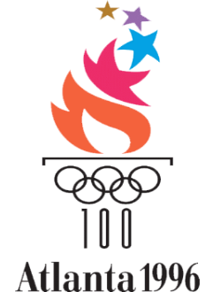
The 1996 Games were given a dramatic and emotional start when the cauldron was lit by sporting legend Muhammad Ali. Next to the site of the main competition venues was an open area known as the Centennial Olympic Park with no security system. In the early hours of 27 July, tragedy struck when a terrorist bomb _______________ in the Centennial Olympic Park, resulting in the _______________ of two people and the injury of 110 more. […] For the first time in Olympic history, all 197 recognised National Olympic Committees were _______________ at the Games.

Olympics Epidemies
The buildup to the Rio Games was beset by more problems than any other recent Olympiad. Rio Olympics were plagued by massive cost overruns and construction that ran far behind schedule. Athletes, coaches, and tourists were wary of traveling to the crime-riddled city, where, in addition, an outbreak of the _______________ virus led to the withdrawal of a number of prominent athletes.
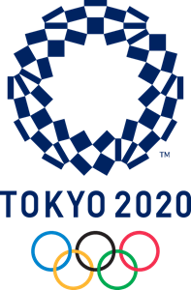
Tokyo 2020 Olympic Games took place in 2021. Scheduled for 2020, the Summer Games were postponed until the next year because of the _______________ pandemic, becoming the first Olympics ever held after the proposed start date. They were still referred to as the 2020 Games for marketing purposes and to keep with Olympic naming tradition. The pandemic also prompted the Japanese Olympic Committee to bar spectators from the sporting venues, making the competition the only Olympics ever held without official _______________.

Olympics Diversity
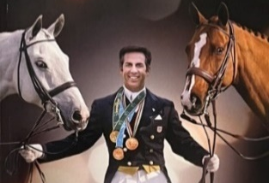  At Seoul Olympic Games in 1988, equestrian American athlete Robert Dover became the first openly gay athlete to _______________ at a modern Olympic Games. | 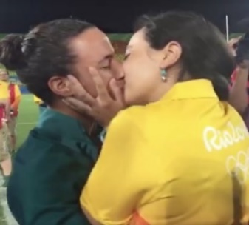  A history-making gay marriage proposal occurred at the Rio Olympics in 2016 when a _______________ couple got engaged at the games. BBC reports Marjorie Enya, 28, a volunteer manager at Rio’s Deodoro Stadium, popped the question to Brazilian women’s rugby sevens player Isadora Cerullo, 25, following the first-ever women’s rugby sevens finals.
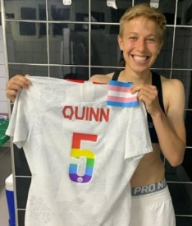  It was at those Tokyo Games in 2021 that the Canadian women’s football team captured gold in the sport, while also marking an historic _______________ in the queer space: Canadian midfielder Quinn became not only the first openly non-binary and transgender athlete to win an Olympic gold – but an Olympic medal of any colour. Transgender athletes were allowed to participate in the games since 2004. |  | 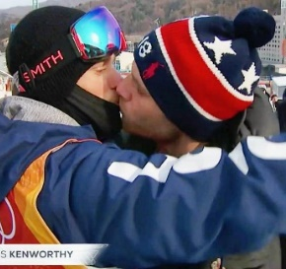  Gay freestyle skier Gus Kenworthy said it was a moment that he "never believed" possible as a child after he was filmed _______________ his partner on live television. Without his knowledge, American broadcaster NBC had been _______________ him live as he spoke to family and _______________ his boyfriend before heading up to the start at the 2018 Winter Olympic Games in PyeongChang, South Korea.
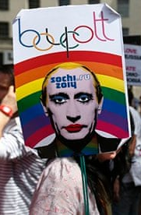
President Vladimir Putin signed a law at the end of June 2013 prohibiting the promotion of nontraditional sexual relationships to minors. It has been interpreted as banning _______________ pride parades — children might see them — and preventing any discussion of homosexuality among teenagers. The law has made _______________ athletes and spectators fearful of discrimination, and even _______________, at the Winter Olympic Games in 2014. And Thursday, as the International Olympic Committee coordinating commission made its last inspection tour of Sochi before the opening ceremony Feb. 7, its members added fuel to this particular flame. Russia, they said, was not violating Olympic anti-discrimination principles.
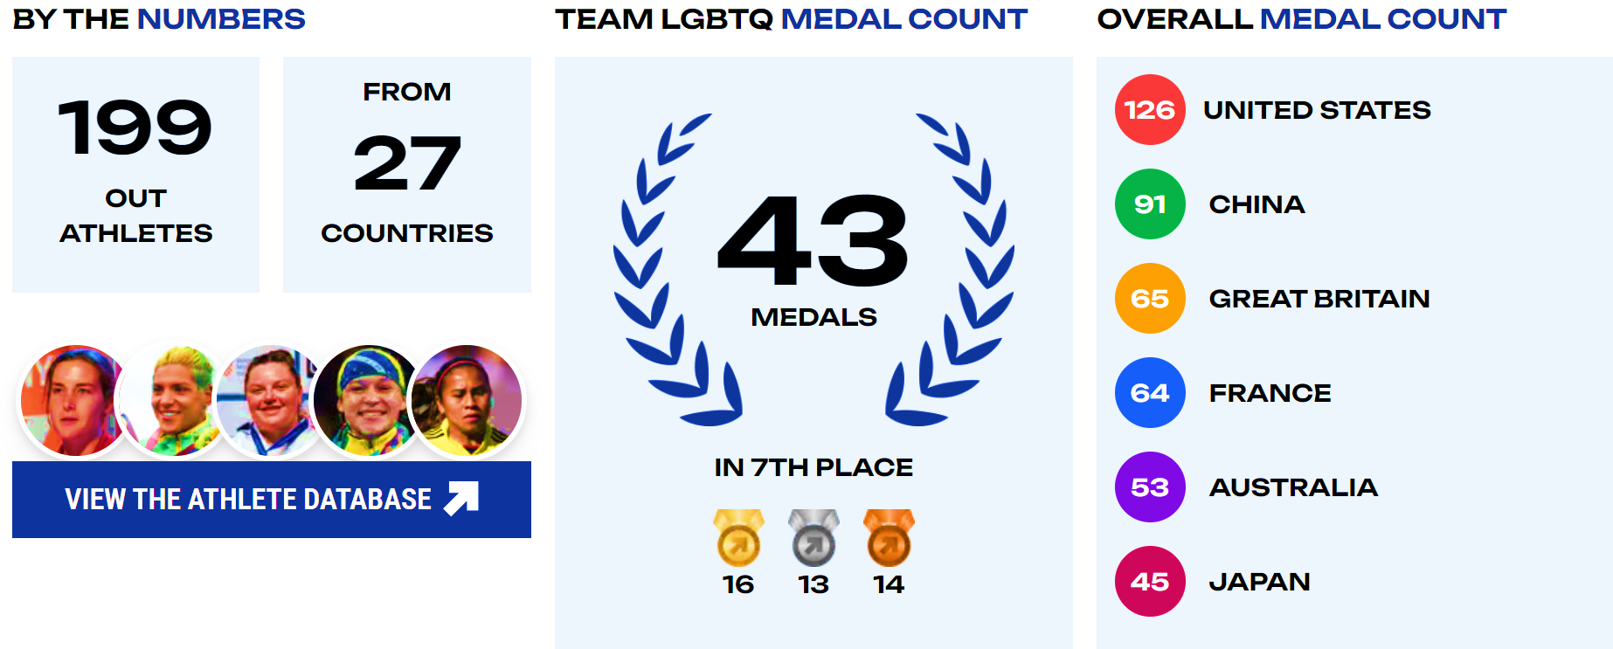
The number of openly LGBTQ+ Olympians has skyrocketed in recent decades. Jim Buzinski, co-founder of Outsports, said when they started tracking athletes at the Sydney Olympics in 2000, they counted only around five who were openly LGBTQ+. “More and more people are coming out,” Buzinski said. “They realize it’s important to be _______________ because there’s no other way to get representation.” At least 199 out _______________ athletes were in Paris for the 2024 Summer Games, according to the LGBTQ sports site OutSports.

Olympics openly LGBT athletes
OLYMPIAN LGBTQIAPN+ ATHLETES TIMELINE
 | 1912 | 1928 | 1932 | 1936 | 1948 | 1952 | 1956 | 1960 | 1964 | 1968 | 1972 | 1976
Man | 1 | 1 | 1 | 0 | 1 | 0 | 1 | 2 | 1 | 4 | 3 | 4
Woman | 0 | 2 | 2 | 1 | 0 | 1 | 2 | 0 | 2 | 4 | 2 | 7
Transgender | 0 | 0 | 0 | 0 | 0 | 0 | 0 | 0 | 0 | 0 | 1 | 1
Intersex (non-binary, others) | 0 | 1 | 1 | 2 | 0 | 0 | 1 | 0 | 0 | 0 | 0 | 0
 | 1980 | 1984 | 1988 | 1992 | 1996 | 2000 | 2004 | 2008 | 2012 | 2016 | 2020 | 2024
Man | 3 | 5 | 10 | 12 | 18 | 25 | 20 | 13 | 18 | 22
Woman | 2 | 8 | 12 | 11 | 38 | 41 | 40 | 64 | 75 | 97
Transgender | 0 | 1 | 0 | 1 | 1 | 2 | 0 | 0 | 1 | 1
Intersex (non-binary, others) | 1 | 0 | 0 | 0 | 1 | 1 | 1 | 2 | 0 | 1

Gay Games
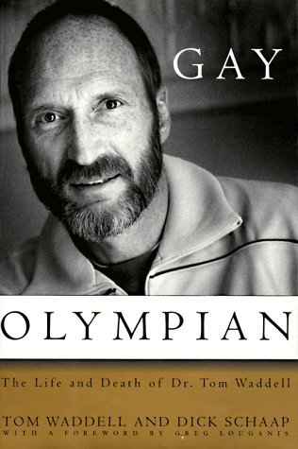
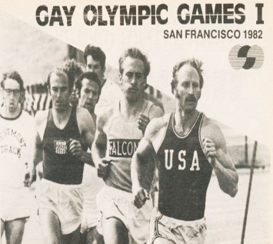
Tom Waddell is the founder of the _______________ Games. He was born in 1937 in Paterson, New Jersey to a Catholic family. He tried to suppress being gay and threw himself into sports. He excelled in athletics as a means to compensate it. In 1968 Olympics in Mexico City, Waddell placed sixth among the 33 competitors. He broke five of his own personal records in the ten events. Many years after his Olympic days […] Waddell joined a gay bowling team which inspired him to create a gay sports event based on the Olympics.
He traveled around the States campaigning for support to bring the ‘Gay Olympics’ into being. The first Gay Olympics was to take place in San Francisco in 1982 as a sports competition and arts festival, but the United States Olympic Committee (USOC) sued Waddell’s organization over its use of the word “_______________.” So, he had to change the name, and it became The ______________________________.
Gay Games Timeline
Logo | 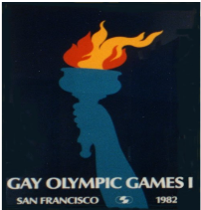 | 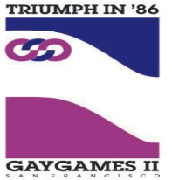 |  | 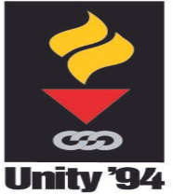
Theme | Challenge | Triumph | Celebration | Unity
City, State, Country | San Francisco (CA), USA. | San Francisco (CA), USA. | Vancouver (BC), Canada. | New York City (NY), USA.
Date | August 28th – September 5th, 1982. | August 10th – 17th, 1986. | August 4th – 11th, 1990. | June 18th – 25th, 1994.
Sports | 17 | 21 | 27 | 31
Participants | 1,350 | 3,500 | 8,800 | 12,500
Nations | 12 | 17 | 27 | 40
Logo | 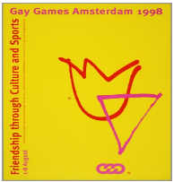 | 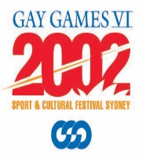 | 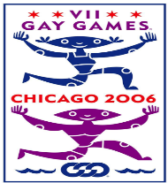 | 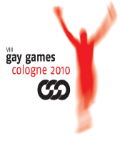
Theme | Friendship | Under New Skies | Where the World Meets | Be part of it
City, State, Country | Amsterdam, The Netherlands. | Sidney (NSW), Australia. | Chicago (IL), USA. | Cologne (NRW), Germany.
Date | August 1st – 8th, 1998. | November 2nd – 9th, 2002. | July 15th – 22nd, 2006. | July 31st – August 7th, 2010.
Sports | 33 | 33 | 30 | 35
Participants | 13,000 | 12,100 | 11,700 | 9,500
Nations | 68 | 70 | 70 | 70
Logo |  | 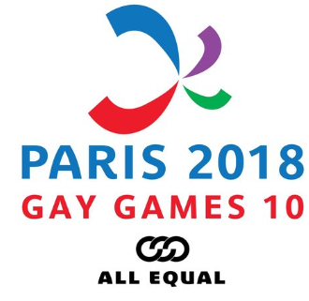 | 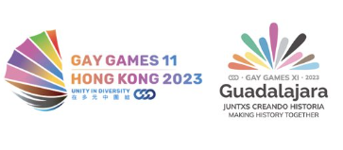 | 
Theme | #GoAllOut | All equal | Unity in Diversity (Hong Kong), Making History Together (Guadalajara) | --
City, State, Country | Cleveland + Akron, (Ohio) USA. | Paris, France. | Guadalajara, Mexico and Hong Kong, China. | Valencia, Spain.
Date | August 9th – 16th, 2014. | August 4th – 17th, 2018. | November 3rd – 11th, 2023. | June, 2026.
Sports | 37 | 36 | 55 (sports and cultural events) | --
Participants | 8,000 | 10,317 | 10,318 | --
Nations | 50 | 91 | 102 | --
Sources:

- https://aaregistry.org/story/first-black-wins-olympic-medal/
- https://blackbraziltoday.com/on-the-national-team-they-didnt-want-to-use-the-same-bathroom-as-me-gold-medal-winning-gymnast-daiane-dos-santos-recalls-incidents-of-racism-as-a-black-gymnast/
- https://olympics.com/en/olympic-games/montreal-1976
- https://olympics.com/en/olympic-games/munich-1972/mascot
- https://www.bbc.com/sport/olympics/sports-disciplines
- https://www.britannica.com/event/Moscow-1980-Olympic-Games
- https://www.britannica.com/event/Seoul-1988-Olympic-Games
- https://www.cbsnews.com/news/openly-gay-athletes-still-scarce-at-olympic-games/
- https://www.ef.com/wwen/blog/language/24-facts-about-the-olympics/
- https://www.gaygames.org/previous-editions
- https://www.gaygames.org/previous-editions
- https://www.nbcnews.com/nbc-out/nbc-out-proud/lgbtq-athletes-paris-olympics-rcna162518
- https://www.outsports.com/
- https://www.outsports.com/2021/7/12/22565574/tokyo-summer-olympics-lgbtq-gay-athletes-list/
- https://www.romeo.com/en/blog/history-of-the-gay-games/
- https://www.slideshare.net/slideshow/olympics-25775231/25775231
- https://www.smithsonianmag.com/history/brief-history-openly-gay-olympians-180968125/
- https://www.theatlantic.com/entertainment/archive/2012/07/remember-when-the-olympics-used-to-have-an-art-competition-no/260355/
- https://www.topendsports.com/events/summer/athletes/pourtales.htm
- https://www.washingtonblade.com/2016/08/11/olympics-get-first-sex-proposal/
- https://www.washingtonpost.com/world/russia-anti-gay-law-casts-a-shadow-over-sochis-2014-olympics/2013/09/29/3646344c-27a6-11e3-9372-92606241ae9c_story.html
- https://www.womenshistory.org/education-resources/biographies/alice-coachman#:~:text=Alice%20Coachman%20was%20the%20first,%2C%201923%20in%20Albany%2C%20Georgia.

