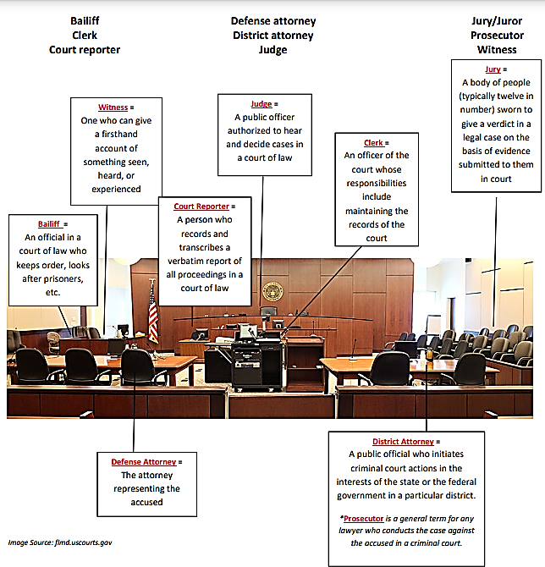
https://www.occourts.org/system/files/general/courtoom_vocabulary.pdf

TERMOS DO DICIONÁRIO JURÍDICO EM INGLÊS

- Abuse of discretion = Abuso de poder
- Abuse of privilege = Abuso de privilégio
- According to law; at law = De acordo com a lei
- Accused = Acusado
- Adulteration = Adulteração
- Agreement, contract = Acordo, contrato, convênio
- Attorney/lawyer/solicitor/legal counsel = Advogado
- Burden of proof = Ônus da prova
- Civil Code = Código Civil
- Civil Court = Vara cível
- Claim = Reclamação (de direitos)
- Claimant = Requerente
- Clause/provision = Cláusula
- Copyright = Direito autoral
- Counsellor = Advogado de defesa
- Court, courtroom= Tribunal (onde acontece o julgamento)
- Declaratory action = Ação declaratória
- Defendant = Requerido, réu
- Dismiss a lawsuit or claim = Arquivar um processo, indeferir
- Evidence = prova, evidência, indício
- Execution proceedings = Ação executiva
- Fact = Fato, acontecimento.
- Fine = Sinônimo de punishment, ou seja, punição, penalidade, multa.
- Forgery = Falsificação
- High Court of Justice = Superior Tribunal de Justiça (STJ)
- Honor = Excelência, juiz (Your honor = Vossa excelência)
- Incidence = Incidência
- Inquiry = Indagação, inquirição, interrogatório
- Irrevocable = Irrevogável
- Judge = Juiz
- Judging = Julgamento
- Jurisdiction/district = Jurisdição
- Jury = Júri, jurados
- Justice = Justiça
- Law = Lei
- Legal entity = Pessoa jurídica
- Legal procedure = Procedimento legal
- Legislation = Legislação
- Misrepresentation = Falsidade ideológica
- Oath = Juramento
- Out-of-court settlement = Acordo extrajudicial
- Permit = Alvará
- Plea = Argumento, alegação, pretexto, justificativa.
- Precedent/jurisprudence = Jurisprudência
- Preliminary injunction = Liminar
- Prosecutor = Promotor
- Recourse/appeal = Recurso
- Refuse, reject, dismiss = Indeferir
- Right = Direito
- Statutory requirements = Exigências legais
- Subparagraph = Inciso
- Sue = Acionar, processar
- Suit/prosecution = Processo
- Supreme Court = Supremo Tribunal Federal (STF)
- Tax burden = Carga tributária
- Tax evasion = Sonegação de imposto
- Usury = Usura
- Validate = Legalizar
- Verdict = Veredito, sentença (dado pelo juiz). É o resultado do caso.
- Witness = Testemunha

Observação: Apesar de sentidos parecidos, evidence e fact possuem usos bem diferentes.
https://inglesnarede.com.br/vocabulario/juridico-em-ingles/
https://www.wizard.com.br/carreira/legal-english-termos-juridicos-em-ingles-para-profissionais-do-direito/

Black Lady Courtroom

Defense attorney: Wow, black girl magic for real!
Court reporter/clerk: Right.
Bailiff: I know.
Judge: Well, good morning. God is good?
Defense attorney: All the time.
Court reporter/clerk: Amen.
Prosecutor Attorney: Apologies for my tardiness, your honor. My client was stuck in a revolving door.
Prosecutor Attorney: What in the baby hair???!!!
Defense attorney: It’s a black lady courtroom.
Court reporter/clerk: Black lady courtroom.
Bailiff, Court reporter, Defense attorney: Black lady courtroom, black lady courtroom…Black lady…
Prosecutor Attorney: okay…
Client (accusatory): Yeah, Y’all shouldn’t be dancing.

Judge: I have been sitting in this courtroom for 20 years and I have never seen…
Bailiff: I’m sorry, your honor, look…
Judge: …melanin this popping! Cicely Tyson will be very proud.
Prosecutor Attorney: Yeah, alright.
Client (accusatory): Why would she be proud of that?

Judge: I’d like to call this evidentiary hearing in order in the civil matter on Trina’s Vintage Furniture versus Sweet Song Restaurant. First order business. Do you, Queens, want to get lunch after this?
Defense attorney: I’d like to submit to the court that your honor is welcome to dinner at Sweet Song anytime.
Prosecutor Attorney: Objection, your honor, dining at the defendant restaurant would be prejudicial.
Judge: You’re right.
Prosecutor Attorney: But if you do, this counsel’d like to see it, too.
Judge: A-ha! sustained!!!
Client (accusatory): Excuse me, this is anti-professional…
Prosecutor Attorney: Trina, Trina…let me handle this, okay? I got it. I got you.
Court reporter/clerk: Rude.

Defense attorney: Unfortunately, my clients weren’t able to attend this hearing, but I am sure they would appreciate if you took some time to find out how my girl over there got her guts, oh my God, your [inaudible] is so great!!!
Court reporter/clerk: Oh, thank you. Thank you.
Judge: I see you. I see you.
Client (accusatory): I’m suing your clients and I’m sure – and I still feel the need to tell you – they would not appreciate that.
Defense attorney: Yeah, I know.
Prosecutor Attorney: Why would you say that? This does not help your case.
Client (accusatory): Because they wouldn’t.

Judge: Counsellors, approach the bench please.
Prosecutor Attorney: See it?
Client (accusatory): Thank you, judge, get them together, please.
Bailiff: Ma’am. Shush…
Prosecutor Attorney: Shush, shush…
Judge: You guys can approach, too?
Bailiff: You want me to…
Client (accusatory): She needs to approach, too?!!
Court reporter/clerk: Hey, baby!!!
Judge: Did y’all go to law school huh?
Defense attorney: I did at USC I.
Prosecutor Attorney: I knew you looked familiar.
Client (accusatory): Whatcha talking about?
Court reporter/clerk: I’m going to the USC undergrad or any [inaudible].
Judge: A.K.A. Person Finest.
All they: Wow!!!
Client (accusatory): Whatcha talk about?!!!!
Defense attorney: Thank you so much. God bless y'all.
Bailiff: Black girl magic, ma’am!
Court reporter/clerk: Right!
Bailiff: Well, let’s take this photo.
Client (accusatory): Oh, now they are taking a selfie!!!!
Court reporter/clerk: Okay, put at least a filter on that girl!!! We lead! We lead!
All the gils: [inaudible]
Judge: [inaudible] Bar, ladies, you know. Can you, uh, drop that pic to me?
Bailiff: Alright, sure.

Prosecutor Attorney: Your, honor, my client – who clearly does not understand the historicness of this moment – recently reupholstered several high-end chairs for the defense and was not paid for her work.
Defense attorney: No disrespect for my Sister in Law.
Prosecutor Attorney: Get it. That’s cute.
Defense attorney: But the plaintiff never actually completed the work in question. If it pleases the court, I’d like to consult exhibit B.
Court reporter/clerk: Take your time…
Defense attorney: In fact, you’ll see that there are no chairs, and if there’s no place to sit, you must’ve quit.
Judge: Cecile Canqueteau.
Prosecutor Attorney: Alright, okay. [laughs] as you can see from my supplemental exhibit G, my client clearly posted time stamped photos of the chairs on Instagram. Defense Counsel has clearly just removed them from her pic. [laughs] You tried, sis!
Defense attorney: You right! I’m a fool for that one.

Judge: Alright, the defense photos are deemed inadmissible, and I hereby deem this courtroom ready to ki-ki. Black lady courtroom!
All the ladies: Black lady courtroom, black lady courtroom, black lady courtroom, black lady courtroom …
Client (accusatory): What do you mean? Okay, I understand, this means that’s just over?
Prosecutor Attorney: Yeah, and you won.
Client (accusatory): I won?
Prosecutor Attorney: U-hu.
Client (accusatory): Oh, shit, thank you, judge!!!
Prosecutor Attorney: Okay, also “thank you” me.
All the women: Black lady courtroom, black lady courtroom, black lady courtroom…
Male Bailiff: Ladies!!! Ladies!!!! Anybody got any comments? They don’t have any over the white men’s courtroom.
Court reporter/clerk: You know, I just happen to have some on my bra boo.
Bailiff: Help yourself.
All the ladies: Black lady courtroom! Black lady courtroom…

2.532.029 visualizações 8 de set. de 2019 #ABlackLadySketchShow #ABLSS #HBO
"Cicely Tyson would be very proud." A Black Lady Sketch Show is a narrative series set in a limitless magical reality full of dynamic, hilarious characters and celebrity guests. The show presents sketches performed by a core cast of black women, including Robin Thede, Ashley Nicole Black, Quinta Brunson, and Gabrielle Dennis.

Transcription: Automatic transcription from youtube corrected by Cristiane de Brito Cruz.
Courtroom Kiki (Full Sketch)
HBO Original – A Black Lady Sketch Show
Directed by Dime Davis
Writers: Robin Thede; Lauren Ashley Smith; Ashley Nicole Black; Amber Ruffin; Akilah Green; Brittani Nichols; Rae Sanni; and Holly Walker.
Obs: A sigla A.K.A significa also known as (também conhecido/a como).
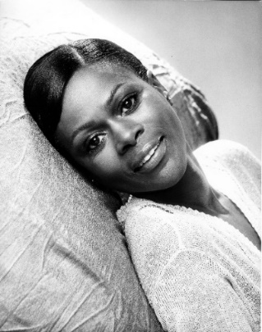
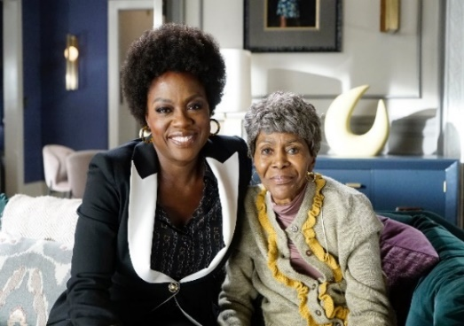
Cicely Tyson (born December 19, 1924, Harlem, New York, New York, U.S.—died January 28, 2021) was an American model and actress noted for her vivid portrayals of strong African American women. […] Discovered by a fashion editor at Ebony magazine, she quickly rose to the top of the modeling world. In 1957 she began acting in Off-Broadway productions […] Because she was committed to presenting only positive images of Black women, Tyson initially did not have steady work in film and television. […] In 1974 she appeared in perhaps her best-known role, that of the title character in the television drama The Autobiography of Miss Jane Pittman, adapted from the eponymous novel by Ernest J. Gaines. Her performance as a 110-year-old woman whose life is depicted from slavery up through the civil rights movement of the 1960s won Tyson two Emmy Awards.
https://www.britannica.com/event/Black-Arts-movement

In 2015 Tyson was nominated for an Emmy for her guest-starring role in ABC's How to Get Away With Murder and was a recipient of the Kennedy Center Honors. The following year, she was honored with the Presidential Medal of Freedom by Barack Obama.
https://www.biography.com/actors/cicely-tyson

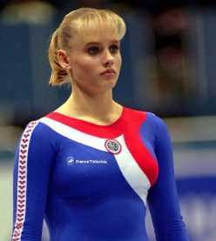
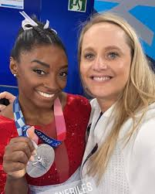
Cécile Canqueteau-Landi (born October 3, 1979) is a French gymnastics coach and former artistic gymnast. She competed at the 1996 Olympics and currently coaches at World Champions Centre in Spring, Texas. She coached from 2007 to 2017 at the World Olympic Gymnastics Academy. […] In October 2017, Canqueteau-Landi joined the coaching staff at World Champions Centre, where she and husband Laurent Landi are personal coaches to Simone Biles, and where she is assistant head coach of the girls' competitive program.

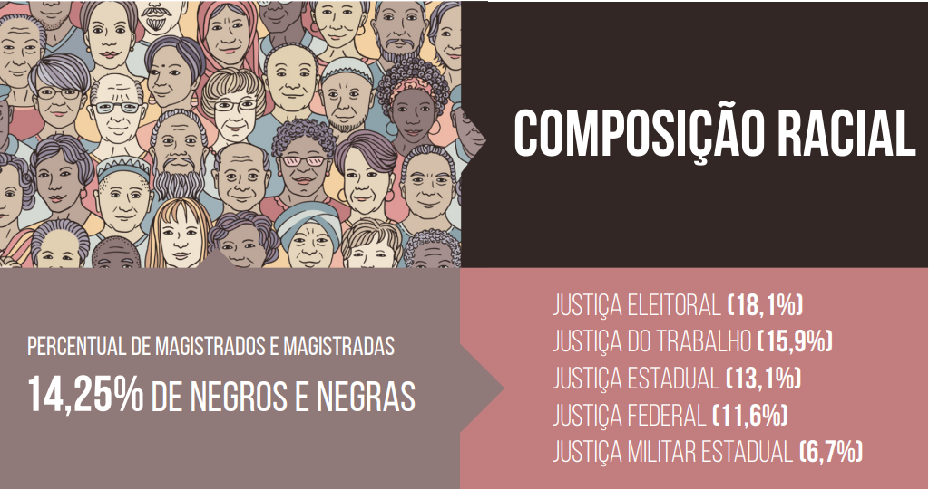

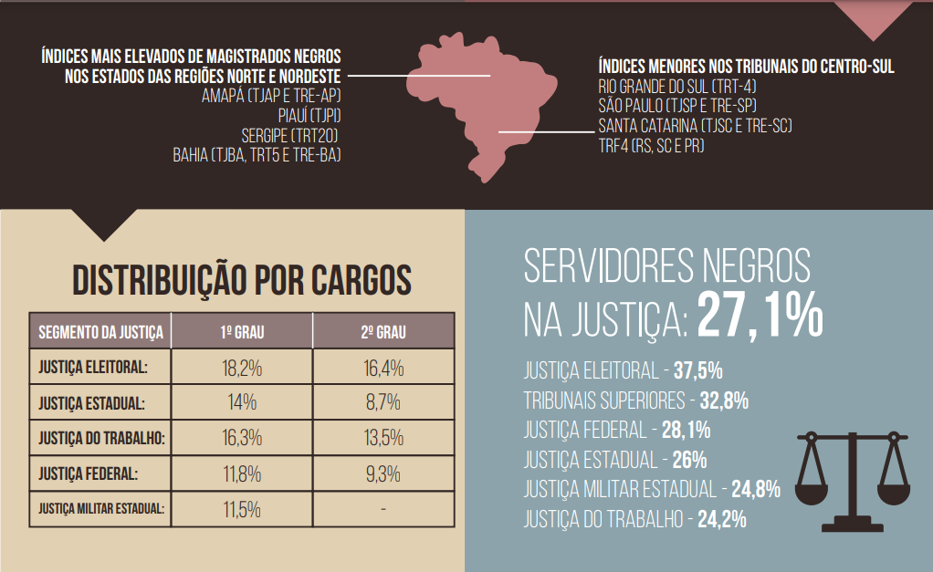

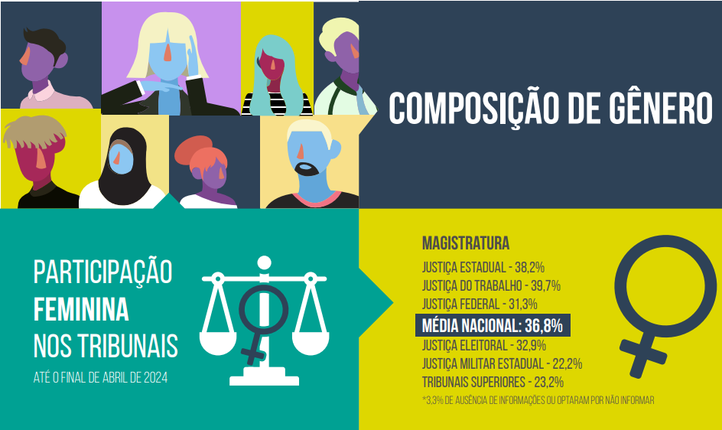

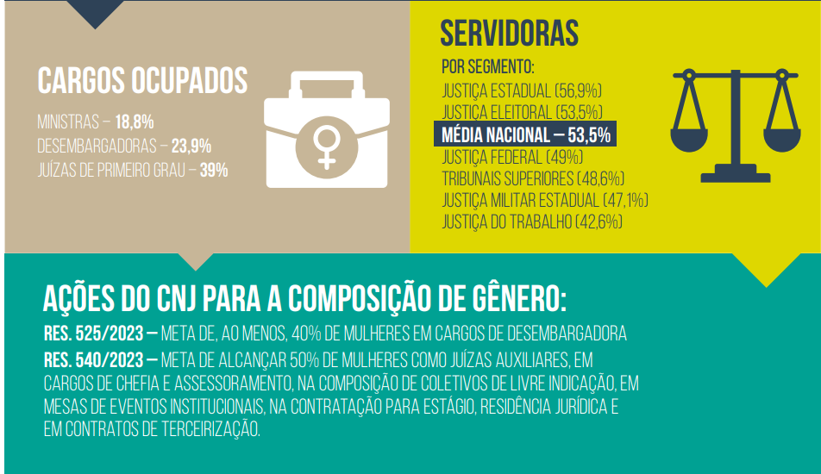

https://www.cnj.jus.br/wp-content/uploads/2024/05/justica-em-numeros-2024.pdf

