Aluno(a): ____________________________________________________
Profª: Cristiane Cruz
Data: 17/09/2015
Atividade Avaliativa de Língua Inglesa – 2º Bimestre

TECNOLOGIA EM SISTEMAS PARA INTERNET

Migrant crisis: Chaos at Croatian border
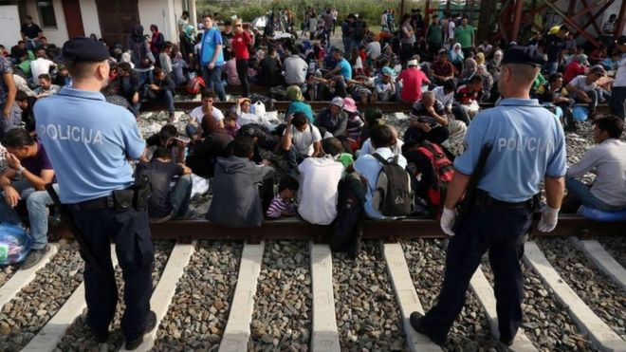
17/09/2015
Riot police in the Croatian border town of Tovarnik are trying to control crowds of migrants crossing from Serbia, as the EU struggles to deal with the mass movement of people on its southern borders.
More than 6,000 have reportedly so far entered Croatia from Serbia after Hungary closed its border on Tuesday.
Croatia has warned it has limited capacity for migrants. Hundreds were involved in clashes at the Hungary-Serbia border on Wednesday.
Many of the migrants are fleeing fighting in Syria, Iraq and Afghanistan and want to reach Germany. BBC reporter asked German Prime Minister what would happen if all those migrants achieve their objective of going to Germany. “They coming to our country is their objective. I think they will not conquer this, better say, I hope not” says him. Long queues have formed in Tovarnik as people await buses and trains to reception centers elsewhere in Croatia.
Thousands have arrived in Croatia since Hungary closed its southern border
The BBC's Lyse Doucet, at Tovarnik station, says the crowds there - many of them Iranian, Iraqi or Syrian - are angry and frustrated, demanding to know when transport will arrive.
"We want to go!" they are chanting, as a wall of people confront a wall of Croatian riot police.
Some have been waiting a day, she says. “They should go back to their country” a police officer said. “They might receive us more patiently” says a Syrian boy. “Germany must prevent their invasion” says Germany Prime Minister.
Many migrants in Serbia travelled to the Croatian border after Hungary completed a fence along its border, trying to find a new route through the Balkan countries into northern Europe.
The Croatian Prime Minister, Zoran Milanovic, said that while the migrants were welcome, there was a risk of putting resources under too much strain. “If they have opportunities to enter in our country our reserves would be at risk and believe me they will probably do it” he said.
Health Minister Sinisa Varga said Croatia was expecting an estimated 20,000 migrants to arrive in the next two weeks. More 35,000 in a month. “If the migrant do so we cannot mesure what will happen to those countries” the Minister said to bbc news.
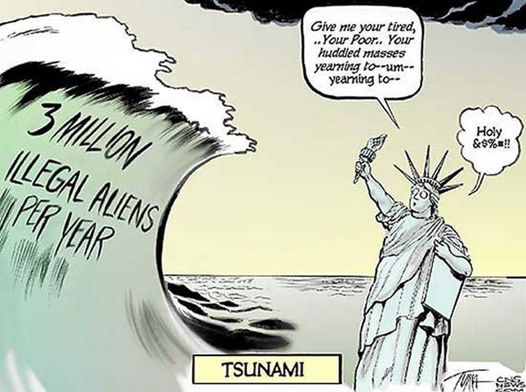
(adapted) http://www.bbc.com/news/world-europe-34278228

Image: http://www.ambrosekane.com/2013/06/19/whites-enraged-at-the-plague-of-third-world-immigration/
Leia os textos e responda:

- A palavra “fence” sublinhada no texto significa:
- Cerca
- Terrorismo
- Enfrentamento
- Vencer
- A palavra “approach” sublinhada no texto significa:
- Apropriação
- Abordagem
- Aproximação
- Apropriação
- O governo dos países europeus:
- Tem tratado os imigrantes com violência, usando bombas.
- Tem tratado os imigrantes com medidas de contenção como gás e canhões de água.
- Trata os imigrantes com muito respeito.
- Promove assistência a qualquer imigrante.
- A correspondência do número com a informação está CORRETA na letra:
- 6.000 imigrantes entraram na Sérvia.
- 7.266 imigrantes morreram na Alemanha.
- 120.000 imigrantes morreram afogados até hoje.
- 5.650 cruzaram a fronteira da Croácia desde quarta-feira.
- O assunto principal do segundo texto é:
- O que significa a palavra “imigração”.
- A crise de imigração que atualmente está ocorrendo no mundo.
- A morte de Aylan Kurdi, menino que foi o símbolo dos problemas de imigração no mundo.
- A imigração do povo Sírio para países da Europa.
- Na frase “Hundreds were involved in clashes at the Hungary-Serbia border on Wednesday.” A estratégia de coesão utilizada foi:
- Reference
- Ellipsis
- Lexical cohesion
- Conjunction
- As palavras destacadas na frase abaixo se referem a:
More than 6,000 have reportedly so far entered Croatia from Serbia after Hungary closed its border on Tuesday. Croatia has warned it has limited capacity for migrants.
- Its = Croatia, It = Serbia
- Its = Croatia, It = Hungary
- Its = Hungary, It = Croatia
- Its = Serbia, It = Hungary
- O exemplo abaixo traz uma coesão através do processo chamado:
The Croatian Prime Minister, Zoran Milanovic, said that while the migrants were welcome, there was a risk of putting resources under too much strain. “If they have opportunities to enter in our country our reserves would be at risk and believe me they will probably do it” he said.
- Lexical cohesion
- Substitution
- Conjuction
- Ellipsis
- Analise a frase abaixo:
BBC reporter asked German Prime Minister what would happen if all those migrants achieve their objective of going to Germany. “Coming to our country is their objective. I think they will not conquer this, better say, I hope not” says him.
A palavra destacada dá coesão ao texto através do processo de:
- Lexical cohesion
- Substitution
- Conjunction
- Reference
- As palavras destacadas no texto dão a ideia de coesão. Estas palavras formam a coesão do texto a través da coesão por:
- Ellipsis
- Reference
- Lexical cohesion
- Substitution
- A palavra “queue” significa:
- Confusão
- Tumulto
- Atraso
- Fila

- O tempo verbal destacado abaixo é:
Riot police in the Croatian border town of Tovarnik are trying to control crowds of migrants crossing from Serbia, as the EU struggles to deal with the mass movement of people on its southern borders.
- Simple Present
- Present Progressive
- Simple Past
- Past Progressive

- O tempo verbal destacado abaixo é:
More than 6,000 have reportedly so far entered Croatia from Serbia after Hungary closed its border on Tuesday. Croatia has warned it has limited capacity for migrants. Hundreds were involved in clashes at the Hungary-Serbia border on Wednesday.
- Simple Present
- Present Progressive
- Simple Past
- Past Progressive

- O tempo verbal destacado abaixo é:
Long queues have formed in Tovarnik as people await buses and trains to reception centers elsewhere in Croatia. The BBC's Lyse Doucet, at Tovarnik station, says the crowds there - many of them Iranian, Iraqi or Syrian - are angry and frustrated, demanding to know when transport will arrive. "We want to go!" they are chanting, as a wall of people confront a wall of Croatian riot police. Some have been waiting a day, she says.
- Present Perfect
- Past Perfect
- Present Progressive
- Past Progressive

- O tempo verbal destacado abaixo é:
Health Minister Sinisa Varga said Croatia was expecting an estimated 20,000 migrants to arrive in the next two weeks. More 35,000 in a month. “If the migrant do so we cannot mesure what will happen to those countries” the Minister said to bbc news.
- Simple Present
- Simple Past
- Simple Future
- Present Progressive
Em relação à frase abaixo:
The BBC's Lyse Doucet, at Tovarnik station, says the crowds there - many of them Iranian, Iraqi or Syrian - are angry and frustrated, demanding to know when transport will arrive.
"We want to go!" they are chanting, as a wall of people confront a wall of Croatian riot police. Some have been waiting a day, she says. “They should go back to their country” a police officer said. “They might have received us more patiently if they passed through the same problem” says a Syrian boy. “Germany must prevent their invasion” says Germany Prime Minister.

- O modal should foi usado:
- Por tratar-se de um oferecimento
- Por tratar-se de uma possibilidade
- Por tratar-se de um pedido
- Por tratar-se de um conselho

- O modal might have foi usado:
- Por tratar-se de um oferecimento
- Por tratar-se de uma possibilidade
- Por tratar-se de um pedido
- Por tratar-se de um conselho
- O modal must foi usado:
- Por tratar-se de uma obrigação
- Por tratar-se de uma recomendação
- Por tratar-se de uma certeza
- Por tratar-se de uma possibilidade irreal

- Escreva um exemplo de referente (use seu nome).
- Escreva um exemplo de frase usando o passado perfeito (passado antes do passado) (use o nome da professora).

