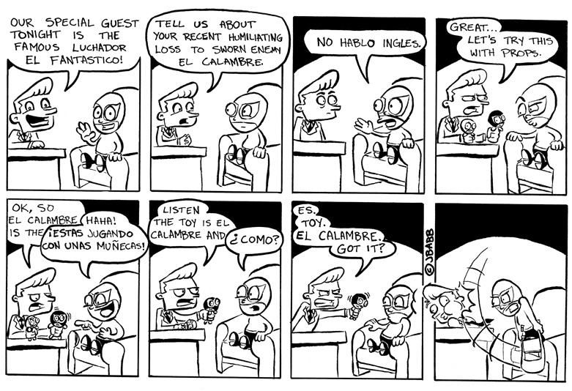

Spanglish
by Justin on August 9, 2010 at 2:01 am
Posted In: Webcomic
To those who don’t speak Spanish (or at least don’t understand my broken attempt at it), here are a few translations:
- Estoy El Calambre: “I am El Calambre.”
- Estas jugando con unas munecas: “You are playing with dolls.”
(For those paying close attention, El Calambre was a nod to Rhode Montijo and his amazing comic, Pablo’s Inferno. Check out his latest work at the site linked through his name.)
http://jbabbcomics.com/archives/spanglish

Spanglish
by Justin on August 9, 2010 at 2:01 am
Posted In: Webcomic
To those who don’t speak Spanish (or at least don’t understand my broken attempt at it), here are a few translations:
- Estoy El Calambre: “I am El Calambre.”
- Estas jugando con unas munecas: “You are playing with dolls.”
(For those paying close attention, El Calambre was a nod to Rhode Montijo and his amazing comic, Pablo’s Inferno. Check out his latest work at the site linked through his name.)
http://jbabbcomics.com/archives/spanglish

Spanglish is the New Ad-lingo¹

By Luis Sierra-Campos

What’s the new what? Spanglish is the new ad-lingo.

Spanglish is what marketers are using to sell everything from the War in Iraq.

To Burger King’s fusion food “Chicken Fries”

But don’t get it twisted, Spanglish, code-switching between English and Spanish, has been around for a long time. And you can hear it everywhere Spanish speakers live and communicate with one another. I mean, the last time I was driving through my school parking lot with a friend, I found myself saying:

“Hey! –There’s un Parquiadero, just step on the breaks.”

When meaning to say “Hey Look! A parking space, step on the brakes.” But, according to Catarino Lopez, Creative Director for Bromley Communications, and maker of the BK Chicken Fries Commercial, no one will be stepping on the brakes of the Spanglish Ad craze any time soon.

Catarino Lopez: In a high school you always have an incoming class of freshmen² and you always have an outgoing class of seniors³, and the Latino market is exactly that — there is always an incoming class of immigrants and who are coming fresh from other countries, to find jobs and better opportunities.

And as immigrants become what Lopez refers to as sophomores⁴ and juniors⁵, the products advertisers try to sell them get more and more expensive. Like this Toyota commercial.

Kid: “Papá, why do we have a hybrid?”
Dad: “For your fuuuutuuure.”

But this ad isn’t just selling a 30 thousand dollar hybrid car. It’s selling something more, assimilation! It runs on gas and electrical power.
Dad: Mira aquí. It uses both.”
Kid: “Like you, with English and Spanish.”

The Association of Hispanic Advertising Agencies estimates that Latino purchasing power will grow to over a TRILLION dollars by 2010. But Ilan Stavans, the editor of the Spanglish Dictionary, and Professor at Amherst College, believes the financial impact of Spanglish will be minor when compared to the way it will rewrite culture.

Ilan Stavens: Spanglish is not likely to disappear in the next 10 to 20 year’s. Just the opposite. It will become the much more frequent in media that not only targets Latinos but targets the country as a whole ultimately shaping the way we used the English language and used the Spanish language.

Yeah that’s right? ¿eso era lo que yo pensava? Spanglish is about my hybrid identity, not my hybrid car — because, well, I just can’t afford one! So it’s nothing new to me, but for those marketers who think it’s el ultimo grito, “Spanglish is the new Ad-lingo.”

Aired on NPR news Day to Day, June 19th, 2008

http://lsierracampos.wordpress.com/2009/09/07/spanglish-is-the-new-ad-lingo/

Luis Sierra Campos
Luis Sierra Campos is a Los Angeles based Multimedia Producer, Journalist, and Community Educator.

Believing in the power of media to educate, change, and mobilize the lives of communities at large. Campos, coordinates a youth written quarterly, 100% Bilingual (Spanish and English), Hyperlocal news paper, The Boyle Heights Beat/Pulso de Boyle Heights, for the community of Boyle Heights in Los Angeles, California. Additionally, he's a media instructor for The HeArt Project, a Los Angeles based arts education non-proft organization for high school students.

As Senior Producer for Hear In The City: Radio Realities from the Urban Landscape, a weekly radio magazine show on KPFK 90.7FM in Los Angeles, Campos reports on local immigration issues, arts and culture, and directs the community health-reporting Desk.

Campo's voice has been prominent in the U.S and Mexico radio airwaves reporting for National Public Radio (NPR), Public Radio International (PRI), and Instituto Mexicano de la Radio(IMER). Additionally, a commentator, reporter, and blogger for Youth Media International(Youth Radio).

Campos obtained a Bachelors of Arts in Media Studies and a minor in Cultural Social Anthropology from Pitzer College. A recipient of the Kaiser Family Foundation HIV/AIDS Global Radio Reporting Fellowship and recently the Jan Björklund Swedish Ministry of Education Global Health Reporting Fellowship at Uppsala University in Sweden—studying the affects of water pollution in agricultural countries in Latin America
Luis's passion is practicing Bikram Yoga (Lock the Knee!!)

Vocabulary:
1- Lingo = 1.A characteristic language of a particular group (as among thieves); "they don't speak our lingo"[Wordnet]; 2.Language; speech; dialect[Websters]. Ad-lingo (Ad = Advertisement); The language of/for advertisement.
2- Freshman: 1. A first-year undergraduate.[Wordnet].2. Any new participant in some activity.[Wordnet].3. Novice; one in the rudiments of knowledge; especially, a student during his fist year in a college or university.[Websters].
3- Senior: 1. An undergraduate student during the year preceding graduation.[Wordnet] 2. A person who is older than you are.[Wordnet] 3. A person who is older than another; one more advanced in life.[Websters] 4. One older in office, or whose entrance upon office was anterior to that of another; one prior in grade.[Websters] 5. An aged person; an older.[Websters] 6. One in the fourth or final year of his collegiate course at an American college; -- originally called senior sophister; also, one in the last year of the course at a professional schools or at a seminary.[Websters].
4- Sophomores: Noun: 1. A second-year undergraduate. [Wordnet] 2. One belonging to the second of the four classes in an American college, or one next above a freshman. [Websters]. Adjective 1. Used of the second year in United States high school or college; "the sophomore class"; "his sophomore year".[Wordnet] 2. Being callow, inexperienced, half-baked or unfledged. [Eve - graph theoretic] 3. Adjective base of the adverb sophomorely.[Eve - graph theoretic]
5- Junior: 1. Younger; lower in rank; shorter in length of tenure or service.[Wordnet] 2. Used of the third or next to final year in United States high school or college; "the junior class".[Wordnet] 3. Including or intended for youthful persons; "a junior sports league"; "junior fashions".[Wordnet] 4. Lower in standing or in rank; later in office; as, a junior partner; junior counsel; junior captain.[Websters]

Exercise
1. O termo Spanglish é usado no texto como:

2. Descreva o 1º comercial que aparece no texto. Traduza as falas do pai e do filho(a).

3. Qual é a previsão dada para 2010?

4. Descreva um pouco sobre o autor.

5. Descreva os termos freshman, sophomore, junior e senior que aparecem no texto. A que eles se referem e qual é a importância deles para o spanglish?

