MEMO TO: For those whom it may concern
FROM: Brad Towle
DATE: 5/14/2004
CONCERNING: Using Eagle files to create boards on the LPKF

Summary:
Professor Ross Snider has an LPKF board router that can make a single or double-sided printed circuit board (PCB). Having a fuller understanding of the router would be able to boost efficiency in both Senior Design as well as in research. Boards could possibly be made on campus for roughly ten or twenty dollars versus off campus for higher fabrication fee. However the method of converting the Eagle PCB format over to the board maker is tricky at best. This memo is written to help other students/faculty convert Eagle to CAM files.

Introduction:
To begin, the board router can only do two layers, this means that the program used to create the board router format, CircuitCAM, needs only three layers. These are drill hole locations, top traces, and bottom traces. Unfortunately, this severely limits the amount of writing, or silk screening, you are able to do on the board itself. This is a large drawback because there will be no printing on the board for part placements. If more than two or three complex boards are to be produced, it would be worth the price to get them fabricated by an external company.
STEP 1 –Start with an Eagle file.
This tutorial assumes you have an Eagle file prepared and you are sure of the component placements. First, load up your project. It will look something like this:
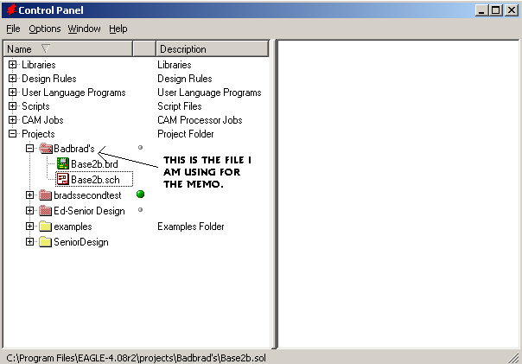
Figure 1: Opening Screen for Eagle Software
The project name in this example is labeled Badbrad, the next point of interest is the PCB layout file. This file is labeled with the “.brb” at the end. Double click to open it up. This will show you what your board would look like versus the schematic which merely shows how the board is wired. Click in the text box on the top of the screen, the command box, and type run “drillcfg”. Figure 2 shows this.

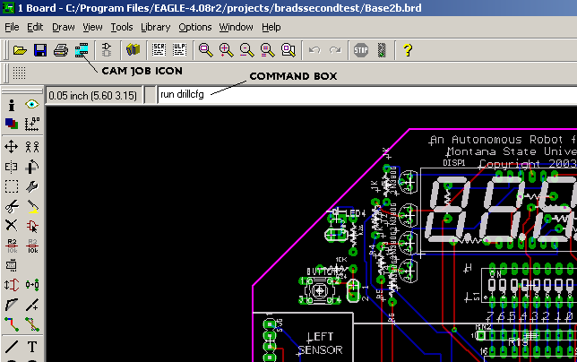
Figure 2: Eagle’s board editor
STEP 2- Making the CAM job
Once return has been hit, you will be asked to select either inches or mm systems. The choice is up to you; for this example choose inches. It will then display a set of values. Assuming your board is correct, these values will also be correct. Click ok and then it will ask where to save the .drl file. Save it away to a safe spot as it will be needed later. Now going back to the board screen click the CAM job icon (see Figure 2), which will open a window as shown in Figure 3.
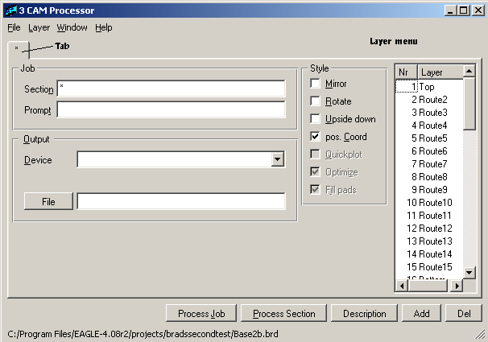
Figure 3: Opening screen on the CAM processor
First, the program that will be used, CircuitCAM, can only take one Gerber file at a time, hence only one layer at a time. Gerber is the file format that allows Eagle to transfer its data to another non-Eagle application. It is possible to do every layer separately and get the same results. However, the method I will show you will allow you to be able to re-make all your files with a couple clicks of the button. It should be noted that this part of the tutorial is pretty much a copy from the “how to” document (B) referenced at the end of the memo.
First, click “add”, Notice that another tab appears. If the delete (Del) is clicked the current tab that is open will close. Click “add” until you have three separate tabs. Now in the first tab you want to type the following information: section = “Top”, select device and pull down to GERBER_RS274X. For the board router MSU has this file is the best for compatibility sake. For the file put ‘.top’. This will merely let you know what layer you are importing later; it does not change any format. Now for the remainder of the settings I suggest using the default for the offsets, (x=0,y=0), disabling pos. Coord and enabling Optimize. You must now select what layer you want to include. Obviously you want top, therefore, in the Layer menu select “1 TOP”. You will also want 17 Pads and 18 Vias to be selected. Pads will give you space that you can solder parts on, and vias are the smaller spaces connecting a trace to the other layer. Both of these settings need to be on for the bottom layer. Your screen should look like Figure 4.
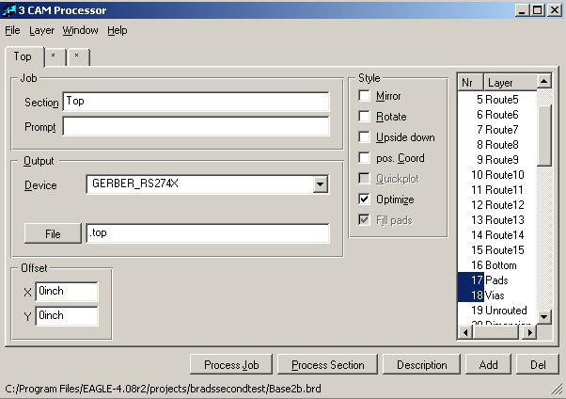
Figure 4: Top layer finished
Reminder: sometimes other layers will have to be deselected because the computer automatically highlights extra layers you do not need. With MSU’s router, only 1,17, and 18 should be highlighted for the top Gerber.
Click the next (*) tab. This will be the bottom layer. There are only three things you change for the bottom. One, change the section name to bottom. Two, change the file type to ‘.bot’, and finally de-select the 1 Top layer and select the 16 Bottom layer. It should look like Figure 5 when finished.
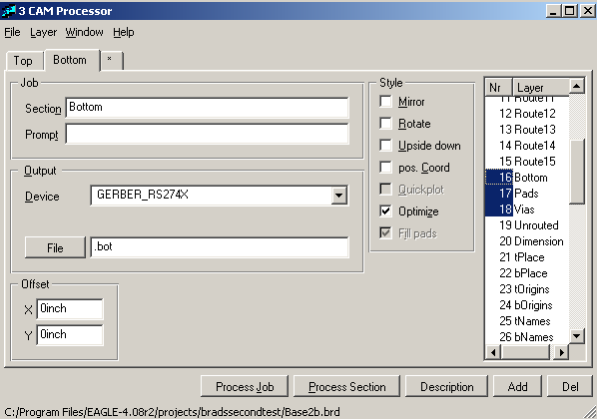
Figure 5: Bottom layer finished
Now you can create the drill files using the third tab(*). First label the section Drill. The LPKF uses a device called EXCELLON so select this device on the output pull down. Then you will see two options pop up, a rack, and the file, the file (.drl) you made at the very beginning of the memo is the rack file. Push the button labeled rack and go select the .drl file. For tolerance, use .025 in for the negative and positive values. If you are doing extremely precise stuff, in the area of hundredths of a mm, then this should be reconsidered. For a standard PCB board this is fine. The file suffix you will use will be .drd. Finally, only two layers are used for the drill Gerber. They are 44 Drills and 45 Holes. The setup should look like figure 6:
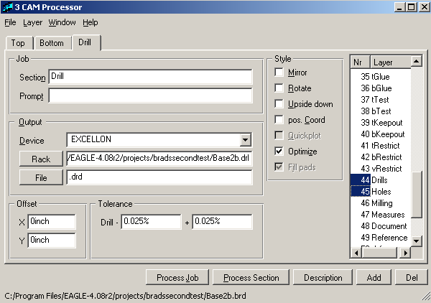
Figure 6: Drill Gerber when finished
Now here is the beautiful part of this whole ordeal. Go to the File menu and Save Job As… this allow you to save everything in a .cam file. Whenever printing on the LPKF is needed, regardless of what project it is, merely open the CAM menu, load this job, and the Gerber is set. Now click Process Session for top, bottom, and drill. The computer will whirl away for a bit, and then stop. Close the Cam menu and go back to Eagle’s main menu. There under your project file you will see a change as seen in figure 7.
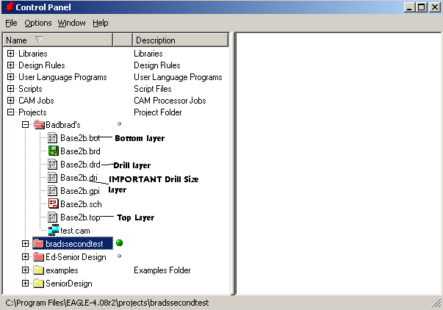
Figure 7: Files created from CAM process Sessions.
STEP 3- Importing to CircuitCAM
Notice that a couple of other files pop up that you didn’t specify. Only one matters and that is the .dri file. This gives the size of apertures and other things for CircuitCAM. The following files will need to be transferred to the computer attached to board router: .bot, .top, .drd and the .dri. Now start CircuitCAM, create a new double-side board, and then you will see a black screen (Figure 8). Either hit the Import Icon or go to File:Import. Select the drive with your files on it.
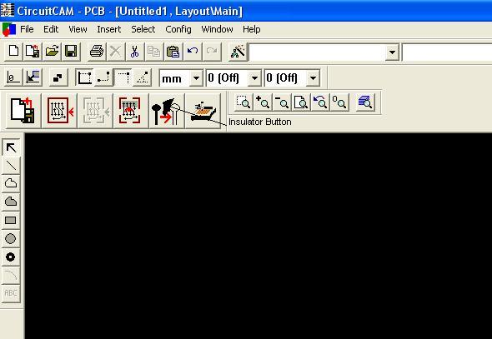
Figure 8: Opening Screen on Circuit Cam
Please notice the Insulator Button marked in Figure 8. This will be used later in the process. First, import the .dri file. (File->import->yourfile.dri) The screen should come up that looks like Figure 9.
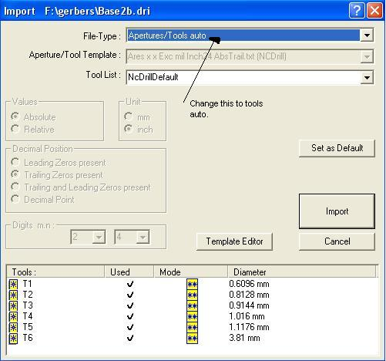
Figure 9: Importing a .DRI file
NOTE (Do not change anything but the file type. I suggest selecting Apertures/Tools Auto. This way you do not have to worry about setting the apertures manually. Now that you have selected Apertures/ Tools Auto, click Import.
Now import the .DRD file. This will bring up a screen that looks like Figure 10.
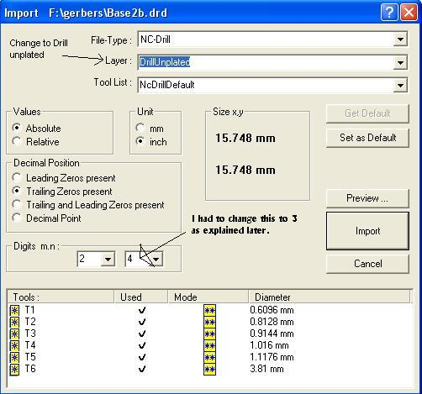
Figure 10: Importing a Drill file
Change the layer to DrillUnplated, or plated if that is the type of material being used. Click import, and the drill holes have been completed.
Go to Import and click .top layer. This time the import file menu is a little different. Don’t worry merely: make the Layer selection to Top Layer and click Import, as seen in Figure 11.
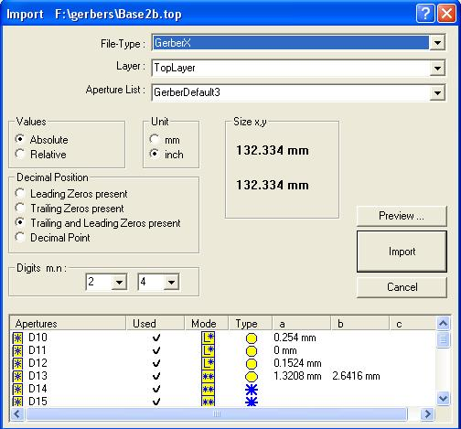
Figure 11: Importing the top layer.
A problem may occur about now: if your screen looks like Figure 12 then something is not aligned properly. It is STRONGLY suggested not to change the top or bottom layers, merely adjust the “Digits m.n” menu on your .drd file. (I had to change mine to 3. as seen in figure 10.) A new .cam file may have to be made to re-import the files in order to change the .drd file.
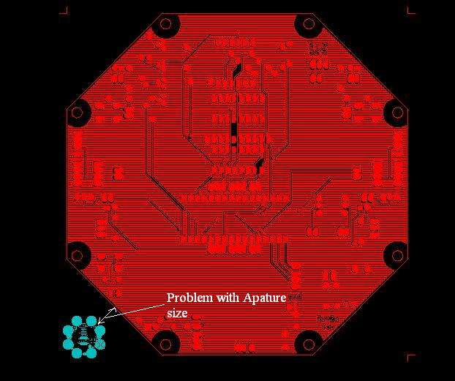
Figure 12: Size error in the drill file (.drd).
However if the holes do line up with the top layer go on to the next step and import the bottom layer. Same as before, but this time Select Layer-> BottomLayer then click import. (Figure 13)
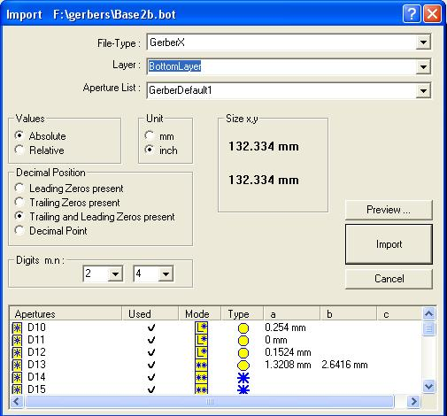
Figure 13: Importing the Bottom file
STEP 4- Exporting to Board Master
First, insulate your board. On the main screen click on the insulator icon shown in figure 8, this allows the separate layers to be incorporated into one. The computer will take a few moments and then stop. Now it is time to export to the Board Master, A program that actually cuts the board. Go to File -> Export -> LPKF -> lpkf/CircuitBoardPlotter. Save the file somewhere where you can access it easily. (Figure 14)

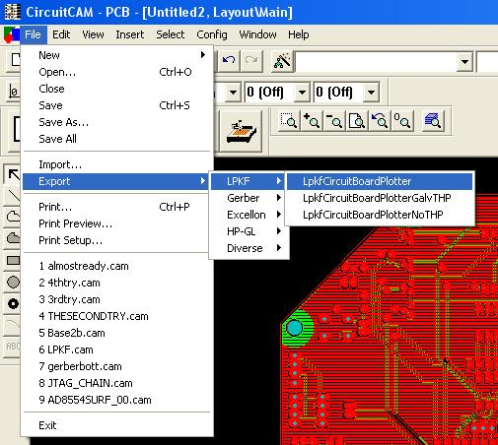
Figure 14: Exporting to Board master
Now open Board Master and import the file you just made. NOTE: you have to import it; you cannot load the LPKF file. The board should pop up and be ready to cut.

IMPORTANT: When starting from Eagle software the Board Master will display an outline of the bottom layer along with the drill layer. Do not worry, it will only drill the holes not the whole bottom layer.

WARNING: Please ask someone to help you before starting Board Master. There are some details about the LPKF board cutter that are tricky. DO NOT try this alone until someone has had time to sit down with you and explain the entire routine.

Conclusion:
I hope this report has shed some light on how to transfer files from Eagle to CircuitCam to Board Master. The process seems daunting at first but remember only the top, bottom, and drill layers are needed. Import the drill aperture first then import the drill file. After loading the top layer the settings on the .drd file may have to be modified in order to make the board layers align. Then load the bottom and you are good. Hopefully, this report will reduce the project’s time and energy spent on routing your own board.

Bibliography

A) “Using the LPKF to create PCB’s” University of Otago;
http://www.physics.otago.ac.nz/research/electronics/eagle_howto.html

B) “How-to Document” LPKF Laser & Electronics;
http://www.lpkfusa.com/downloads/support/docs/ht_export_eagle.pdf

